Chapter 16 – The Gilded Age
(1878 to 1889)

Vocabulary
deflation __________________________________________________________ _________________________________________________________________

bimetallism ________________________________________________________ _________________________________________________________________

immigrant _________________________________________________________ _________________________________________________________________

laissez faire _______________________________________________________ _________________________________________________________________

labor union ________________________________________________________ _________________________________________________________________

strike ____________________________________________________________ _________________________________________________________________

quota ____________________________________________________________ _________________________________________________________________

civil service _______________________________________________________ _________________________________________________________________

scab _____________________________________________________________ _________________________________________________________________

anarchist _________________________________________________________ _________________________________________________________________

trade union ________________________________________________________ _________________________________________________________________

collective bargaining ________________________________________________ _________________________________________________________________

assimilate _________________________________________________________ _________________________________________________________________
Identification
Terence V. Powderly ________________________________________________ _________________________________________________________________

James Garfield _____________________________________________________ _________________________________________________________________

Chester Arthur _____________________________________________________ _________________________________________________________________

Booker T. Washington _______________________________________________ _________________________________________________________________

John Marshall Harlan ________________________________________________ _________________________________________________________________

Grover Cleveland ___________________________________________________ _________________________________________________________________

Samuel Gompers ___________________________________________________ _________________________________________________________________

Benjamin Harrison __________________________________________________ _________________________________________________________________

Jane Addams ______________________________________________________ _________________________________________________________________
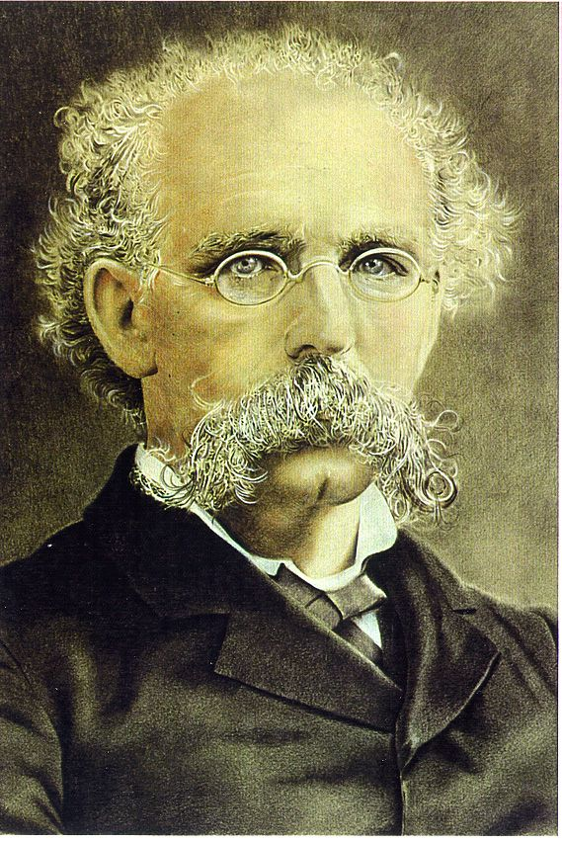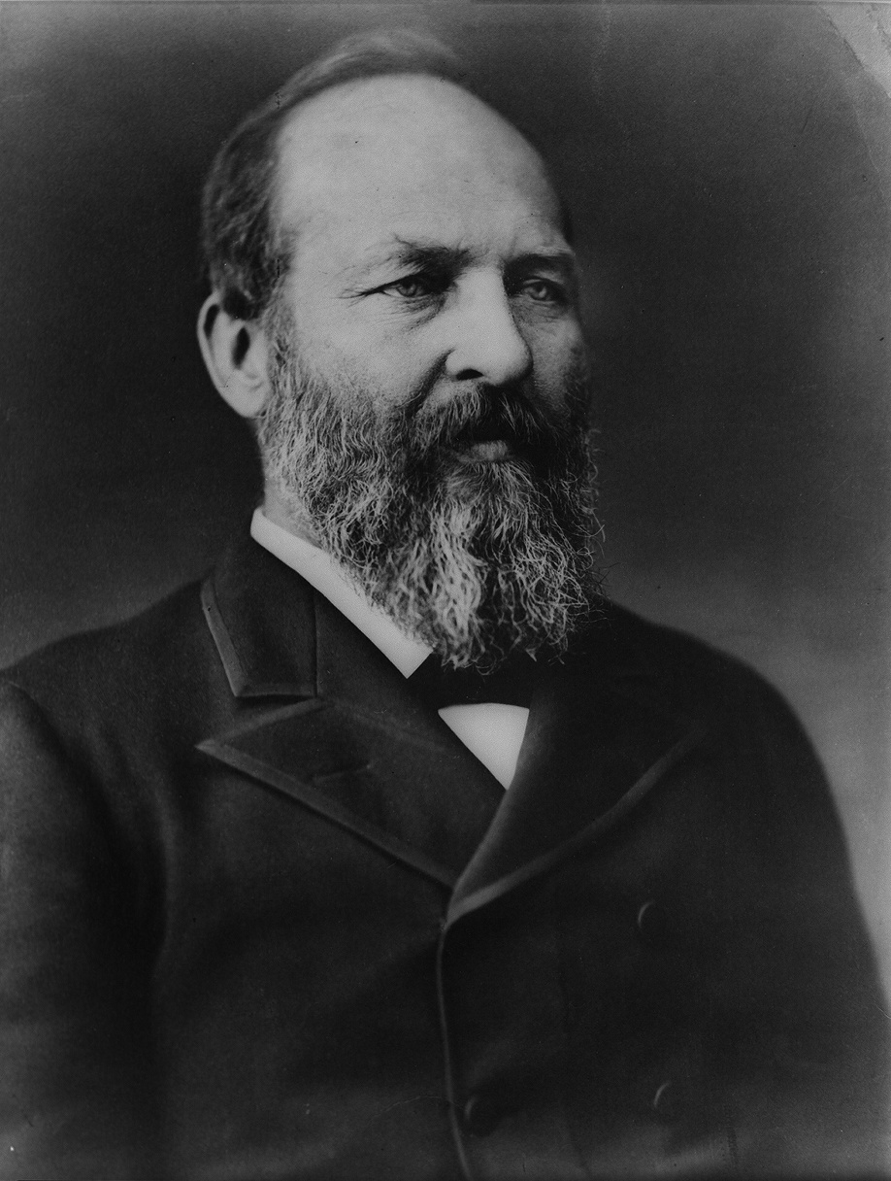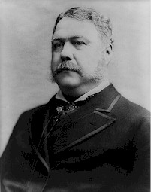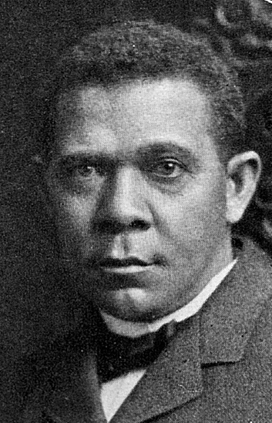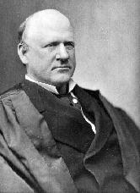
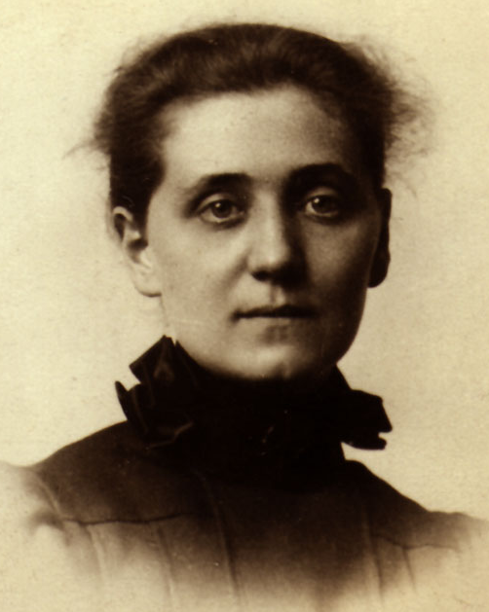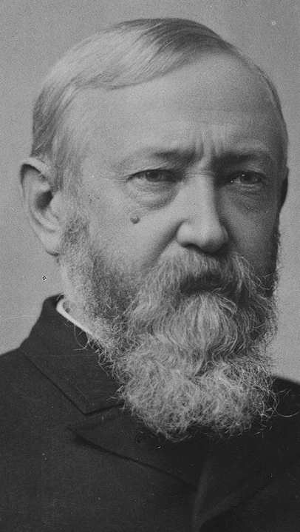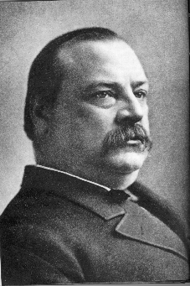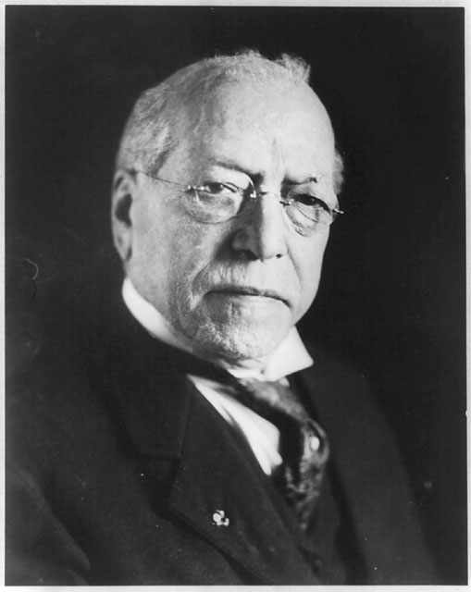
Top Row (Left to Right): Terence V. Powderly, James Garfield, Chester Arthur, Booker T. Washington & John Marshall Harlan.
Bottom Row (Left to Right): Grover Cleveland, Samuel Gompers, Benjamin Harrison & Jane Addams.

Chapter 16 Short Answer Questions (10 Points)
You must answer ONE of the following questions on a separate sheet of paper by the day of the Chapter Test. You must answer in complete sentences and answer as completely as possible. You are encouraged to type your answer but handwritten responses will be sufficient.

Be sure to write the question that you are answering at the top of the page!

- How did the relationship between employer and employee change as the industrial revolution took hold in the United States after the Civil War?

- Provide an example and explain how the United States Government was racist in its immigration policies of this time.

- Explain two technologies of this time period that led to the development of skyscrapers.

- How do the results of the Haymarket Riot demonstrate how government sided with management in most labor disputes of this time?

If you want assistance, you may see me before or after school or email me at mrdan4th@hotmail.com for help.

