Chapter 23 – The Cold War Begins –
1945 to 1959
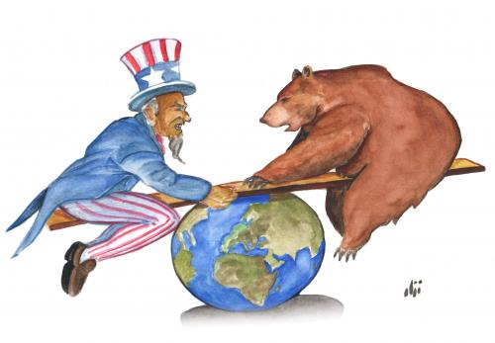

Review:
World War II was the most terrible conflict in the history of the world. More than 60 million people died. Lives were changed forever. With the fighting over, now came the opportunity to learn from our past mistakes and move on. But doing this would not be easy. Rebuilding would be necessary. The way in which Americans viewed the world had changed and it was clear that we could never return to an isolationist nation. The years that followed this conflict marked a period of great success for the United States and unparalleled fear. We are today looking back at this period in hopes of learning more about our role in the world.

Lesson 1 –

The Balance of Power

Main Idea: After the end of World War II, two superpowers arise. Balancing the interest of these two countries will dominate the rest of the century and beyond.

The United Nations
After World War I, the Allied Powers attempted to set up an international organization that would prevent another large war. The brainchild of President Woodrow Wilson, the League of Nations was never able to succeed at that task. Part of the responsibility has to fall on the United States. You’ll remember that in the 1920s, we returned to an isolationist foreign policy – the Senate voted against the Treaty of Versailles; and the U.S. never joined the League of Nations. We learned from that nasty lesson and even before World War II was over, the framework was in place for the creation of a new, more powerful international organization.

The United Nations (UN) first met in April 1945 in San Francisco, California. It was there that the basic structure of the organization was agreed upon. By October 1946, New York City became the new permanent home of the UN. The goal of this body was and continues to be to prevent war and protect human rights around the world.

It is important that you are familiar with the basic structure of the UN. First, we’ll begin with the General Assembly. The UN General Assembly is made up of all of the nations with membership in the United Nations. Currently there are 191 member nations in the UN. It is in the General Assembly where each member nation gets one vote to cast on UN decisions. No one country has any more power than another in the General Assembly. This is not the case in the United Nations Security Council.
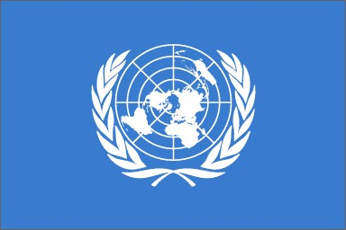
The United Nations Security Council has the responsibility of maintaining international peace and security. The UN Security Council is made up of 15 nations. Membership in the Security Council for 10 of the 15 nations is for 2 years. Those 10 positions rotate out to other nations after the two year term is up. Five of the members have permanent membership on the Security Council. They are
- China
- France
- Russia (formerly the Soviet Union)
- United Kingdom (Great Britain)
- United States
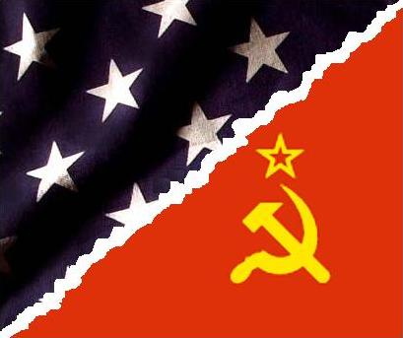You will notice that these nations represent the countries that made up the Allies in World War II. With permanent membership, each of these countries has veto power on all decisions in the Security Council. This is a very important power, and when we discuss the Korean War, you will see why.

The Iron Curtain
There are a few things that we need to understand as we are learning about the Cold War. First, just what the heck is a “cold war”? How does it differ from a “hot war”? Well, the term is used to describe the tension between the United States and its allies in Western Europe on one side and the Soviet Union and its allies in Eastern Europe on the other. The difference between this and a “hot” war, would be that this is just tension, not actual fighting as had happened in World War II.

So then, how did this start? Wasn’t the Soviet Union our ally in World War II? Why the tension? You should know that often times, tension is created by how we view others. The impression that we have may or may not be accurate, but it will determine how a relationship will develop. What happened regarding the relationship between the U.S. and the Soviet Union was determined by mistrust and misunderstanding. This is still something that we are dealing with today.

First, let’s not forget that Josef Stalin was a dictator. He wound up on our side mostly because he was attacked by Hitler’s Germany. (The enemy of my enemy is my friend). Let’s also remember that maintaining power was something that was of primary importance to Stalin. When Germany nearly defeated the Soviets in the early years of the war, it was clear to Stalin that he could never let that happen again. The best way to do this was to make sure that the nations nearest to the Soviet Union would be friendly.

At the Yalta Conference in February 1945, Stalin had promised to allow free elections in the countries that the Soviets had liberated from Nazi Germany. Poland, Czechoslovakia, and Hungary, among others, were to be able to choose their own forms of government. Stalin reneged on his promise. He felt that the only government that he could allow in these countries had to be communist. That was the only type of government that he could control and therefore be friendly toward the Soviet Union.

The United States and its allies (most notably Great Britain) were upset with this. You should also remember the history of fear in this country when it comes to communism. Our interpretation of Stalin’s motives was that he was trying to spread communism internationally. That represented a clear threat to our capitalist economy and way of life. This is where the tension comes in for us. What we should have realized was that Stalin had given up on international communism years before and that he was simply interested in preventing another attack on his country.

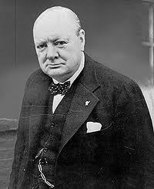 The misunderstanding on the Soviets’ part was that there really wasn’t any threat of future invasion. The destruction of Nazi Germany was too complete for that to be an issue. But if you try to look at things from their point of view, you might understand why they were so nervous. Twice in a span of less than thirty years a country (Germany) had invaded their territory. Both times millions of Russians had died (about 28 million in World War II). Maintaining security had to be pretty important to them.

In 1946, British Prime Minister Winston Churchill was invited by President Truman to speak at Westminster College in Missouri. It was here that Churchill gave his famous “Iron Curtain” speech. He said,

From Stettin in the Baltic to Trieste in the Adriatic, an “iron curtain” has descended across the continent… whatever conclusions may be drawn from these facts – and facts they are – this is certainly not the liberated Europe we fought to build up, nor is it one which contains the essentials of permanent peace.
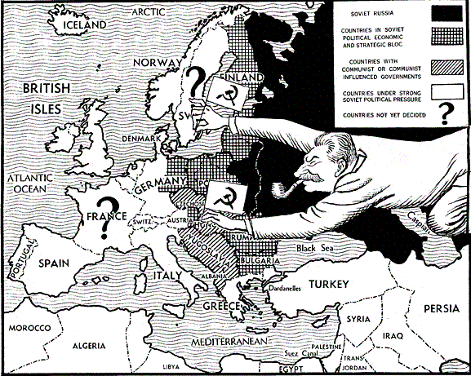
Churchill called upon the United States to stand up to the Soviets, fearing that Stalin’s goal was to conquer the rest of Europe. It was clear that in order to avoid another world war, the United States would have to come up with a new policy to counter the growing Soviet threat. From this point on, for every Soviet action, there was a reaction by the United States and its allies (and vice versa). Even after Stalin’s death in 1953 and a new Soviet leader in Nikita Khrushchev, the misunderstanding and the tension continued.

Truman Doctrine
The first step taken by the United States to stand up to this perceived Soviet threat came when President Truman asked Congress for $400 million in aid for Greece and Turkey. In these two Mediterranean countries, a strong communist movement was threatening to overthrow the governments. Communist governments in Greece and Turkey would give Stalin an even bigger presence in Europe. Truman feared that this could spread, undermining democratic governments throughout Europe.
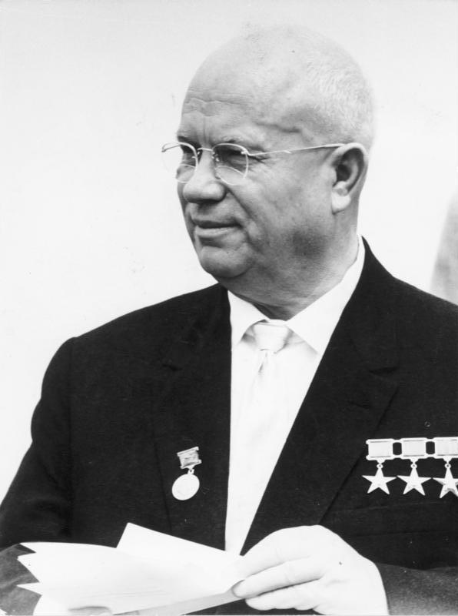
Congress granted him this money and thus began the Truman Doctrine. This stated that the United States would support "free peoples who are resisting attempted subjugation by armed minorities or by outside pressures." This became the cornerstone of a foreign policy called containment. The United States would, from now on, seek to keep any Soviet expansion or communist revolution contained – meaning to keep it from spreading. Almost every foreign policy decision made by the U.S. between 1947 and 1991 had some sort of connection to the containment strategy. For instance, the U.S. became a strong supporter of the newly created state of Israel in 1948 in part to have a powerful anti-Soviet presence in the Middle East.
Nikita Khrushchev

Marshall Plan
George Marshall was the top general in the U.S. Army during World War II. Generals Eisenhower and MacArthur were the supreme commanders in their specific theaters of operation, but they ultimately had to answer to General Marshall. In 1947, Marshall became President Truman’s Secretary of State.
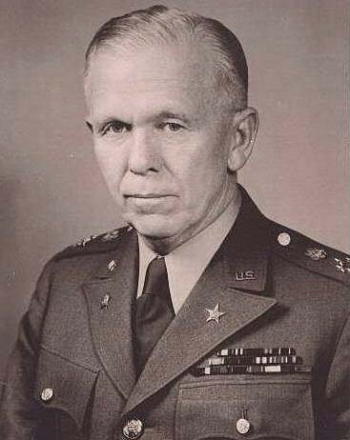
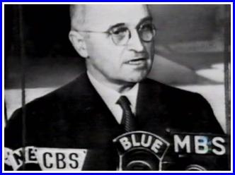 In order to achieve the goal of containment, Marshall came up with a plan that would help stop the spread of communism in Europe. Economies in post-war Europe were struggling to rebound from the devastation of the war. As we learned after World War I, this can cause people to turn to extreme ideals, and communism was becoming a popular solution for many radicals. Marshall and Truman argued that it was in the best interest of the United States to help improve these struggling economies. This could prevent possibly communist revolutions.
Secretary of State George Marshall

In 1948, Congress and the president signed the Marshall Plan into law. Approximately $12.4 billion in aid to European countries was provided by the United States government. The aid was even offered to the Soviet Union and the Eastern European satellite nations it controlled. (They rejected the money). Economies in Europe began to rebound. This, in turn, helped the U.S. economy because it allowed these nations to import U.S. goods. Ultimately, this aid achieved the goal of halting communist radicals and thus containing Soviet influence.
President Truman Speaks to Congress

Lesson 1 Review Questions – (write answers in complete sentences on a piece of loose-leaf paper).

- What is the goal of the United Nations and how does the U.N. Security Council work?
- What was Stalin's reasoning for wanting the countries closest to the Soviet Union to have communist governments?
- What was Churchill doing when he gave his "Iron Curtain" speech?
- What was the key strategy behind the Truman Doctrine?
- Why was the Marshall Plan such an important part of the Truman Doctrine?

Lesson 2 –

Changes At Home

Main Idea: There were plenty of new changes that came about here in the United States after the end of the war.

Breaking the Color Barrier
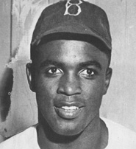 As you should remember, big league baseball used to have African American baseball players in the late 1800s. By the early 1900s, blacks were not allowed to play in the major leagues. The Negro Leagues of the 1920s showcased outstanding talent, but still the color barrier banning black ballplayers remained in the majors.

This changed in 1947 when Jackie Robinson played for the Brooklyn Dodgers. Despite threats and merciless jeering by bigoted fans and players alike, Robinson proved that race was not barrier when it came to talent. He hit .295 and stole 29 bases in 1947. In 10 seasons, Robinson averaged .311 and stole 197 bases. In 1949 he was named the National League MVP. But more important than his statistics was his ability to be a pioneer and take the abuse dished out by so many ignorant people. This paved the way for more African American baseball players. Robinson was inducted into the Baseball Hall of Fame in 1962.
Jackie Robinson

U.S. Economy
In the short time following the end of the war, the U.S. economy experienced some difficulties. During the war there were price regulations in place that kept prices low. In addition, Americans were rationing domestic goods. In fact, it was next to impossible to buy a new car made between 1942 and 1945. Once the war was over, Congress passed a huge tax cut. Add to this that Americans had been supporting the war effort through buying savings bonds. Now people had plenty of money to spend. All of this triggered inflation. Prices for goods began rapidly increasing – sometimes up to 25%.

If salaries do not increase to match inflation, you have labor problems. Unions began striking, sometimes crippling important industries like transportation (railroad workers strike). President Truman threatened military action and briefly restored wartime price controls.

In 1946, the public returned a Republican majority to Congress, the first time since FDR swept into office in 1932 with his New Deal reforms. In 1947 the Republicans passed the Taft-Hartley Act which was targeted at controlling labor unions. President Truman vetoed the bill, which he called a return to “slave labor” but his veto was overridden by the Republican-controlled Congress. The Act prohibits closed shop agreements and requires unions and employers to give 60 days notice before engaging in strikes. It also allows the president to intervene in any strike that could be considered a national emergency.

Eventually, the economy righted itself and began to grow faster than any other period in U.S. history. From 1945 to 1960 the Gross National Product went up from $200 billion per year to $500 billion. (That’s an increase of 150% or 10% per year for 15 years!) Economically, the 1950s were really good years.

One of the things that really helped was the G.I. Bill. In 1942, FDR got Congress to approve a plan that provided benefits to World War II veterans. Soldiers returning home could get low interest loans to start businesses or farms. They also could get money from the government to go to college. Now that the war was over, veterans were taking advantage of this bill. For the first time, many young men who had never had the opportunity of going to college were enrolling and improving themselves. After college they were finding good paying jobs.

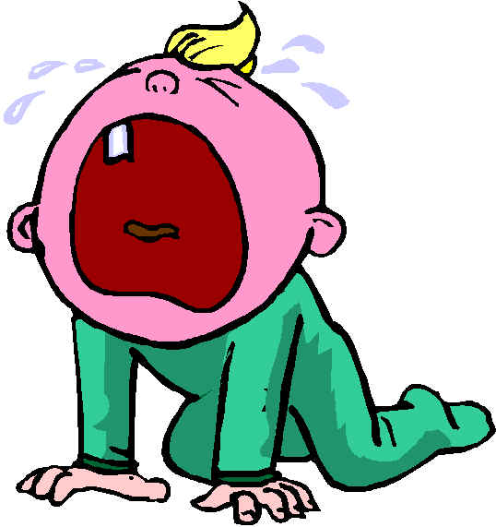 Another thing that increased was the birth rate. Without an economic depression or a war, people were having more children. Birth rates increased 20% in the 1950s. Children born between the years mid 1940s and mid 1960s are said to be part of the baby boom. This increased population led people to move out of the cities for more room. The suburbs began to grow. With the affordability of the automobile and the construction of new highways (i.e. Interstate Highway System), people could move out of the city and still have jobs in the city.

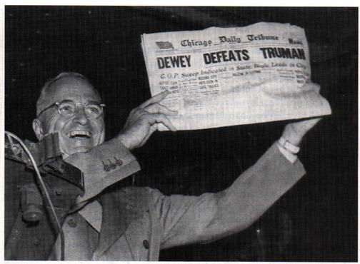 To meet the growing need for communities outside the city, developers like William Levitt worked on building affordable housing. In 1949, Levitt created Levittown in Long Island, New York, building small, almost identical housing on small lots of land. Building identical houses led to lower costs. The experiment worked and developers across the country were following Levitt’s lead. The only downside was that these developers excluded minority buyers for fear of scaring off white buyers. Clearly this was an issue that needed to be addressed.
President Truman holds a copy of the Chicago Tribune with the wrong headline after winning the 1948 election.
Houses in Levittown, New York

Election of 1948
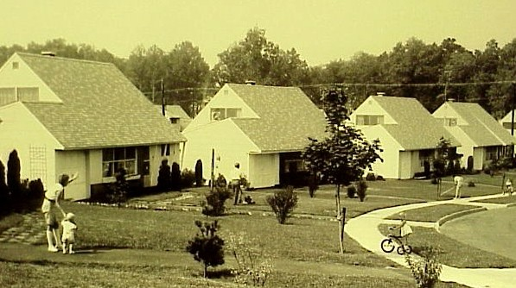 Politically, things did not look good for President Harry Truman in 1948. His Democratic Party had lost control of Congress in 1946 and many people were unhappy with the inflation that plagued the economy right after the war. The Republicans ran New York Governor Thomas Dewey, who had first gained fame as a prosecutor of organized crime in New York City. Because of Truman’s slumping popularity, most people thought that Dewey would win.

Truman decided to go out and campaign despite the polls. He crossed the country by train on his “whistle-stop” tour, campaigning against the Republican-controlled Congress. Up to election night the predictions of Dewey’s win continued. Truman was convinced and happily woke the next morning to learn of his victory. The Democratic Party even won back control of the Congress. Truman would continue as president for four more years.
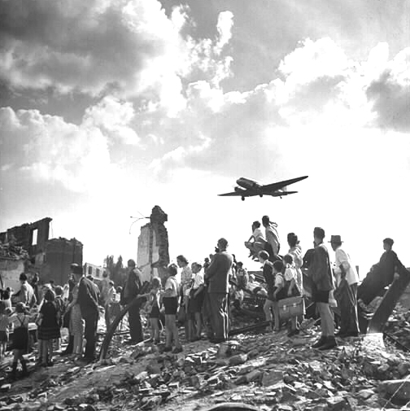Lesson 2 Review Questions – (write answers in complete sentences on a piece of loose-leaf paper).

- Provide multiple reasons why Jackie Robinson is an important part of American History?
- What were some of the reasons why the U.S. economy struggled in the early years after the war?
- How did the GI Bill help World War II veterans?

Lesson 3 –

Testing the Balance of Power

Main Idea: Major changes around the world caused many to fear that a new World War would erupt. The two superpowers would continue to seek advantages around the world.

Berlin Airlift
After World War II, Germany was divided up among the four major Allied nations. This meant that the United States, Great Britain, France and the Soviet Union each controlled a zone in Germany. Berlin, Germany’s capital was located within the Soviet zone. But the capital city was also divided in to four zones of occupation.
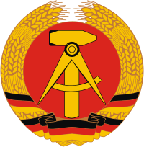
In June 1948, the Soviets cut off rail and road routes leading into the western zones of Berlin (those controlled by the U.S., Great Britain & France). This action was in response to a currency reform instituted by the western sections without Soviet input. Clearly Stalin was mad and decided that he wanted to demonstrate his ability to control all of Berlin.
Symbol of the German Democratic Republic – East Germany
President Truman had a decision to make. Without resources coming into West Berlin from Western Germany, there was no way that part of the city could continue. Sending in troops could provoke a violent response from the Soviets and thus lead to another World War. Truman did not want that problem. So instead, he decided to airlift supplies into West Berlin. For 321 straight days, the United States and Great Britain flew 2.5 million tons of supplies into West Berlin. The Soviets finally agreed to reopen the routes from the West into West Berlin. Politically it was a victory for the western allies as Stalin was forced to back down.

Cold War Gets Colder
By 1949 the relationship between the United States and the Soviet Union had gotten worse. There are a number of reasons why. Let’s begin with Germany. You’ll remember how Germany was divided after the war into zones controlled by the different Allied armies. In May, the British, French & American zones combined to create the Federal Republic of Germany, or West Germany. The Soviets refused to allow a reunified Germany. In October, the Soviet zone formed its own country complete with a communist (Soviet-friendly) government – the German Democratic Republic or East Germany. If a conflict between the Americans and Soviets would take place, odds are that it would happen between these two new countries.

Also in 1949, the Soviet Union successfully tested its own version of the atomic bomb. This was very unsettling in the United States 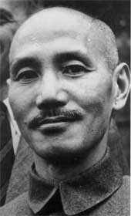because this meant that the Americans no longer held a monopoly when it came to this horribly dangerous technology. It was expected that the Soviets would soon acquire the technology but U.S. intelligence felt they were still some years away. An investigation proved that the Soviets were able to get some of their technology through a network of spies in the U.S. By 1951 an American couple was found guilty of revealing atomic secrets to the Soviets. Julius and Ethel Rosenberg were sentenced to death. They were electrocuted in 1953.
Chiang Kai-shek – leader of Nationalist China
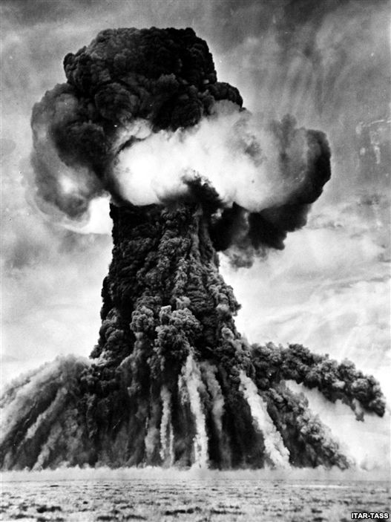
The development of Soviet nuclear technology meant the beginning of an arms race. Both nations were determined not to let the other get the upper hand when it came to weapons technology. As a result, both countries spent billions of dollars on these weapons of mass destruction. Truman’s containment policy was extended to the development of nuclear weapons. This arms race continued until the collapse of the Soviet Union in 1991.
First Atomic Test in the Soviet Union

Another development that began in 1949 was a new alliance system. The United States and 11 other countries came together to form the North Atlantic Treaty Organization (NATO). The primary purpose of the alliance is to “safeguard the freedom, common heritage, and civilization of their peoples, founded on the principles of democracy, individual liberty and the rule of law.” Also, an attack on any of the NATO nations was to be considered an attack on all. This was meant as a deterrent to Soviet aggression in Europe. The Soviets countered with their own alliance with the creation of the Warsaw Pact in 1955. This alliance between the Soviet Union and the communist countries of Eastern Europe also promised that an attack on any one country was an attack on all Warsaw Pact nations. It appeared as though the cold war might get hot at any moment.
Mao Zedong – leader of Communist China (Peoples Republic of China)

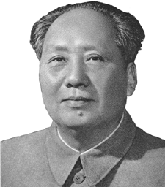 Meanwhile, in China things were also looking bleak for the United States. The U.S. government spent millions of dollars in money and weapons in support of China’s Nationalist leader Chiang Kai-shek. China had been fighting a civil war between Chiang’s Nationalists and the Chinese communists before the Japanese invaded in 1937. Both sides temporarily put hostilities aside to fight the Japanese but once they were gone, the civil war resumed. By 1949, the Chinese Communists under Mao Zedong defeated Chiang and the Nationalists were forced off the Chinese mainland to Taiwan (island of Formosa). Here the Nationalists set up a government in exile. The U.S. continued to support the Nationalists and refused to recognize the new communist government in China (Peoples Republic of China). This would continue until 1979.

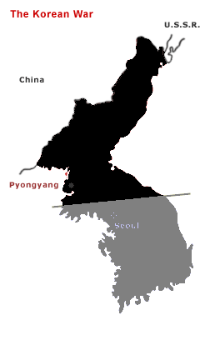Korean War – Cold War Gets Hot
In the last days of World War II, the Soviet Union declared war on Japan and conquered much of the territory they held in Manchuria and Korea. After working out an agreement with the Americans, the Soviet held territory on the Korean peninsula was everything north of the 38th parallel (38°North latitude). As was their habit, the Soviets installed a communist government there while the United States supported a democratic government in the southern half of the peninsula. These two countries became North Korea and South Korea.
Korea – divided at the 38th Parallel – before the war.

In June 1950, the communist leaders of North Korea decided that they should unify the Korean peninsula. They launched an all-out attack on South Korean and U.S. forces across the 38th parallel. The attack came as a complete surprise to the Americans as well as the Soviets. This was not an action that was conceived or even approved by Stalin. You’ll see why as you continue to read.

President Truman saw this as a blatant disregard for the sovereignty of the South Korean people and immediately called upon the United Nations to take action. The UN met and agreed to send an international task force headed by the United States to halt the aggression of North Korea. Truman decided to put General Douglas MacArthur in charge of the UN forces in Korea.

As to how this happened…. You will remember that the Soviet Union was one of the 5 permanent members of the UN Security Council. As one of those members, they had veto power. They could have invoked this veto power to stop the UN from authorizing the international task force to fight the North Koreans. The reason they didn’t do this was because the Soviets’ ambassador to the UN was not there.
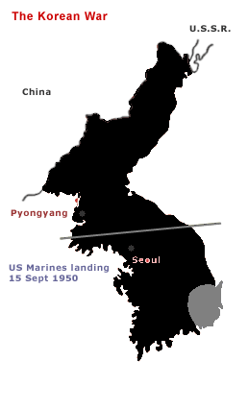
The Soviet Union was upset with the UN because they still did not recognize the Peoples Republic of China (Communist China) as the representative government there. The Nationalists, who were now ruling in exile from Taiwan, still held a permanent position at the UN Security Council. So to protest this, the Soviets walked out of the UN. This is how we can be sure that Stalin didn’t give the North Koreans the green light on their invasion of the South. The timing was horrible.

Anyway, back to the fighting…. By the time that the UN had authorized all of this and the army was ready to go, things were looking very bleak. The North Koreans had pushed the South Koreans and the Americans to the very tip of the peninsula. Something had to be done and quickly or the war would be over before the UN forces could do anything about it.
Korea – Summer of 1950 – North Korea controls almost all of the peninsula.

MacArthur had a plan. It was brilliant but incredibly risky. He would launch an invasion force made up of international troops (with the Americans leading the way) and land behind enemy lines at a place called Inchon. If the North Koreans prevented the invasion force from landing then the war would be over. But they didn’t. This time they were caught by surprise. MacArthur’s troops secured Inchon and moved to cut off the North Koreans already thin supply lines. At the same time, the South Koreans and Americans at the tip of the peninsula broke out with new reinforcements and pushed the North Koreans back across the 38th parallel. The communists had been forced back. All of this had happened by September 1950.

President Truman flew out to Wake Island in the Pacific Ocean to meet with General MacArthur to discuss the war at the end of September. At this meeting MacArthur assured Truman that the chances of Soviet or Communist Chinese intervention were “very little.” Truman then decided that this was the time to punish the communists 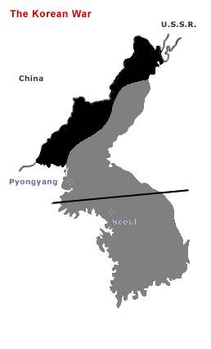for their aggression. The goal of the war changed from liberating South Korea to uniting the entire peninsula under a democratic government.
Korea – October 1950 – before China invades.

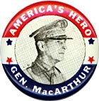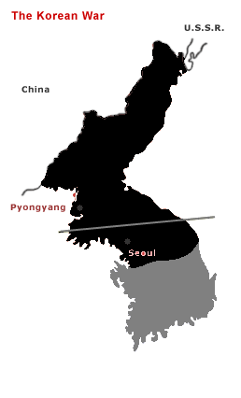As the UN forces began pushing the communists further to the north, the Chinese began threatening to intervene. MacArthur continued to ignore these threats as his forces were easily moving north. While the UN forces pushed north, the Chinese began organizing their troops near the Yalu River – the border between North Korea and China. On October 19, 1950, 150,000 Chinese troops crossed the Yalu and attacked the UN forces. Now MacArthur was caught by surprise.

Now the Chinese and North Korean forces pushed MacArthur’s troops back into South Korea. By January 1951 they had captured the South Korean capital at Seoul. MacArthur argued with Truman that the war now needed to be expanded by attacking communist China. Truman wanted nothing to do with expanding the war and neither did our allies. Despite orders to keep his plans to himself, MacArthur went public when he told the media that we needed to use nuclear weapons against China to win the war. Our allies were shocked and Truman had had enough. On April 11, 1951 Truman fired MacArthur.
Korea – January 1951 after the Chinese invasion.

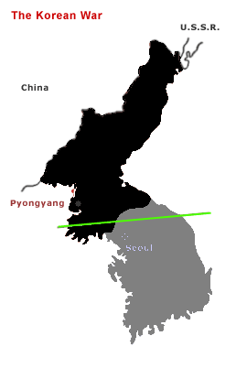MacArthur’s firing was very unpopular back in the United States. He was, after all, a hero from World War II. Many thought that he would run for president against Truman in 1952. But Truman stuck to his guns. MacArthur’s actions were a violation of his oath as a soldier. He had gone against the orders of his commander-in-chief.

By the middle of 1951 the war bogged down into a stalemate. The UN forces had recaptured some of the territory the Chinese and North Koreans had taken. The war would continue for two more years like this. By July 27, 1953 a cease-fire was established. A demilitarized zone (DMZ) was set up on the 38th parallel. This DMZ continues to this day with troops placed on both sides. There is no peace treaty in effect. So technically, the Korean War has never ended. From an American perspective, the communists were turned back and the war never spread into a world conflict. But over 33,000 Americans died in this war and as we can see, that number probably didn’t need to be so high.
Korea – July 1953 after the cease-fire that ended the fighting.

Lesson 3 Review Questions – (write answers in complete sentences on a piece of loose-leaf paper).

1. Who was the couple found guilty of treason in the early 1950s? What happened to them?
2. What were the two alliances that were formed in the late 40s and early 1950s?
3. Who won the Chinese Civil War and what happened to the losing side?
4. How do we know that the Soviet Union didn’t give their blessing to North Korea’s invasion of South Korea?
5. Why did Truman fire General MacArthur in the Korean War?

Lesson 4 –

Tense Times at Home

Main Idea: As the world around us changed, so too did the United States. Fear of these changes brought about both good and bad results.

Election of 1952
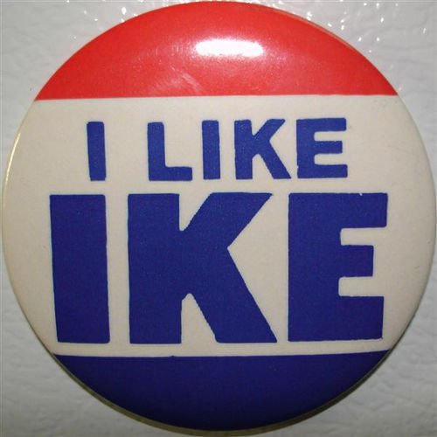 Harry Truman decided that he would not run again for another term. In 1951, the 22nd amendment to the constitution had been ratified, limiting the presidency to two terms. Truman didn’t fall under this since he had filled the remainder of FDR’s fourth term when he came to the presidency in 1945. He could have served another term but decided he’d had enough.

A man who was courted by both major political parties since 1948 was former General Dwight D. Eisenhower. By 1952 Eisenhower had become a Republican and that party was happy to run him for president that year. Eisenhower was extremely popular as the hero of D-Day and former Supreme Commander of Allied Forces in Europe during World War II. Senator Richard Nixon of California, a man who had earned a reputation as strongly anti-communist, became the Republican candidate for vice president.
Eisenhower’s nickname was “Ike” – this was a popular campaign button.

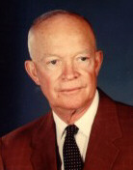 With Truman leaving the White House, the Democrats selected Illinois Senator Adlai Stevenson to run against Eisenhower. In a lop-sided election, Eisenhower won over 55% of the popular vote and 39 of a possible 48 states. Stevenson would run again against Eisenhower in 1956 and results were even more in Eisenhower’s favor.
Dwight Eisenhower
McCarthy’s New Red Scare
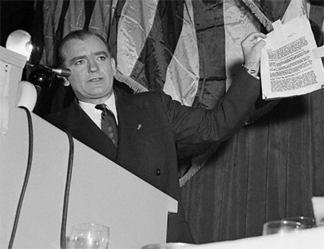 The Red Scare of the 1920s showed how fearful Americans were when it came to communism within our borders. By the early 1950s a Republican Senator from Wisconsin had gained fame by starting one of the largest communist “witch-hunts” in U.S. history. His name was Joseph McCarthy and in 1950 he claimed to know of 205 workers within the State Department that were members of the communist party.
Senator Joseph McCarthy holds up a list of he claims that contains the names of known communists in the State Department.

Such a claim was shocking; especially when you consider that the State Department is responsible for our relationship with foreign countries. McCarthy was essentially saying that members of our own government were undermining our democratic values. A Senate subcommittee was set up to investigate communist infiltration within the government. Already in place was the House Un-American Activities Committee, which investigated possible communists in other areas of American life that might be seeking to subvert U.S. foreign policy.

Even being accused of communist connections was enough to ruin careers. After investigations in the Hollywood film industry, a number of writers, directors and actors were blacklisted by the motion picture industry. Famous silent film star Charlie Chaplin was one of those blacklisted in Hollywood. He eventually left the U.S. to return to his native England.

By 1954, McCarthy’s popularity and power was coming apart. His committee had gone after the United States Army in late 1953, making the accusation that communists had infiltrated the military. In hours of televised testimony McCarthy was exposed as a bully and it became clear that he was all about accusations and not about proof. When a lawyer for the Army turned on McCarthy saying, “Have you no sense of decency?” the crowd in the committee room burst into applause. By December 1954 the Senate voted to censure McCarthy for his empty accusations.

Civil Rights
While America worried about communists and fought them in Korea, true equality and democracy still had a long way to go. The 1950s marked a beginning point in the modern civil rights movement. A number of things happened during these years that would eventually bring about meaningful change for minorities.

The first real step came in 1948 and it came from Harry Truman’s White House. It was in this year that Truman ordered an end to discrimination in federal hiring. But even more important was his order that the United States military be desegregated. Race would no longer play a role in determining who would take part in all branches of the military. The Korean War was the first war since the American Revolution to be fought by a U.S. military of differing racial backgrounds.

The judicial branch would play the ultimate role in improving civil rights during the 1950s. A number of important Supreme Court decisions would lay the foundation for real change. The first was the Brown v. Board of Education of Topeka, Kansas in 1954. This landmark decision changed they way children go to school.
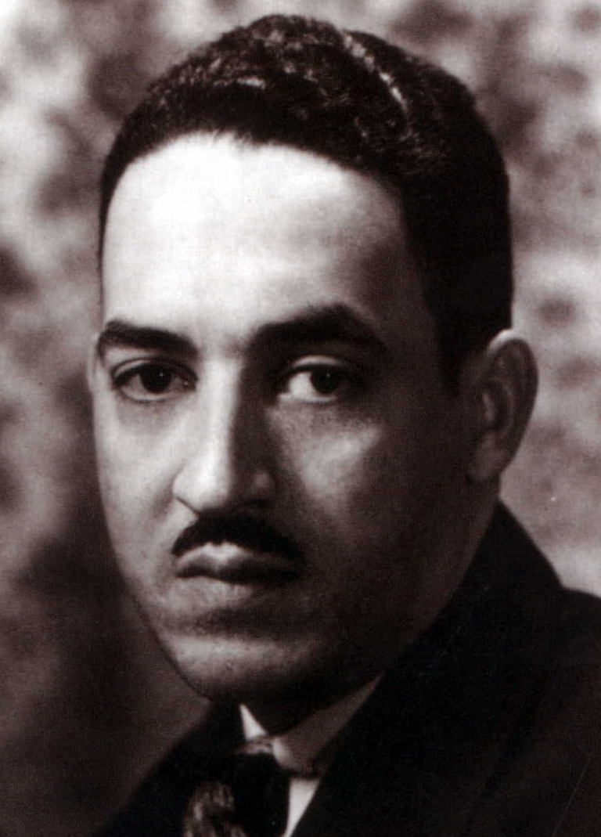
A man by the name of Oliver Brown had a daughter who was forced to attend an all-black school miles from his home. Nearby, there was an all-white school his daughter could not attend. Brown’s lawyer, Thurgood Marshall (from the N.A.A.C.P.) argued that Mr. Brown’s constitutional rights under the 14th amendment were being violated. Remember that the 14th amendment guarantees equal protection regardless of race.
Thurgood Marshall

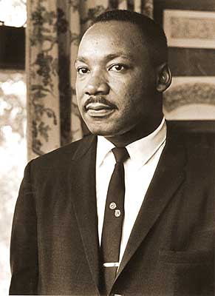 The case was arguing that “separate but equal” was not constitutional. You should remember that a similar case was argued before the court in 1896 in the Plessy v. Ferguson case. In that case the court ruled that separate but equal facilities (in this case separate sections for whites and blacks on a train) were constitutional. Fifty-eight years had passed and the makeup of the court naturally had changed. This time the court ruled that “separate educational facilities are inherently unequal.” The court overturned the Plessy case and ordered all schools to be desegregated.

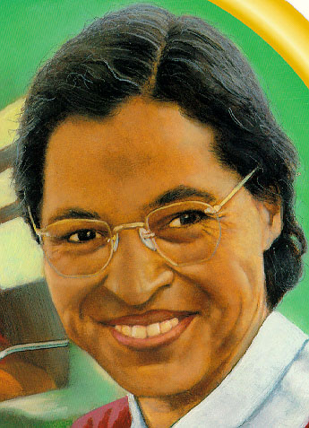 In 1956, Montgomery, Alabama became the focal point for another civil rights challenge. Jim Crow laws in the South were still part of everyday life for blacks at the time. Rosa Parks got on a Montgomery public bus on December 1, 1955. She sat in the front of the bus which was allowed only until a white person got on the bus. When she refused to give up her seat to a white man, the police arrested her.
Rosa Parks
Martin Luther King, Jr.

A protest was organized. The pastor of the Dexter Avenue Baptist Church was put in charge of the protest. His name was Martin Luther King, Jr. At this time, an overwhelming majority of the bus passengers in Montgomery were black. When King organized a boycott of the bus system, there was an immediate effect. The boycott lasted nearly a year. By November 1956, the Supreme Court ruled that segregation on buses was unconstitutional. Martin Luther King, Jr. had become a powerful new leader in the fight for civil rights.

Segregation took another hit in 1957 when Congress passed a new Civil Rights Act. This act allowed the federal Justice Department to sue to protect a person’s civil rights. Its set up was targeted at guaranteeing blacks the right to vote, particularly in the South.

All of these changes brought about a great deal of hostility, particularly from southern whites. Enforcing the Supreme Court decisions rests in the hands of the executive branch. President Eisenhower was determined to make sure they were followed. Violence was the result in many of the situations. In the case of Little Rock High School in Little Rock, Arkansas, Eisenhower hoped to avoid a violent confrontation.

Governor Orville Faubus of Arkansas employed the state National Guard to block the entrance of 9 black students on September 5, 1957. President Eisenhower took control of the National Guard troops and ordered them to protect the black students who were being threatened by mobs of angry whites. The courage of these 9 students should not be overlooked. Despite threats against their lives, they took the first steps to bringing integration in the South.

The civil rights movement would gain momentum and continue to bring about changes in the 1960s. These years were difficult and the people who championed the cause of equality were subject to real danger. Would you be willing to risk your life to help bring about change that would help other people?

Nuclear Threat
By 1952 the United States had upgraded its nuclear weapon technology to create the first Hydrogen bomb. This bomb was several times more powerful than the one exploded over Hiroshima. The arms race was now in full bloom as the United States and the Soviet Union continued to improve their nuclear technology and increase their available weapons.

But in the 1950s the means of delivering a nuclear bomb was still by airplane. This meant that there was still hope of surviving a nuclear war by shooting down the enemy’s bombers. School children were instructed to “duck and cover” when it came to nuclear attack. You are familiar with fire drills and tornado drills. Kids in the 1950s actually would perform a drill where they would climb under their desks and cover their heads with their hands. In truth it wouldn’t do much good if you were anywhere near a nuclear detonation.
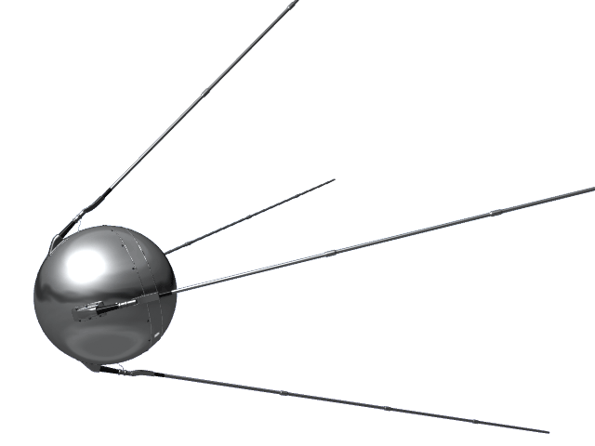
When the Soviets launched the first man-made satellite into orbit in 1957, it became clear that the U.S. was lagging behind. Sputnik I was launched in October 1957 and by the end of the year the Soviets had launched Sputnik II. If the Russians had the rocket technology to put a satellite in space it meant they had the technology to fire a rocket with a nuclear bomb on board. This took the arms race to a new level. “Duck and Cover” became irrelevant as both superpowers would soon have the ability to launch nuclear tipped rockets at one another.
Sputnik
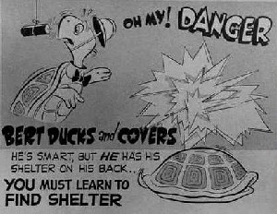
Domino Theory
President Eisenhower’s foreign policy continued Truman’s policy of containment. He continued to be concerned with the growth and spread of communism particularly in Southeast Asia. In 1954, the French had been forced out of their colony in Indochina. The result was the partitioning of the country of Vietnam into a communist North Vietnam and a democratic South 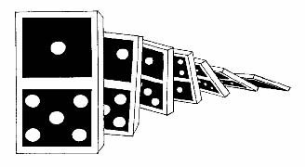Vietnam (sound familiar?). The United States would pick up where the French left off and support democracy in the south.

The justification for Eisenhower’s sending aid and advisors to Vietnam was to prevent the spread of communism. He likened the Asian nations to a row of dominoes. Tip one and the rest will fall. If the U.S. allowed Vietnam to become all communist, other Asian nations may become communist as well. It is this thinking that led us into the Vietnam War.

The Golden Age of Television
You probably have watched television. Odds are that you have several in your home. The technology behind television was developed as early as the 1920s but it really wasn’t until the 1950s that it became popular. Television sales shot through the roof in the early 1950s. Programming included news, sports, comedy & drama. Early television broadcasts were live and made for some very interesting viewing. Color television was developed in the 1950s but wouldn’t really become popular until the 1960s.

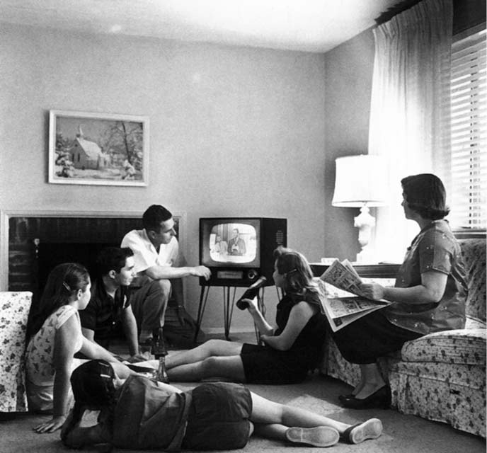 In 1950 a survey indicated that children were watching up to 27 hours of TV a week. With the development of this entertainment technology came the debate about TV viewing. How much is too much? Will it cause us to become a generation of idiots? What about sex and violence? All of these topics are still relevant today.

Television replaced the radio as the primary means of home entertainment. Some very popular shows debuted in the 1950s. Some you may be familiar with are I Love Lucy, Gunsmoke, The Today Show, The Tonight Show, and American Bandstand. Love it or hate it, television became our window to the world.

Cuba
The United States had a history with the nation of Cuba that goes back to the Spanish-American War of 1898. During that conflict, the U.S. helped the people of Cuba gain their independence from Spain. Although the Americans promised the Cubans their independence, the Platt Amendment allowed the U.S. government to have a prominent role in Cuban affairs. By 1934 the Platt Amendment was revoked but the U.S. was allowed to continue its lease of Guantanamo Bay for use as an American military base.

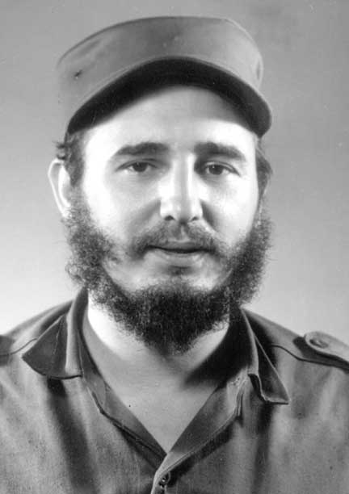 In 1952, Fulgencio Batista seized power and became the dictator of Cuba. A number of guerilla groups formed but Batista remained in power. The United States did not seem overly concerned with supporting Batista as long as he protected the interests of American businesses. During his rule 75% of arable land in Cuba was owned by foreigners or foreign companies (mostly American businesses).
Fidel Castro

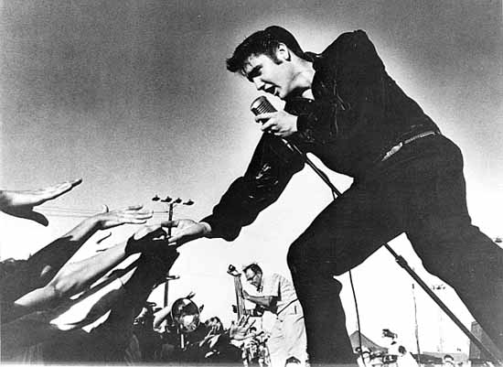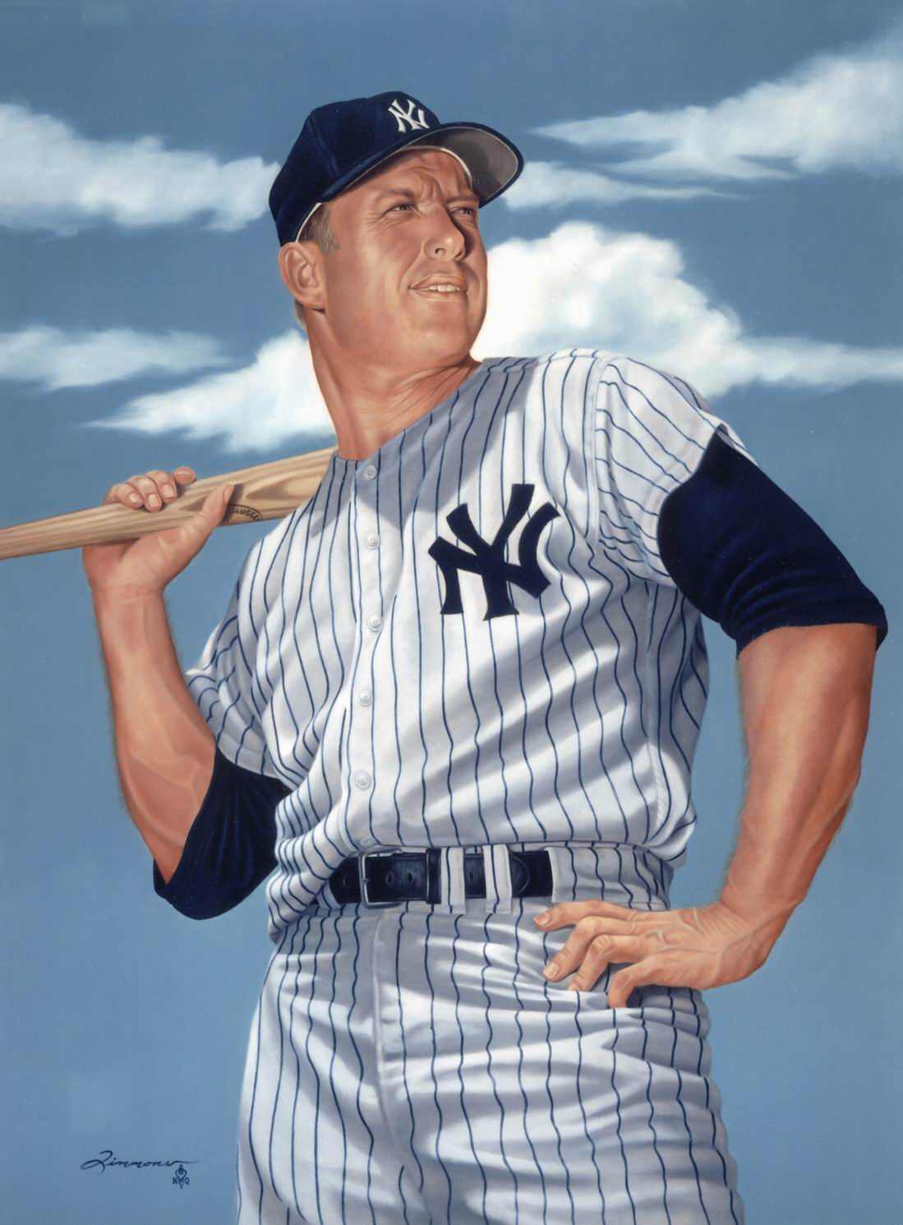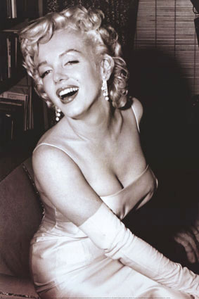 In 1958, Fidel Castro gained the support of a number of unhappy Cubans. By the end of the year his guerilla group had overthrown Batista’s government. On January 1, 1959 Batista fled the country. Castro’s new government seized private property from upper class Cubans (many who had benefited from Batista’s regime). He also introduced land reforms and took property away from foreign companies. Now the United States was upset and Castro’s relationship with America grew worse.
Marilyn Monroe

Eventually, Castro declared himself a communist and began appealing to the Soviet Union for diplomatic relations and aid. Castro knew that by seizing property from wealthy American businesses he would have a difficult time establishing a good relationship with the U.S. So he turned to the Soviets and hoped to build a socialist state in Cuba. Castro’s relationship with the Soviets would lead to further problems with the United States in the next decade.
James Dean

Lesson 4 Review Questions – (write answers in complete sentences on a piece of loose-leaf paper).

- Who did Dwight D. Eisenhower defeat twice when running for president in the 1950s?
- What was the name of the landmark Supreme Court decision that ended segregation in public schools?
- What is the domino theory?
Other interesting happenings:
Mickey Mantle
Elvis Presley

Entertainment
- 1951 – Future President Ronald Reagan stars in Bedtime for Bonzo with a chimpanzee.
- 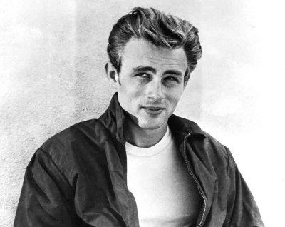1953 – Marilyn Monroe stars in 3 movies; she also appears on the cover and as the centerfold for Hugh Hefner’s new magazine Playboy.
- 1955 – Hollywood heart-throb James Dean dies in an automobile crash.
- 1956 – Elvis Presley’s Heartbreak Hotel hits #1 on the charts.

Sports
- The New York Yankees win eight American League pennants and six World Series championships. (1950-1959)
- 1956 – Mickey Mantle wins the Triple Crown (Average, Home Runs & Runs Batted In).
- 1958 – Major League Baseball’s Brooklyn Dodgers move to Los Angeles and the New York Giants move to San Francisco.

Literature
- 1951 – J.D. Salinger’s The Catcher in the Rye becomes a best seller.
- 1954 – Ernest Hemingway earns the Nobel Prize for literature for his book The Old Man and the Sea.
Extra Credit Questions (worth 10 points – answer in complete sentences on a piece of loose-leaf paper)
- Jackie Robinson was a baseball player and a very good one at that. Do some research – how did he overcome the racial bitterness of other baseball players when he came into the league? Who were some of the other ball players who followed Robinson as African-American major leaguers as well as the first Hispanic major leaguers and how did Robinson play a role in their careers?
- For awhile, Joseph McCarthy became one of the most powerful and feared men in the United States. Watch the movie Good Night, and Good Luck. Do a movie review but make sure to explain how this compares to what you’ve learned in class.
- Just recently, relations between the United States and Cuba have changed drastically. Explain how and why these changes have come about. What does this mean for both

Timeline of Events
1946 | - New York City becomes the permanent home of the United Nations  - U.S. tests atomic bomb on ships at Bikini Atoll in the Pacific  - Nazi war criminals convicted at the Nuremberg Trials are executed  - Winston Churchill gives his “Iron Curtain” speech in Missouri
1947 | - Communists take power in Poland  - Truman Doctrine issued  - Jackie Robinson becomes first African-American MLB player  - India gains independence from Great Britain  - US Air Force created
1948 | - Communists take power in Czechoslovakia  - Marshall Plan is enacted  - Israel is created by the United Nations – Arab/Israeli Wars begin  - Berlin Airlift begins – will last through 1949  - Peace-Time draft introduced for the second time in US  - Harry Truman wins presidential election
1949 | - Volkswagen Beetle introduced in US  - NATO alliance is created  - Communists defeat Nationalists in China – Peoples Republic of China created  - Soviet Union tests its first atomic bomb  - Communists defeated in Greek Civil War
1950 | - Joseph McCarthy accuses the State Department of having communists working within the department  - South Africa initiates Apartheid – official policy of separating races  - Soviet ambassador to UN leaves protesting UN’s non recognition of communist Peoples Republic of China  - North Korea invades South Korea  - General MacArthur is successful at Inchon invasion – pushes back communists  - China invades North Korea pushing back UN troops
1951 | - 22nd amendment ratified limiting a president to 2 terms of office  - Ethel & Julius Rosenberg convicted of treason and executed 1953  - Truman fires MacArthur from command in Korea  - I Love Lucy debuts on television
1952 | - Elizabeth II becomes Queen of England  - US occupation of Japan ends  - US detonates the first hydrogen bomb  - Dwight D. Eisenhower wins presidential election
1953 | - Josef Stalin dies – Nikita Khrushchev takes over in the Soviet Union  - Sir Edmund Hillary & Tenzing Norgay first to reach the summit of Mt. Everest  - Korean War ends – armistice agreed  - Soviets announce possession of the hydrogen bomb  - First color TVs go on sale in US
1954 | - Marilyn Monroe marries NY Yankee Joe DiMaggio  - US launches the first nuclear-powered submarine  - Vietnamese communists defeat French at Dien Bien Phu  - French leave Vietnam – country divided into communist North Vietnam and democratic South Vietnam  - First issue of Sports Illustrated magazine  - Brown v. Board of Education of Topeka, Kansas Supreme Court decision results in ending segregation in public schools in the US  - First transistor radio produced by Texas Instruments  - First Burger King opens in Miami, Florida  - First TV dinners
1955 | - Ray Kroc creates McDonald’s – first franchise in Des Plaines, Illinois  - First US military advisors sent to South Vietnam  - Richard J. Daley wins election to mayor of Chicago – will remain mayor until 1976  - Warsaw Pact alliance created for Soviet Union and allies  - Rosa Parks is arrested in Montgomery, Alabama for refusing to give up her seat on a public bus to a white man
1956 | - Pakistan becomes the first Islamic Republic  - Hungarian Revolution against communist crushed by Soviet army  - Great Britain and France bomb Egypt to force the reopening of the Suez Canal  - President Eisenhower wins re-election
1957 | - African-American students are protected by federal troops as they attend Little Rock High School  - Soviet Union launches Sputnik – the first man-made satellite  - Soviets launch Sputnik 2 – with the first animal (dog) into space
1958 | - National Aeronautics and Space Administration (NASA) created  - Federal Aviation Administration (FAA) created  - Cuban Revolution results in resignation of dictator Fulgencio Batista
1959 | - Fidel Castro takes over in Cuba  - Motown Records created by Barry Gordy in Detroit, Michigan  - Pope John XXIII begins the Second Vatican Council in Rome  - The Dalai Lama flees Tibet (from Chinese persecution)  - 2 monkeys become the first living beings to return from space flight  - USS George Washington becomes the first submarine to carry ballistic missiles  - St. Lawrence seaway (Canada/United States) opens  - Alaska & Hawaii become the 49th & 50th states

tension: Barely controlled hostility or a strained relationship between people or groups.
subjugation: To bring under control; conquer.
deterrent: A retaliatory means of discouraging enemy attack.
Sovereignty: complete independence and self-government.
arable: capable of being farmed productively.
Socialist: (pertaining to Socialism) a political theory advocating state ownership of industry – under Castro’s plan, Cuba would focus on free health care and education.

