Chapter 24 – The Turbulent Sixties –
1960 to 1969

Review:
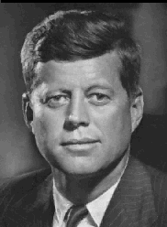The years after World War II saw big changes for the United States. A generation of Americans came home and after some initial problems, the economy steadily grew. The G.I. Bill helped more people go to college than ever before. The relationship with our former ally, the Soviet Union, grew cold, marking the beginning of the Cold War. Our status as a superpower came with the responsibility of stopping the spread of communism around the globe. As a result, we went to war in Korea and by the end of the 1950s we were edging closer to another war in Vietnam. Here at home the Civil Rights Movement gained a momentum that would continue in the turbulent 1960s.

Lesson 1 –

The New Frontier

Main Idea: A new change in Washington ushered in a spirit of new possibilities - a "Camelot Era” that sadly ended in tragedy.
John F. Kennedy

Election of 1960
The 22nd amendment limited Eisenhower to two terms as president. This meant that a new president would certainly be elected in 1960. The race for president turned out to be another close one and the result signaled that the country was ready to move toward a new, youthful direction.

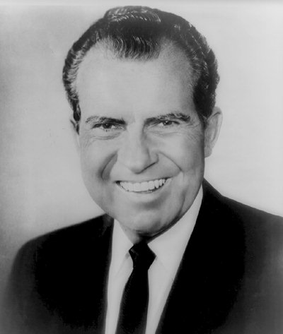 The Republican Party nominated Vice President Richard Nixon of California. Nixon had gained a reputation as a tough anti-communist member of Congress before becoming Eisenhower’s running mate in 1952. He campaigned as Eisenhower’s heir apparent, criticizing his opponent’s lack of experience.

That opponent was Democratic candidate John F. Kennedy, a young senator from Massachusetts. Kennedy’s charm and enthusiastic demeanor won over many Americans. Kennedy’s religious background as a Catholic did not really come into play as it had for 1928 Democratic candidate Al Smith. Nixon insisted that his campaign not focus on Kennedy’s religion.
Richard Nixon

What is unique about this election is that it marked the first televised debate between presidential candidates. The role of television in electing a president took on great importance and this continues to this day. In the 1960 debates both candidates were well prepared and did good jobs. The difference seemed to be their “camera presence”. Kennedy appeared calm and assuring. Nixon looked haggard and his makeup was not good. People who saw the debate said that Kennedy did better but those who heard the debate on radio felt it was more of a toss-up. The power of the television camera became very important.
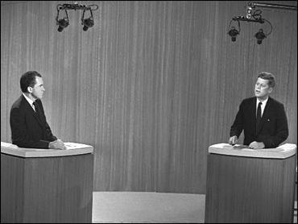
Nixon and Kennedy during their televised debate.
The results were extremely close. Kennedy gained 49.7% of the popular vote compared to Nixon’s 49.5%. Kennedy became the youngest man elected president at age 43 and the first Catholic to hold that office.

President Kennedy
Kennedy came from a wealthy Massachusetts family. His father, Joseph Kennedy had built his wealth in the stock market before the 1929 crash. He had been appointed the Chairman of the Securities and Exchange
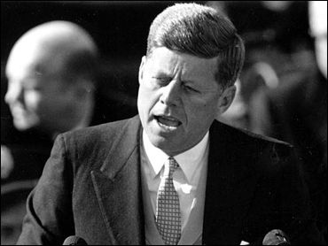
In his inauguration speech, John F. Kennedy made it clear that a new generation of Americans was looking toward a new America. The following is part of his now famous inaugural speech:

Ask not what your country can do for you. Ask what you can do for your country. Let the word go forth from this time and place, to friend and foe alike, that the torch has been passed to a new generation of Americans – born in this century, tempered by war, disciplined by a hard and bitter peace, proud of our ancient heritage – and unwilling to witness or permit the slow undoing of those human rights to which this nation has always been committed, and to which we are committed today at home and around the world.

Kennedy was outlining a new direction for the country and at the same time reaffirming our commitment to the policy of containment put forth by Truman and continued by Eisenhower. His domestic program was known as the “New Frontier.”
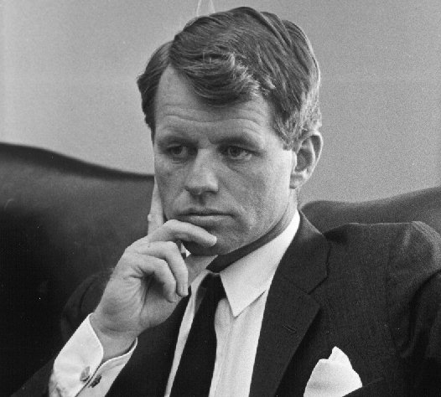
JFK appointed his brother, Robert Kennedy to the position of Attorney General in his cabinet. Robert played an important role in JFK’s decision making throughout his presidency. The two had a close bond that served them well in meeting the challenges of this new era.
Attorney General Robert Kennedy

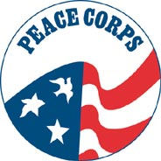 Part of Kennedy’s New Frontier was the creation of the Peace Corps. The object of this organization was to bring aid to the neediest underdeveloped countries of the world. This association still exists today. The official goals of the Peace Corps are:
- To help the people of interested countries and areas in meeting their needs for trained workers;
- To help promote a better understanding of Americans on the part of the peoples served;
- To help promote a better understanding of other peoples on the part of Americans.

When it came to foreign affairs, Kennedy had some hard lessons to learn. He would continue to building of intercontinental ballistic missiles to compete with the Soviet Union. He expanded Eisenhower’s commitment to South Vietnam by sending more Americans to serve as advisors in that country’s fight against communist rebels. But his first test in foreign affairs came in Cuba and it was one in which the president would admit failure.

Bay of Pigs
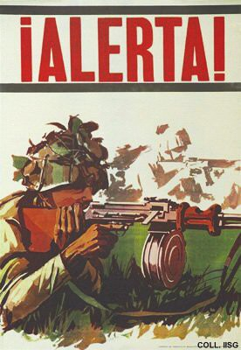 By January 1961 the new Cuban leader, Fidel Castro had embraced communism. Before leaving office, President Eisenhower broke off diplomatic relations with Cuba. The Central Intelligence Agency (CIA), under directions from Eisenhower had been planning an invasion of Cuba by a force of anti-Castro Cubans. (The CIA was also the spy agency responsible for the U2 flights over the Soviet Union). With Castro’s new ties to the Soviet Union, the CIA felt that the plan had to go into effect quickly, before Castro could be supplied with Soviet weapons.
Cuban dictator Fidel Castro receives a hug from Soviet leader Nikita Khrushchev.
Cuban poster warning of an invasion

President Kennedy was informed of the plan and ultimately gave his approval. The invasion took place in April 1961 at a location called The Bay of Pigs. It turned out to be a disaster. A group of Cuban exiles was trained to lead a counter-revolution against Castro. Unfortunately, the information gathered by the CIA and the plan it ultimately put forth was flawed. The agency had miscalculated that there was a large amount of popular resistance among Cubans to Castro. Of the 1,500 Cuban exiles that landed at The Bay of Pigs, 114 were killed and the remainder captured. Although his administration was embarrassed by the incident, Kennedy accepted full responsibility for the failure.

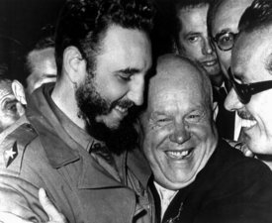
Cuban Missile Crisis
Kennedy’s initial failure in Cuba led Soviet Premier Nikita Khrushchev to believe that the new president was a rookie when it came to world affairs. The two had met in Vienna, Austria in June 1961 and Khrushchev came away from the meeting believing that Kennedy was overmatched in the area of diplomacy. The world and Khrushchev would learn that this was not the case by the fall of 1962.

We need to go back to the concept of the Cold War and the growing nuclear threat to understand what happens next. The Soviet Union felt threatened by the growing U.S. nuclear arsenal placed in Western Europe. Khrushchev was convinced that any future war would undoubtedly involve nuclear weapons and missile technology exposed Soviet cities to possible nuclear annihilation from the West. In response to this, the Soviets concentrated on improving their nuclear arsenal and balancing the tables by exposing American cities to the same nuclear annihilation.

This chance came for the Soviets in the form of Cuba. The Bay of Pigs incident drove a larger wedge between Cuba and the United States. As Castro leaned more upon the Soviets for aid, it was clear that the island could be used as a strategic base to benefit the Soviet Union. This combined with Khrushchev’s belief that Kennedy was diplomatically weak, led the Soviets to begin setting up bases in Cuba for intermediate range nuclear missiles.
President Kennedy goes on television to inform Americans of Soviet missile bases in Cuba.

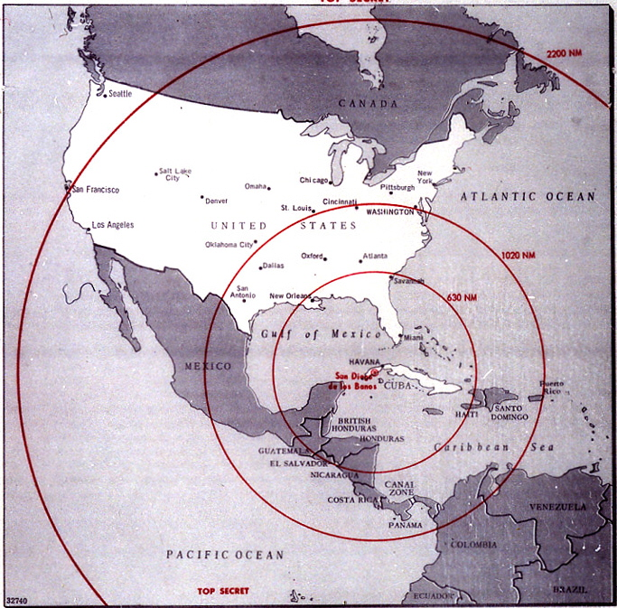 On October 14, 1962 a U2 took photographs of the Soviet bases being installed in Cuba. Kennedy was faced with a huge crisis and had to do something about it. He met with members of the National Security Council to weigh his options. The choices were reduced to either a full-scale invasion of Cuba or a naval blockade combined with the threat of attacking Soviet ships trying to deliver the missiles to Cuba. Either way, the implications were enormous. The possibility that this could develop into a major nuclear conflict, the beginning of World War III, was very real.

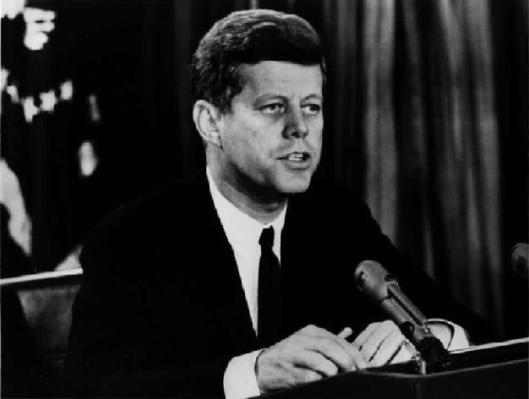 Kennedy went on television to address the American public on October 22. The U.S. would establish a naval blockade of Cuba. Kennedy condemned the Soviets for their actions and the U.S. ambassador to the United Nations called upon the Soviets to admit they had placed nuclear missiles in Cuba. Khrushchev sent letters to Kennedy claiming that the Soviets were only interested in peace and preventing any U.S. invasion of their Cuban ally. What Khrushchev really wanted was for the U.S. to pull their intermediate-range nuclear missiles out of Turkey. Kennedy could not publicly do this because he would appear weak.
CIA file showing the range of Soviet nuclear missiles if fired from Cuba.

On October 27, the Soviet ships were nearing the U.S. quarantine zone near Cuba. Kennedy offered to guarantee the U.S. would not invade Cuba or support any future anti-Castro invasion. Secretly, he sent his brother Robert Kennedy to inform the Soviets that he would pull the U.S. missiles out of Turkey. On October 28, the Soviet ships turned around and the crisis was over. The missile bases were dismantled.
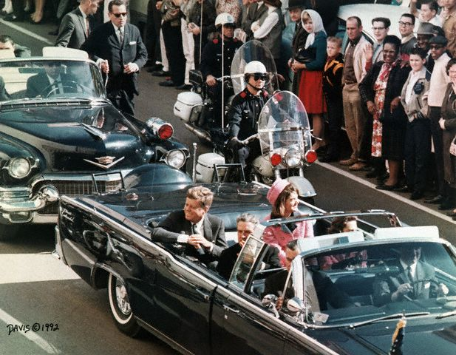
Internationally, Kennedy gained the reputation of standing up to Khrushchev but both sides initially considered the compromise a failure. Regardless, this was the closest both nations came to nuclear war. To improve communications in the future, a phone line (or hot line) was set up between the White House and the Kremlin. Hopefully with this form of instant communication, a potential nuclear misunderstanding could be avoided.
President Kennedy’s limousine moments before his assassination in Dallas.

Assassination in Dallas
By the end of 1963, President Kennedy was preparing to run for reelection the following year. He had solidified his position in world affairs during the Cuban Missile Crisis. In June 1963, Kennedy had made speech at the Berlin Wall condemning the Communist government of East Germany for building the wall in 1961 to essentially keep East Berliners from escaping to West Berlin and the freedom and democracy of West Germany. Now he needed to work on improving his position in terms of getting reelected.

Texas had a state that he had narrowly won in the 1960 election. Vice President Lyndon Johnson had asked the president to visit Dallas to help bring together the Democratic Party in Texas that was troubled with infighting. So Kennedy came to Dallas on November 22, 1963 with wife, Jacqueline. He rode in a convertible limousine with the top down alongside Texas governor John Connally and his wife, Nellie. The presidential motorcade traveled through downtown Dallas on its way to the Dallas Trade Mart where Kennedy was to deliver a speech.

At about 12:30 p.m. Kennedy’s motorcade entered Dealey Plaza in front of the Texas Book Depository building. It was then that at least two shots rang out. The first shot is believed to have struck the president as well as Governor Connally. The second shot struck the president in the head. First Lady Jacqueline Kennedy was splattered with fragments of skull and brain tissue. The motorcade sped off to Parkland Hospital where the president’s death was officially announced at 1:38 p.m.

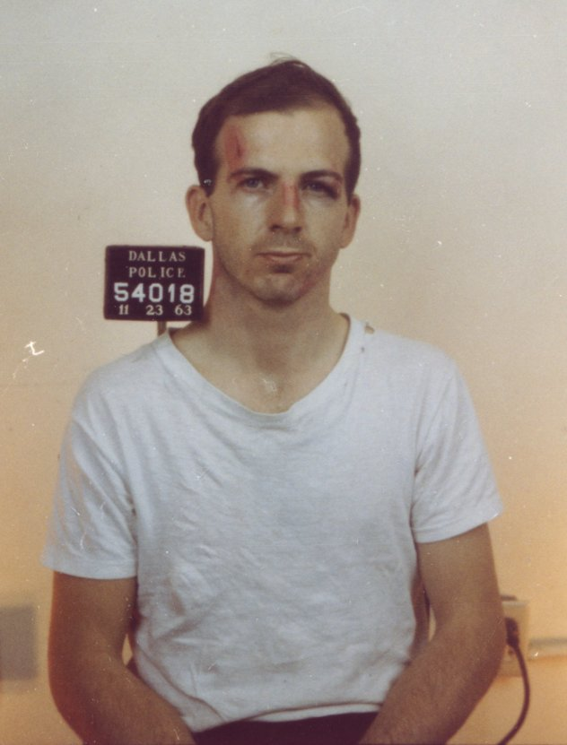 A massive manhunt began immediately. Lee Harvey Oswald, who had held a temporary job at the Book Depository, was arrested for the killing of Dallas policeman J.D. Tippit. Officer Tippit had stopped Oswald walking down the street for questioning. According to eyewitnesses, Oswald pulled a .38 handgun and shot the officer several times, killing him instantly. Oswald was later arrested in a movie theater and was charged with Tippit’s killing as well as President Kennedy’s. He denied any involvement in the assassination.
Police mug shot of Lee Harvey Oswald after the Kennedy assassination.
Police mug shot of Jack Ruby, the man who killed Lee Harvey Oswald.
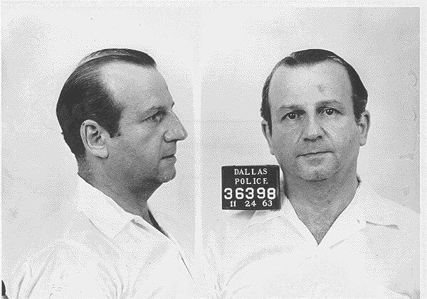 Two days later, on November 24, 1963, Oswald was being transferred to a nearby jail. Reporters gathered in the basement garage of Dallas Police headquarters as Oswald was being moved. Then, captured on live television, Dallas nightclub owner Jack Ruby walked up to Oswald and shot him point-blank in the stomach. Oswald was taken to Parkland Hospital where he was later declared dead.

Ruby had ties to organized crime but had friends in the Dallas Police Department. He was convicted of murder and was sentenced to death. Ruby’s lawyers later won an appeal for a new trial in 1966. But while awaiting his new trial, Ruby entered Parkland Hospital for pneumonia, later dying at the famous hospital on January 3, 1967.
Dr. Martin Luther King, Jr. greets marchers on the steps of the Lincoln Memorial on August 28, 1963.

The Kennedy assassination continues to be a focal point for conspiracy theories. New president Lyndon Baines Johnson ordered the formation of the Warren Commission to investigate the assassination. The commission, named after Supreme Court Justice Earl Warren, concluded in September 1964 that Oswald had acted alone in the assassination of President Kennedy.

Lesson 1 Review Questions – (write answers in complete sentences on a piece of loose-leaf paper).

1. What was so significant about televising the presidential debate of 1960?
2. What were the goals of Kennedy’s Peace Corps?
3. How was the CIA plan at the Bay of Pigs flawed?
4. What role did Parkland Hospital in Dallas play for three people involved in the Kennedy assassination?

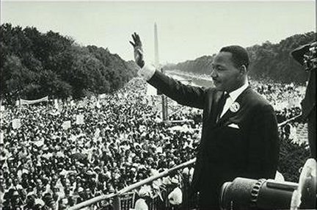Lesson 2 –

Civil Rights

Main Idea: The 1950s saw the beginning of a Civil Rights Movement that would grow in the 1960s.

Civil Rights Movement
The Civil Rights Movement that began in the mid-1950s gained momentum in the 1960s. During the Kennedy administration, civil rights reformers pushed the government to right the wrongs of decades past. The American South became a battleground for change as the conservative bigotry of old used every means possible to keep African Americans 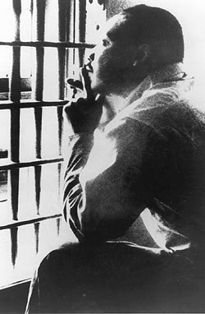from gaining social, economic and political equality.

Dr. Martin Luther King, Jr., the leader of the Montgomery, Alabama bus boycott in 1955, had become the most prominent leader of the Civil Rights Movement. He advocated civil disobedience and nonviolent protest. In April 1963, Dr. King was arrested for taking part in nonviolent protest in Birmingham, Alabama. In his Letter from the Birmingham Jail, King wrote:
Photo of Dr. Martin Luther King in the Birmingham Jail.

I submit that an individual who breaks a law that conscience tells him is unjust, and who willingly accepts the penalty of imprisonment in order to arouse the conscience of the community over its injustice, is in reality expressing the highest respect for law.

Americans around the country were horrified to watch on television as Birmingham police officers turned powerful fire hoses and police dogs on peaceful demonstrators. Such images alerted people around the world to the plight of blacks struggling for freedom in a land that proclaimed to be the home of the free.

Conservative white backlash continued, however. Alabama Governor George Wallace stood in the doorway of the University of Alabama in June 1963 to prevent the first black students from registering for classes. National Guardsmen, under orders from President Kennedy forced the governor aside.

That same month in Mississippi, civil rights leader and NAACP member Medgar Evers was shot to death in his driveway of his house. In September 1963, segregationists detonated a bomb outside of the 16th Street Baptist Church in Birmingham, killing four black Sunday school children. Nearly a year later in Philadelphia, Mississippi, the bodies of three civil rights workers were discovered. It was believed that law enforcement officials may have played a role in the killing.

Dr. King brought his message to the national stage in his march on Washington, D.C. in August 1963. More than 200,000 nonviolent protestors marched on the capital, concluding with King’s famous “I Have a Dream” speech on the steps of the Lincoln Memorial. The speech gets its name from the following quote:

I have a dream that one day this nation will rise up, live out the true meaning of its creed: "We hold these truths to be self-evident: that all men are created equal." I have a dream that one day on the red hills of Georgia the sons of former slaves and the sons of former slave owners will be able to sit down together at a table of brotherhood. I have a dream that one day even the state of Mississippi, a state sweltering with the heat of injustice, sweltering with the heat of oppression, will be transformed into an oasis of freedom and justice. I have a dream that my four little children will one day live in a nation where they will not be judged by the color of their skin but by the content of their character. I have a dream today.

The march on Washington was designed to pressure Congress into action on civil rights legislation. That legislation would have to wait until after the nation mourned its young president’s assassination just a few months later.

Two key civil rights landmarks followed in 1964. The first was the ratification of the 24th amendment to the United States Constitution. This amendment banned the use of poll taxes. Southern states had used poll taxes to keep blacks from voting since the end of Reconstruction in the 1870s. The other landmark was the Civil Rights Act of 1964. Presidents Kennedy and Johnson had lobbied Congress for this piece of legislation and on July 3, 1964 President Johnson signed it into law. The new law prohibited racial discrimination in public facilities, government, employment, voting registration and within any federally funded program. It made Jim Crow laws in the South illegal and signaled a real change in American society. The government was finally addressing the issue of injustice within our country.
President Johnson signs the Civil Rights Act of 1964 while Dr. Martin Luther King, Jr. & members of Congress look on.
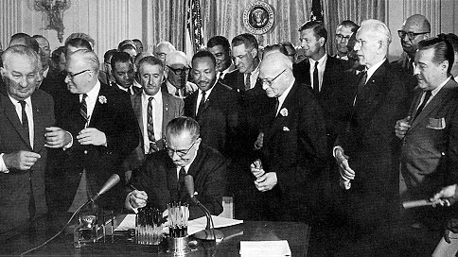
Lesson 2 Review Questions – (write answers in complete sentences on a piece of loose-leaf paper).

1. 1963 was a bad year for civil rights activists in the south. Provide two examples of this.
2. What did Dr. Martin Luther King mean when he said that someone who breaks a law “that conscience tells him is unjust” is really “expressing the highest respect for the law”?
3. What two key civil rights landmarks became a reality in 1964?

Lesson 3 –

Conflict in Vietnam

Main Idea: American foreign policy was focused on containing Soviet (communist) expansion. The U.S. strategy turned to Southeast Asia.

Vietnam: American Involvement
Do you remember the Domino Theory? Do you remember President Eisenhower sending U.S. advisors and military aid to the government of South Vietnam? Hopefully you do remember these things. During President Kennedy’s administration increased the amount of advisors and aid. However, President Kennedy was frustrated by the South Vietnamese leader Ngo Dinh Diem. Diem had become a dictator and was taking advantage of U.S. support. He instituted a violent crackdown on Buddhist monks who had protested his policies. To demonstrate this to the rest of the world, several monks practiced self-immolation – images of which were broadcast around the world, embarrassing the U.S. for its support of such a dictator. As a result, Kennedy was not disappointed when South Vietnamese generals overthrew Diem and killed him just a few weeks before Kennedy’s assassination.

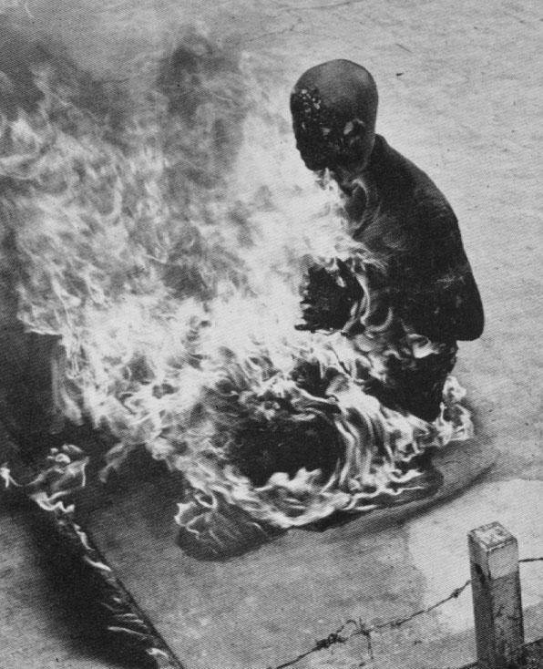 Both Presidents Kennedy and Johnson felt that the United States had to support the government in South Vietnam in order to stop the spread of communism in Southeast Asia. Increasing military personnel was seen as the logical way to do this. By the end of July 1964, President Johnson had increased the number of American military advisors to 21,000. This was only the beginning.
A Buddhist monk sets himself on fire to protest the policies of South Vietnamese dictator Ngo Dinh Diem.

Gulf of Tonkin Incident
On August 2, 1964 two U.S. Navy destroyers were in the waters off the coast of North Vietnam. This body of water is known as the Gulf of Tonkin. Three North Vietnamese patrol boats attacked the U.S.S. Maddox in international waters, but the attack was minor and the Maddox along with jets from the carrier U.S.S. Ticonderoga sank two of the boats. Two days later another attack, completely unprovoked according to the Navy, was carried out on the destroyer U.S.S. Turner Joy. Today, evidence shows that this second attack never really happened!

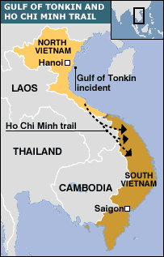 President Johnson, who was seeking reelection in November, went on television and informed Americans of the attacks. His Secretary of Defense, Robert McNamara went before Congress claiming to have proof of a second attack. As a result, Congress passed the Gulf of Tonkin Resolution. (It was unanimous in the House; only two U.S. Senators voted against it). The resolution gave President Johnson the power “to take all necessary steps, including the use of armed force,” in defending the freedom of South Vietnam. Congress had given LBJ the authority to send U.S. troops to fight the communists in Vietnam. As a result, the number of U.S. personnel in Southeast Asia would skyrocket.

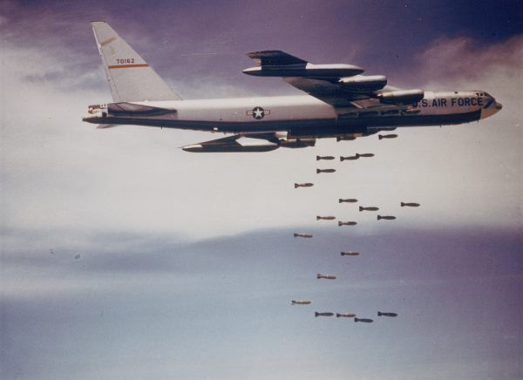
A B-52 bomber drops bombs over North Vietnam. The B-52 was designed to carry nuclear bombs. It could carry up to 70,000 pounds of bombs.
America in Vietnam
The year 1965 saw the United States take a far more active role in the war in Vietnam. The goal of U.S. foreign policy regarding Vietnam was originally to support a pro-democratic government (anti-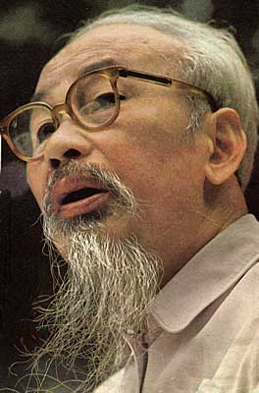communist) through the use of military supplies and advisors. Throughout the early 1960s, the amount of advisors and supplies grew slowly and steadily. By 1965, however, the United States became the primary force in the actual fighting of the war. At the beginning of the year, there were less than 25,000 troops in Vietnam. By the end of the year more than 184,000 troops were there.

Let’s remember the objective – defeat the communists in Vietnam and therefore prevent the spread of communism (domino effect) in Southeast Asia. As the premier military power in the world, it should have been relatively easy to defeat a population that was unable to produce its own weaponry. But that was not the case. The United States did not adequately understand the situation and as a result found itself in a war that it could not win regardless of the size and superiority of the American military.
Ho Chi Minh – leader of Communist North Vietnam

Why did the Vietnamese people fight against us, especially if we were there to prevent them from the evils of communism? You must remember that Vietnam historically had been under the control of foreign powers for hundreds of years. The French had ruled Vietnam as a colony for nearly 100 years. The Japanese had control of Vietnam during World War II. Going back even further, China had ruled there for hundreds of years. The people of Vietnam saw no great difference in the United States.

You must also remember that the government in South Vietnam was more interested in remaining in power than in the rights of the people they were supposed to be protecting. The communists and Ho Chi Minh, leader of communist North Vietnam wanted a united country, free from foreign influence or control. This was a concept that appealed more to the Vietnamese than the prospect of a so-called democratic government in the south.

The United States strategy was to stop the flow of communist guerillas known as the Viet Cong, from moving into South Vietnam from the north. The Viet Cong and their supplies moved down the Ho Chi Minh Trail. (see map on page 9). In March 1965 the U.S. began Operation Rolling Thunder – a series of bombing raids on targets in North Vietnam intended to stop re-supply of the Viet Cong and force the North Vietnamese to the negotiating table. This bombing was stepped up in June 1966 when B-52 bombers began bombing the port of Haiphong and the capital of Hanoi in North Vietnam.

On the ground, the U.S. made it impossible for the North Vietnamese army or the Viet Cong to use conventional tactics – large numbers of troops attacking to take and hold land. Instead, they were forced to use guerilla tactics. In order to fight this enemy, the Pentagon pleaded with President Johnson to send more troops. By August of 1966, Johnson had authorized an increase in troop levels to 429,000. The cost of the war was going up considerably.

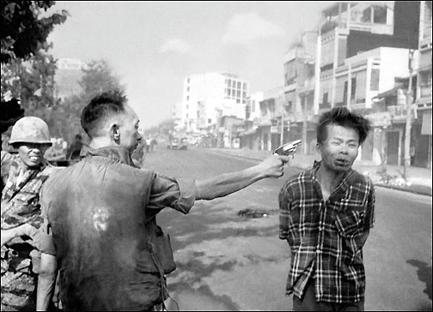
A South Vietnamese police chief executes a Viet Cong suspect in the street. Images like these caused Americans back home to protest U.S. military action in Vietnam.
Vietnam War Protests
As the number of American military personnel going to Vietnam increased, so too did the number of protests against the war. Many Americans felt that the Vietnamese people should decide their own fate and that U.S. soldiers should not be risking their lives half-way around the world. The draft process was also unfair, since one could be exempt from the draft by going to college. This left the poor and underprivileged class open to the draft.

Debate raged across the country as protestors were branded as “un-American” or “unpatriotic.” Critics of the war argued that the government we were supporting lacked legitimacy. Stories and images of the inhumane actions of the South Vietnamese government caused the number of war protestors to grow. By the end of the decade the anti-war movement became a huge political force in the United States. The role of this group in determining the outcome of the war is still debated today.
Lesson 3 Review Questions – (write answers in complete sentences on a piece of loose-leaf paper).

1. How did several monks in South Vietnam demonstrate their unhappiness with their government? How did this affect U.S. support?
2. How did the Gulf of Tonkin Incident lead to greater U.S. involvement in the Vietnam War?
3. What did the United States fail to understand when it came to the people of Vietnam?
4. How was the draft unfair when it came to the Vietnam War?

Lesson 4 –

President Johnson

Main Idea: Lyndon Baines Johnson had to follow in the footsteps of an assassinated president. He wanted to make significant changes to help Americans, but the Vietnam War would continue to frustrate him.

LBJ
The job of being president after the shocking assassination of a young and vibrant leader in John F. Kennedy fell on the shoulders of Lyndon Baines Johnson. Johnson had come to Washington in 1937 as a New Deal Democrat from Texas. By 1948 he became a Senator from Texas and by 1954 he was the Democratic Majority Leader in the Senate. In 1960 he was elected JFK’s Vice President.

It was a difficult time after the assassination. LBJ was sworn in as president on Air Force One next to a shaken Jacqueline Kennedy. He tried to honor JFK’s legacy but had difficulty getting support for his own ideas. He clashed with 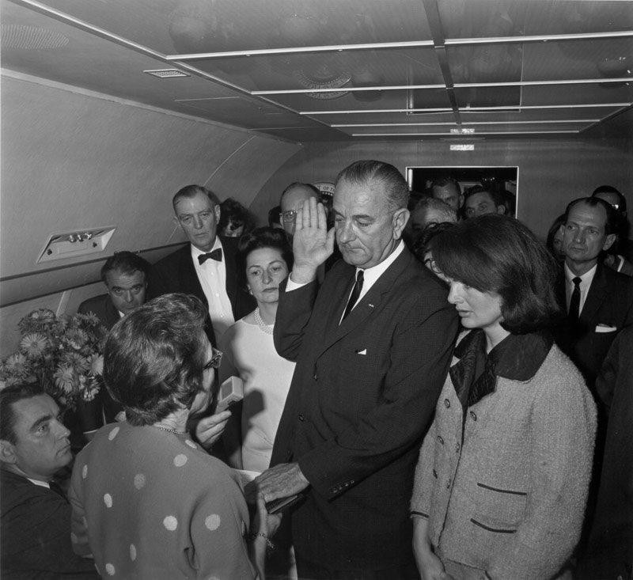Robert Kennedy, who reluctantly continued on as LBJ’s Attorney General. But in 1964 he ran on his own for a full term as president.
Lyndon B. Johnson takes the oath of office on board Air Force One after the assassination of President Kennedy.

Election of 1964
The Republican Party ran conservative Arizona Senator Barry Goldwater for president against LBJ. Democratic campaign ads portrayed Goldwater as a potentially unstable, hawkish leader who might lead us into a nuclear confrontation with the Soviet. Meanwhile, LBJ received the sympathetic support of millions of Americans who still mourned the assassinated JFK. The results were dramatic. LBJ won 61% of the popular vote and carried a huge mandate into his first full term as president.

Great Society
The centerpiece of LBJ’s presidency was to be what he called the Great Society. After his inauguration in January 1965, LBJ outlined his plan, which was to be an extension of the FDR’s New Deal and Truman’s Fair Deal. He wanted to focus on helping those Americans who could not help themselves. The Great Society was supposed to provide assistance to the neediest of American Society.

LBJ’s Great Society plan was made up of a number of different government programs. Johnson called for a war on poverty. This meant the creation of a number of government welfare programs designed to lower the number of Americans living below the poverty line. Examples of some of these programs are:
- Job Corps – a vocational training program aimed at disadvantaged youth.
- Head Start – educational program set up to provide assistance for low-income preschool children
- VISTA (Volunteers in Service to America) – domestic version of JFK’s Peace Corps, provided educational & vocational training for poor people.
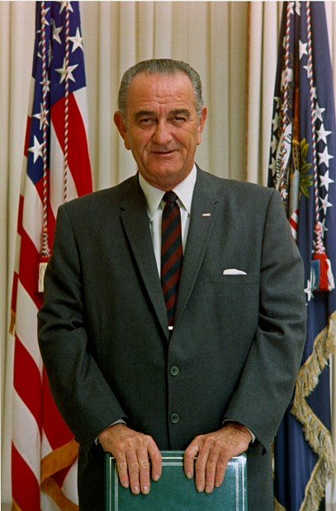
Perhaps the most important programs to come out of LBJ’s Great Society would be a program designed specifically to aid the elderly – a group that made up a large percentage of America’s underprivileged class:
- Medicare – medical insurance program that was added to the Social Security Act. It provides coverage for people over 65 and for people who are receiving social security benefits. Today it covers approximately 41 million Americans.

In addition, the Great Society looked at helping poor Americans without health care coverage:
- Medicaid – program funded and managed by the federal and state governments to provide health insurance for people with low incomes. Today, approximately 43 million Americans are enrolled in this program.

Critics of Johnson’s Great Society have complained that the program did not work and that it created a class of lazy, unmotivated citizens. However, some statistics show that the percentage of Americans living below the poverty line dropped nearly 10% as a result of this program. Regardless, the president was frustrated in fighting a battle to implement these programs while the cost of the Vietnam War grew.

Riots: American Cities Up in Smoke
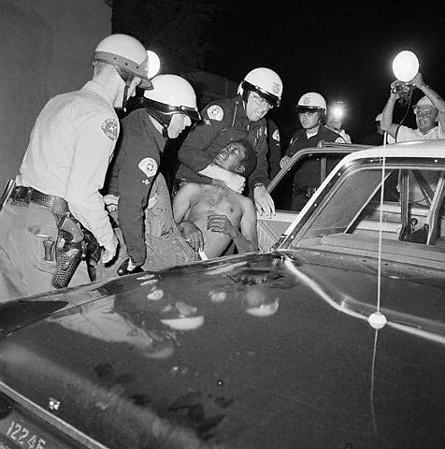 The 1960s is also a decade remembered for the incredible violence that took place, resulting in loss of life and destruction of property in a number of U.S. cities. Most of these riots were sparked by the amount of racial tension in certain areas. Below is a list of a few of these incidents:

Watts – August 1965:
A young black man is arrested for drunken driving and is allegedly beaten by police officers in the Watts neighborhood of Los Angeles, California. The allegations of police brutality touch off six days of rioting in predominantly African-American Watts. The results: 34 dead, over 1,000 injured, 4000 people arrested and over $100 million in property damage.
Police officers arrest a black protestor during the Watts Riot – 1965.

Atlanta – September 1966:
Militant African-Americans attack police cars and other vehicles after the shooting of a black man during a police chase. Rioters chant “Black Power,” a phrase coined by Stokely Carmichael, leader of the Student Non-Violent Coordinating Committee. Carmichael is blamed by Atlanta’s mayor for inciting the riot.

Detroit – July 1967:
Police officers arrest 82 people drinking illegally at a bar on 12th Street on Detroit’s West Side. After the arrests (most of those arrested were black people), a group began breaking windows in a nearby department store. Rioting lasts over five days despite the presence of National Guard troops. Finally, President Johnson is forced to send in the 82nd Airborne to calm things down. The results: 43 dead, nearly 1,200 injured, 7,000 people arrested and over $45 million in property damage.

The rioting caused President Johnson to form the National Advisory Commission on Civil Disorders. In February 1968 this commission reported that the United States was “moving toward two societies, one black, one white, separate and unequal.” They found that white racism was to blame for the rioting and it encouraged the development job creation in poor black communities along with bans on discrimination. As we’ll learn further along, 1968 would turn out to be another year of major rioting.

Constitutional Advancements
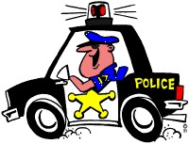 Two important constitutional improvements took place in the mid-1960s. They continue to play a role in society today. The first is the 1966 Miranda v. Arizona case. The Supreme Court ruled 5-4 that a suspect must be informed of his or her rights, including the right to have a lawyer present, prior to questioning by the police. This was a result of an appeal by a convicted rapist in Arizona, Ernesto Miranda. His lawyers argued that he was denied his 5th Amendment right when confessing to his crime. The Supreme Court agreed. This is why, upon taking a suspect into custody, the police make sure today that the suspect is “mirandized.” You’ve probably heard the routine on television…

- You have the right to remain silent and refuse to answer questions. Do you understand?
- Anything you do say may be used against you in a court of law. Do you understand?
- You have the right to consult an attorney before speaking to the police and to have an attorney present during questioning now or in the future. Do you understand?
- If you cannot afford an attorney, one will be appointed for you before any questioning if you wish. Do you understand?
- If you decide to answer questions now without an attorney present you will still have the right to stop answering at any time until you talk to an attorney. Do you understand?
- Knowing and understanding your rights as I have explained them to you, are you willing to answer my questions without an attorney present?

Another improvement came in the form of the 25th Amendment to the Constitution. In 1967 this amendment was ratified, making clear the order of succession to the office of president. Prior to passage of this amendment, the office of vice president remained vacant if that person moved up to the presidency due to the death of the president. Now, a new vice president would be nominated by the president and win confirmation with a majority vote of both houses of Congress.

It also addressed the issue of the president being physically unable to serve. The last years of President Woodrow Wilson’s term served as the inspiration for this part. If the president is unable to serve, the vice president will assume the duties of the president until he is able to resume those duties. Also, if the vice president and a majority of the cabinet believe that the president is unable to serve, then the vice president will take over as president. This way the office of president will be occupied if a president undergoes surgery or should have some sort of illness that could cause him or her to be incapacitated. (Do you remember when Woodrow Wilson had a stroke in 1919?)

Lesson 4 Review Questions – (write answers in complete sentences on a piece of loose-leaf paper).

1. Name a Great Society program, explain what it does and why it was so important.
2. What did President Johnson’s National Advisory Commission on Civil Disorders declare after studying the riots of the mid 1960s?
3. What does the 25th amendment do?

Lesson 5 –

1968: A Very Bad Year

Main Idea: So many bad things happened in 1968 that it deserves study all by itself.

Death and mayhem are two words that could describe 1968. The year represented a turning point for the United States. The reality of the war in Vietnam hit home in the United States when it became clear that the war wasn’t as close to over as the government had been predicting. The assassinations of key political figures led to grief and violence. The campaign for president showed how our country was divided. It was not a good year for the United States.

Vietnam: Tet Offensive
General William Westmoreland, the commanding American general in Vietnam, had claimed he “could see the light at the end of the tunnel” regarding the eventual victory of American and South Vietnamese forces in the war. The claim that the war was nearly over was shattered in January 1968 as the Viet Cong and North Vietnamese launched a massive attack during the Vietnamese New Year celebration of Tet. In the past, a truce lasted so that all Vietnamese could celebrate but 1968 was different.
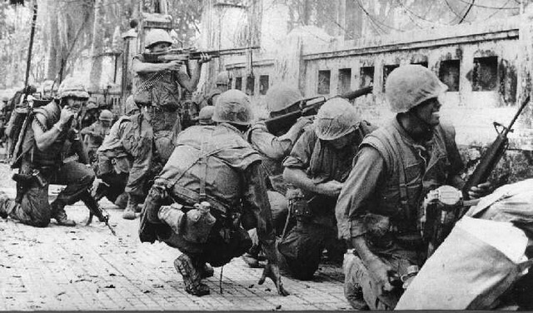
American soldiers pinned down by Viet Cong and North Vietnamese forces in the ancient capital of Hue.
The Viet Cong launched attacks in almost every South Vietnamese city. Most of these attacks were defeated quickly by U.S. and South Vietnamese forces. However, fighting in the capital of Saigon lasted several days. Television crews showed communist forces attacking the U.S. Embassy compound in Saigon. The ancient capital city of Hue was taken over by communist forces for nearly a month. Americans back home were shocked by the boldness of the attack and protests against the war increased. Many Americans who had backed the war were horrified that a nearly defeated enemy could still wage a massive attack like this. Many felt betrayed by the government.

The ironic part about the attack was that it had a devastating effect on the Vietnamese communists. The Viet Cong was decimated. They launched the attack hoping to spark support from within the cities and the opposite resulted. The U.S. forces killed or captured many of the communists. When the fighting was over nearly 50,000 communists were dead with another 6,000 captured. Their ability to continue their guerilla efforts was damaged severely. But the impact of their attacks swayed American public opinion and resulted in the replacement of Westmoreland. Ultimately, the U.S. would begin lowering the number of troops in Vietnam as protests at home increased.

Election of 1968: Johnson Will Not Run
The popularity of President Johnson had hit a low point after the Tet Offensive. In March, Minnesota Senator Eugene McCarthy came in a close second to the president in the New Hampshire Democratic Primary. This was shocking because Johnson was the party incumbent and expected to win the Democratic nomination. By the end of the month, Johnson shocked the nation when he went on television and said he would not seek or accept his party’s nomination for another term as president of the United States. Clearly Johnson felt unable to pursue his goals for the Great Society at the expense of the country’s deepening conflict in Vietnam.
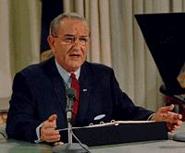
A number of Democratic candidates surfaced upon Johnson’s withdrawal. His vice president, Hubert H. Humphrey of Minnesota threw his hat into the ring. Perhaps the candidate with the best chance was New York Senator Robert F. Kennedy; the former Attorney General. Unfortunately 1968 would not be a very good year for him either.
President Johnson announces he will not run for president in 1968.

Assassination: Martin Luther King, Jr.
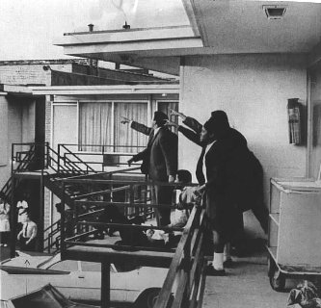 In April 1968 Dr. Martin Luther King, Jr. was in Memphis, Tennessee to support a sanitation workers strike. At 6:01A.M. on the morning of April 4, Dr. King stepped out on to the balcony of his hotel and was shot in the neck. He was pronounced dead an hour later. An escaped convict by the name of James Earl Ray was convicted of King’s assassination. He pled guilty but later tried the rest of his life to withdraw his plea and get a new trial. It never happened.

King’s assassination led to a wave of riots in more than 60 cities across the country. The violence and destruction was unprecedented. The rioting lasted several days. All of this happened in contrast to King’s fundamental belief in nonviolence. He will forever be remembered as a champion of human rights. King’s contributions to the civil rights movement will be remembered forever and he is honored as one of our country’s greatest Americans.
Dr. King’s supporters point in the direction of the where the shot that killed Martin Luther King was fired.
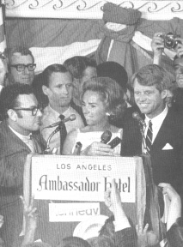

Assassination: Robert F. Kennedy
After President Johnson pulled out of the presidential campaign, Robert F. Kennedy became the front-runner. Kennedy, who had left Johnson’s administration to run for election as a senator from New York, was very popular and ran a campaign that focused on ending the war in Vietnam, aiding the urban poor and bringing an end to racial violence and discrimination.
Senator Robert Kennedy (alongside wife Joan) delivers a speech at the Ambassador Hotel.

On June 4, 1968, Robert Kennedy had just won two big Democratic primaries in South Dakota and California. In the early morning hours of June 5, he gave a speech at the Ambassador Hotel in Los Angeles, California. After delivering the speech, he walked through the kitchen to greet some supporters on his way out. It was there that a Palestinian immigrant by the name of Sirhan Sirhan fired two shots that killed Robert Kennedy. He died the next day on June 6. The assassination, coming just two months after the assassination of Dr. King, shocked the country.
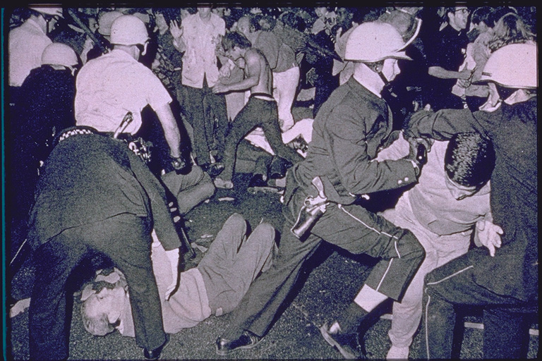Democratic Party Convention: Violence in Chicago
Chicago Riot Police arrest Vietnam War protestors outside of the Democratic National Convention in August 1968.
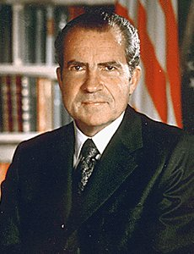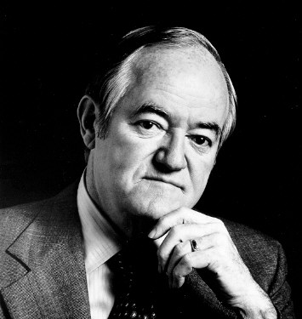 In August the Democrats held their nominating convention in Chicago, Illinois. The party was divided after the dropping out of President Johnson and the assassination of Robert Kennedy. The two main candidates were Minnesota Senator Eugene McCarthy who campaigned on ending the Vietnam War immediately, and Vice President Hubert H. Humphrey (also of Minnesota) who followed the president’s policy of tying U.S. troop reduction to concessions by the North Vietnamese at peace negotiations. Humphrey had the delegates to win the nomination and he became the Democratic candidate.

The bigger news seemed to be happening outside of the convention. Anti-war demonstrators from around the country had come to Chicago to protest the war in Vietnam. Chicago’s Mayor Richard J. Daley refused to allow permits for the protestors. As the protests continued regardless, the mayor sent in riot police to subdue the crowds. All of this happened as network television cameras rolled and protestors shouted, “the whole world is watching!” The chaos and violence surrounding the convention left many Americans disillusioned with the Democrats.
Republican Candidate Richard Nixon
Democratic Candidate Hubert Humphrey

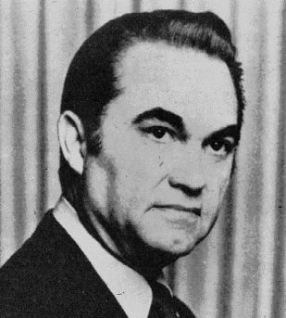Election of 1968
The Democratic Party’s candidate for president was Vice President Hubert Humphrey. But much of the Democrats support throughout history had come from the American South. George Wallace was the Democratic governor of Alabama. He was upset with the party’s support of desegregation in the South so he decided to run as a third-party candidate for president. He became the nominee of the American Independent Party and although he realized there was little chance for success, he hoped to deny the Democrats a victory for president. He also hopped to force concessions by the federal government on desegregation.
American Independent Candidate George Wallace

The Republicans, meanwhile, ran former California Senator and former Vice President Richard Nixon. Nixon ran a “law-and-order” campaigned designed to appeal to Americans who were shocked and outraged by the violence occurring across the nation. The election was close but Nixon won and the Republicans took control of the White House for the first time since 1961. Wallace attracted enough Southern voters to guarantee defeat for Humphrey and the Democrats. Nixon and Humphrey both secured 43% of the popular vote, but with Wallace winning 4 key southern states, Nixon easily had enough electoral votes to win the election.
Recruits for the Army of the Republic of South Vietnam – 1970.
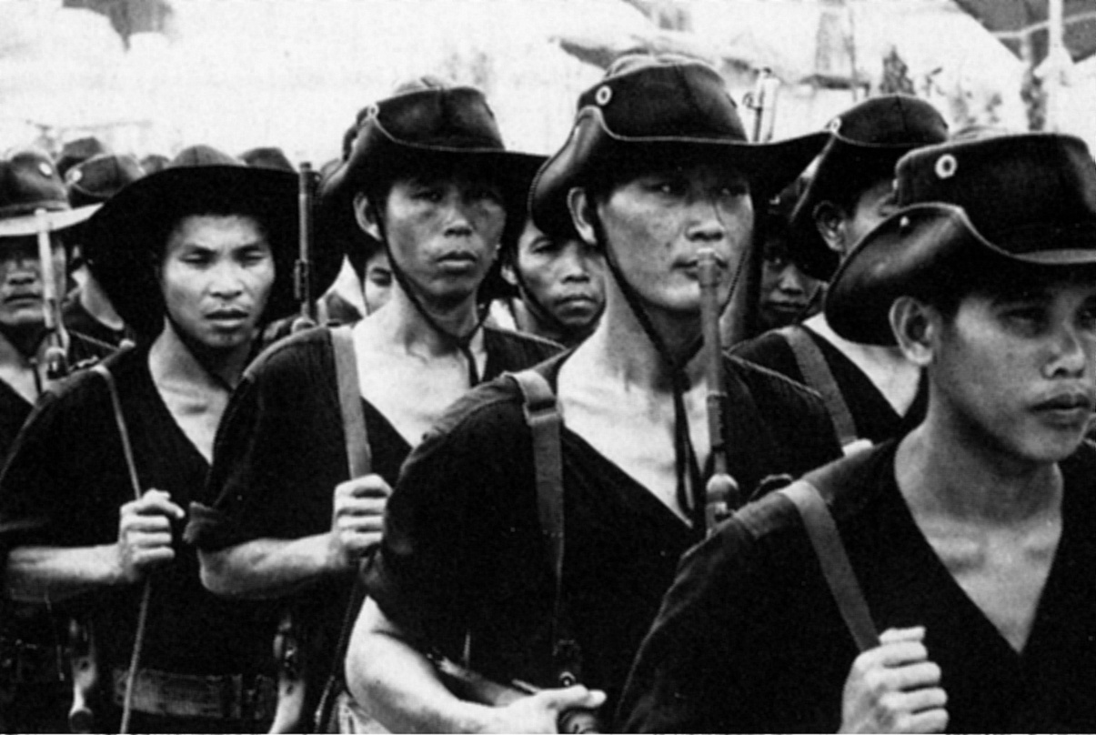Vietnamization
During the election of 1968, Nixon had promised “peace with honor” regarding the Vietnam War. He did not ever say how he planned to do this and Humphrey alleged that Nixon must have a “secret plan” to end the war. Upon becoming president, Nixon presented the “Nixon Doctrine” – a policy of turning over the main fighting of the Vietnam War to the South Vietnamese. This became known as the Vietnamization of the war. American troops were gradually called home and by 1971 the responsibility fell on the army of South Vietnam. It was equipped with all the modern weaponry that the United States could provide but that did not guarantee them success.

Lesson 5 Review Questions – (write answers in complete sentences on a piece of loose-leaf paper).

1. Even though the Tet Offensive was a disaster for the communists, how did this fundamentally change the view of the Vietnam War here at home in the U.S.?
2. Who won the majority of popular votes in the 1968 election?
3. What was President Nixon’s plan for “peace with honor” regarding Vietnam?

Other Interesting Events:
The Eagle Has Landed: Man Walks On the Moon
President Kennedy had challenged the country in his inauguration speech in 1961to put a man on the moon by the end of the decade. That challenge was met on July 21, 1969. The National Aeronautics and Space Administration (NASA) had spent the years following Kennedy’s challenge by building rockets and spacecraft with the ultimate goal of landing on the moon.

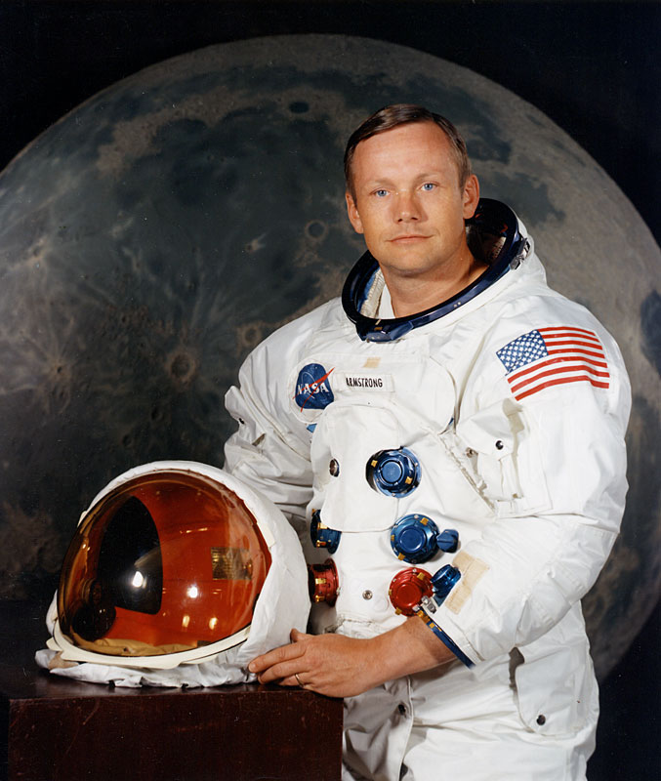 The Apollo XI mission began with blastoff from Cape Kennedy, Florida (renamed in memory of the president) on July 16. On the 21st, the Lunar Module landed and in front of a television audience of approximately 600 million people, Astronaut Neil Armstrong became the first man to walk on the surface of the moon. His words are immortalized… “That’s one small step for man, one giant leap for mankind.”
Astronaut Neil Armstrong

There would be further trips to the moon but this mission was the first and demonstrated how technically advanced our nation had become. In less than 70 years powered flight had advanced from the windy shores of Kittyhawk, North Carolina to the surface of the moon.

Entertainment
- 1962 – Marilyn Monroe died at age 36. Her death was caused by a suicidal drug overdose.
- 1966 – Walt Disney died at age 65. Disney introduced America to Mickey Mouse and created a movie empire and theme park.
- 1967 – Public Broadcasting is created by the federal government.
- 1969 – Actress Sharon Tate is murdered in her Hollywood home by a Charles Manson’s gang.

Sports
- 1960 – Montreal Canadiens capture their 5th Stanley Cup in a row, dominating the National Hockey League.
- 1961 – Roger Maris of the New York Yankees breaks Babe Ruth’s single season homerun record by 61 homeruns.
- 1962 – Wilt Chamberlain of the Philadelphia Warriors scores 100 points in win over the New York Knicks in the NBA.
- 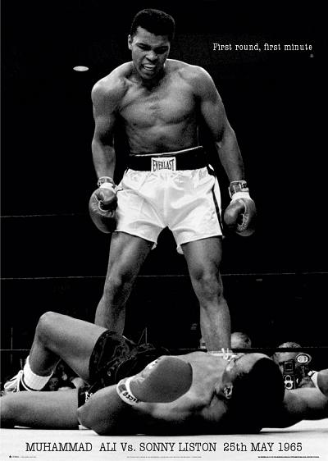1964 – Cassius Clay scores a TKO over Sonny Liston to become the heavyweight champion of the world. Clay successfully defends his title in 1965 in a rematch.
- 1966 – Boston Celtics win their 8th NBA title in a row and ninth in the last ten years.
- 1966 – Cassius Clay converts to Islam and changes his name to Muhammad Ali. In 1967 Ali is stripped of his title as champion when he refuses to register for the draft. He is sentenced to prison but that is overturned by the Supreme Court.
- 1968 – two U.S. black track athletes who finished 1st and 3rd in the 200-meter dash at the Mexico City Olympics raised a black gloved fist during the national anthem in a display of “Black Power”

Music
- 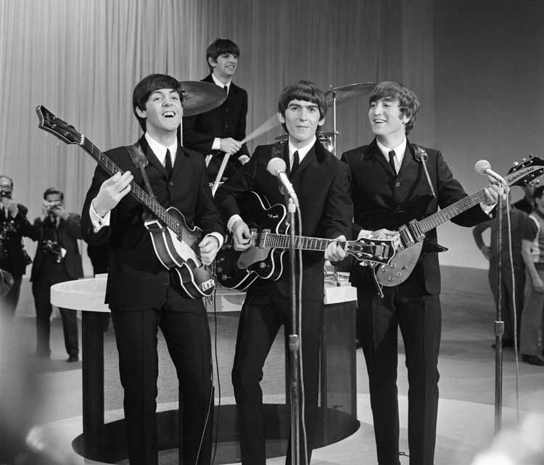1963 – Bob Dylan debuts as a folk singer with Blowin’ In the Wind, an anti-war song.
- 1964 – The Beatles arrive in New York for their first U.S. tour. Their music starts a craze and influences musicians for generations.
- 1965 – The Rolling Stones first arrive in the U.S. Their music will also influence musicians for generations but they will continue to perform into the next millennium.
- 1966 – The Monkees television show is a hit; American bands such as The Beach Boys and The Byrds are popular.
- 1967 – Monterey Pop Festival in San Francisco attracts 50,000 with bands like The Doors, the Grateful Dead, Buffalo Springfield, The Who, and Jimi Hendrix.
- 1969 – Woodstock Music Festival in upstate New York – 3 days of rock music and counterculture activities (drug use, casual sex, anti-war protest).

Fashion & Culture - things that are popular in the 1960s:
- Mini skirts
- Indian religion of Hare Krishna
- Go-Go Boots
- Hippies
- Increased illegal drug use including psychedelic drugs like LSK
- Long hair on women and men

Extra Credit Question (worth 10 points – answer in complete sentences on a piece of loose-leaf paper) - choose either:
- The United States military took part in a horrifying incident that resulted in the killing of innocent Vietnamese in the village of My Lai in 1968. Do some research - explain what happened and its effect on the American public.
- Muhammad Ali is an athlete that was famous in the 1960s. Do some research – why did he convert to Islam? What was his connection to Malcolm X and the Nation of Islam? What happened to him when he refused to refuses to join the military during the Vietnam War?
- Do some research - in 1960 the Soviet Union shot down a U.S. spy plane called the U2 and captured the pilot. How did this happen and what effect did it have on U.S. - Soviet relations?
- The election of 1960 was one of the closest in presidential politics. Do some research – what role did Chicago Mayor Richard J. Daley play in helping Kennedy get elected? Why was the city of Chicago connected with election fraud?

Timeline of Events
1960 | - 3,500 U.S. soldiers sent to South Vietnam  - Soviets shoot down U2 spy plane & capture pilot Francis G. Powers  - Paris summit between US and Soviet Union cancelled  - John F. Kennedy wins presidential election
1961 | - 23rd amendment allows residents of Washington, D.C. to vote in presidential elections  - Bay of Pigs invasion fails in Cuba  - Soviet Yuri Gagarin becomes first human in space  - Alan Shepard becomes the first American in space  - Kennedy meets Khrushchev in Vienna, Austria to discuss disarmament  - 18,000 US military advisors sent to South Vietnam
1962 | - US institutes an embargo on Cuba (still in effect today)  - The first Wal-Mart store opens in Rogers, Arkansas  - Cuban Missile Crisis
1963 | - Feminist Betty Friedan publishes The Feminine Mystique  - Martin Luther King, Jr. is arrested for protesting in Birmingham, AL  - Civil Rights activist Medgar Evans is murdered in Jackson, MS  - ZIP Codes are introduced in the US  - 16th Street Baptist Church bombing in Birmingham, AL kills 4  - South Vietnamese President Ngo Dinh Diem is assassinated  - Malcolm X delivers his Message to the Grass Roots in Detroit, MI  - President Kennedy is assassinated in Dallas, TX – Lyndon Baines Johnson becomes the 36th US President
1964 | - John Glenn becomes the first American to orbit the earth  - 24th amendment outlaws Poll Taxes  - Ford introduces the Mustang  - Nelson Mandela is sentenced to life in prison in South Africa  - Civil Rights Act of 1964 signed into law  - Gulf of Tonkin Incident prompts Gulf of Tokin Resolution in Congress  - Philadelphia Race Riot  - Leonid Brezhnev takes over as leader of Soviet Union  - President Johnson wins re-election over Barry Goldwater  - Martin Luther King, Jr. wins the 1964 Nobel Peace Prize
1965 | - Malcolm X assassinated in New York City  - Martin Luther King, Jr. leads 25,000 in the March on Selma, AL  - US troops sent to Dominican Republic to prevent communist rebellion  - First organized burning of draft cards to protest Vietnam War  - US troop levels in Vietnam increase to 400,000  - Watts Riots in Los Angeles, CA  - Soviet Union ships rockets to North Vietnam
1966 | - Chicago Blackhawk Bobby Hulls breaks NHL record with 51 goals in a single season  - St. Louis Gateway Arch dedicated  - Miranda v. Arizona results in police reading suspects their rights  - National Organization for Women (NOW) is formed  - Bobby Seale & Huey Newton form the Black Panther Party  - Atlanta Riots  - Ronald Reagan elected governor of California  - Walt Disney dies  - Kwanzaa is first celebrated
1967 | - Super Bowl I: Green Bay Packers beat Kansas City Chiefs  - Large anti-Vietnam War protests held in New York & San Francisco  - Six Day War – Israel defeats attacking Arab forces  - Thurgood Marshall becomes first African-American member of US Supreme Court  - 12th Street Riot – Detroit  - Milwaukee Race Riot
1968 | - Vietnamese Communists begin Tet Offensive  - Eugene McCarthy comes in 2nd in Democratic Presidential New Hampshire Primary  - My Lai Massacre occurs - US troops kill Vietnamese civilians  - President Johnson announces he will not seek another term  - Martin Luther King, Jr. assassinated in Memphis, TN  - Robert Kennedy assassinated in Los Angeles, CA  - Anti-war protests result in violence at Democratic National Convention in Chicago  - US bombing of North Vietnam increases  - Richard Nixon defeats Hubert Humphrey in presidential election  - Apollo 8 orbits the moon
1969 | - Boeing 747 makes first flight  - Golda Meir becomes first female prime minister of Israel  - John Lennon records Give Peace a Chance  - First US troop withdrawals from South Vietnam under policy of Vietnamization  - Apollo 11 – Neil Armstrong becomes the first man on the moon  - Woodstock Music Festival takes place  - Between 250,000 to 500,000 protesters march on Washington, D.C.  - Wendy’s hamburger chain opens in Columbus, OH  - The first GAP store opens in San Francisco, CA  - November - My Lai Massacre exposed in newspapers

Camelot: the glamorous ambience of Washington, D.C. during the administration of President John F. Kennedy, 1961-63.
heir apparent: someone who is supposed to inherit a position because of their relationship to a predecessor.
poll tax: a tax of a fixed amount per person and payable as a requirement for the right to vote
self-immolation: Deliberate sacrifice of oneself, especially by fire.
Pentagon: term referring to the Department of Defense – named after the building that houses it outside Washington, D.C.
hawkish: One who demonstrates an actively aggressive or combative attitude, as in an argument.
incumbent: currently holding an office.

