Chapter 3 – America Breaks From England

1775 to 1783

Identification
Thomas Paine _____________________________________________________ _________________________________________________________________

Thomas Jefferson __________________________________________________ _________________________________________________________________

Marquis de Lafayette ________________________________________________
_________________________________________________________________

Horatio Gates ______________________________________________________
_________________________________________________________________

Tadeusz Kosciuszko ________________________________________________ _________________________________________________________________

Friedrich Von Steuben _______________________________________________ _________________________________________________________________

Charles Cornwallis __________________________________________________ _________________________________________________________________

George Rogers Clark ________________________________________________ _________________________________________________________________

John Paul Jones ___________________________________________________ _________________________________________________________________

Benedict Arnold ____________________________________________________ _________________________________________________________________

See Back for Photos

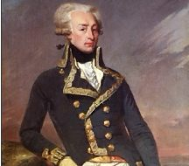
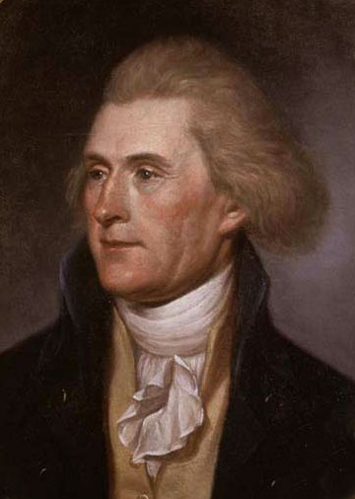
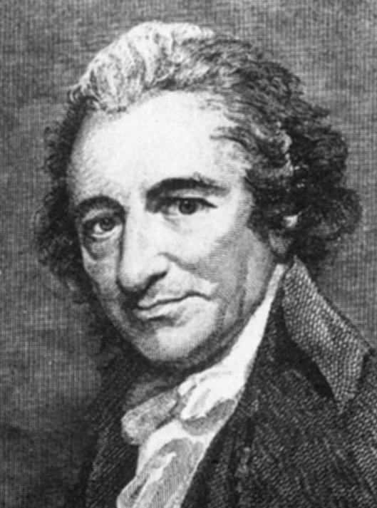

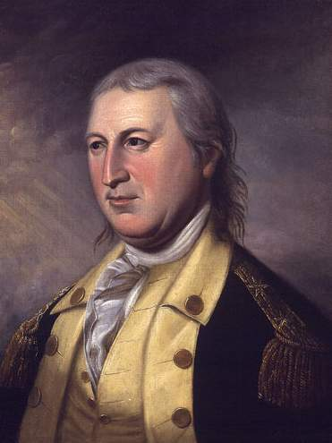
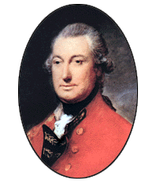
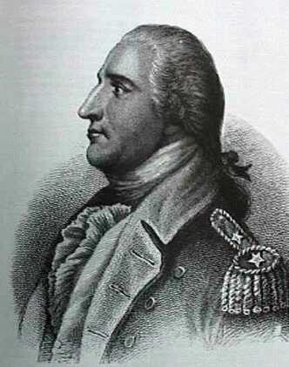
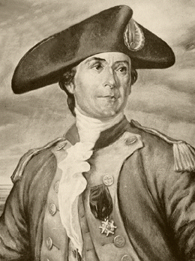
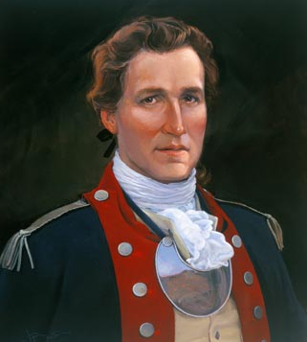
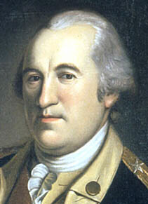
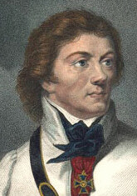
Top Row (Left to Right): Thomas Paine, Thomas Jefferson & Marquis de Lafayette

Middle Row (Left to Right): Horatio Gates, Tadeusz Kosciuszko, Friedrich Von Steuben, Charles Cornwallis & George Rogers Clark

Bottom Row (Left to Right): John Paul Jones & Benedict Arnold

