Chapter 8 – Manifest Destiny – 1840 to 1849
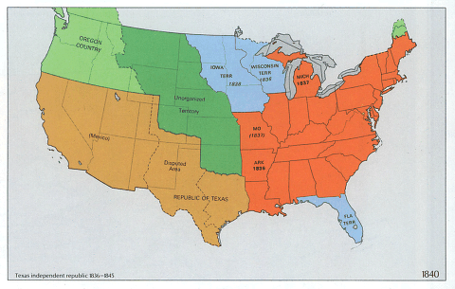

Review
The Jacksonian Era saw some major changes for the young United States. More people were voting than ever before. The majority of Native American people had been forced west of the Mississippi River. The first real crisis that threatened to break the American people into a civil war was narrowly prevented. But the seeds of that crisis would continue to grow for the next 20 years. And when we left off, the country was in the throes of an economic depression that started with the Panic of 1837. How would things change during the 1840s? Read on and you’ll find out.

Lesson 1 – Mid-19th Century Politics

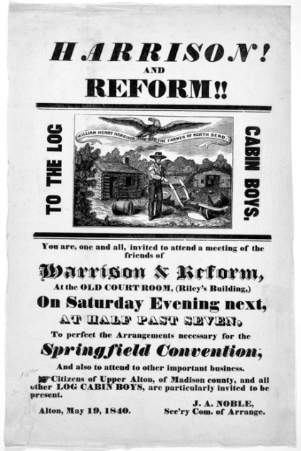
Main Idea: The early 1840s gave us ineffective government but by the middle of the decade, Americans turned to political leaders who believed the United States should rule all of North America.

The Election of 1840
You will remember that the United States was suffering through an economic depression at the conclusion of our last reading. This economic problem would ultimately cost President Martin Van Buren his job. The Democratic Party would nominate Van Buren and again, the policies of Andrew Jackson would remain the main plank of the Democratic platform. This time the Whig Party was better organized. Instead of nominating regional candidates, they went with the Whig candidate from 1836 that had done the best in that election – William Henry Harrison.

The campaign was one of the most negative in the young history of our country. In the end, Harrison and his running mate, former Democratic Senator John Tyler of Virginia won the election with their campaign slogan, “Tippecanoe and Tyler too”. They received 53% of the popular vote. More importantly, Harrison won 234 electoral votes to Van Buren’s 60. The United States would have its first Whig President.

Mom always said, “Don’t go out in the cold without a coat and hat!”
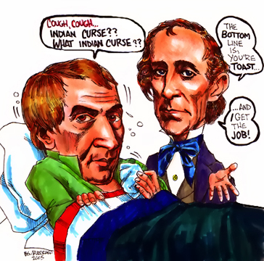
William Henry Harrison was sworn into the office of president on March 4, 1841. It was an extremely cold and windy day. Harrison was sworn in on the steps of the Capitol building in Washington, D.C., as most presidents are still inaugurated in modern times. But Harrison didn’t wear a coat or hat that day and he gave an inaugural address that lasted over 2 hours. It was one of the longest inaugural speeches in U.S. history. If his mother had been alive, surely she would have told him no wearing a coat and hat was a bad idea and that he would catch a cold. And she would have been correct. Harrison did catch a cold and that cold turned into pneumonia.

Ok, so you don’t really get pneumonia by going outside without a coat or hat in bad weather. But that’s beside the point. Harrison only got worse as a parade of office-seekers came to the White House in search of jobs. Doctors tried nearly everything they could to help him but nothing worked. After 30 days as president, Harrison died. Some attributed his death to a curse placed upon him by Tecumseh after the Battle of Tippecanoe but that doesn’t really make any sense. Others have pointed out that Harrison was the first of the “Zero-Year-Curse” presidents. Every president elected in an even numbered year (1840, 1860, 1880, etc.) died in office until President Ronald Reagan broke the curse (elected in 1980 – served until 1989). It’s spooky stuff but ultimately meaningless stuff. With Harrison dead, John Tyler became the first Vice President to take over for a president.

John Tyler – Accidental President
To say that President Tyler was an ineffective president is like saying water is wet. Tyler was elected as a Whig but you should remember that he was a former Democrat. When he became president, much of what the Whig-controlled Congress passed, Tyler vetoed. The Whigs were so upset with him that they actually kicked him out of the party in 1841 – the same year he became president.

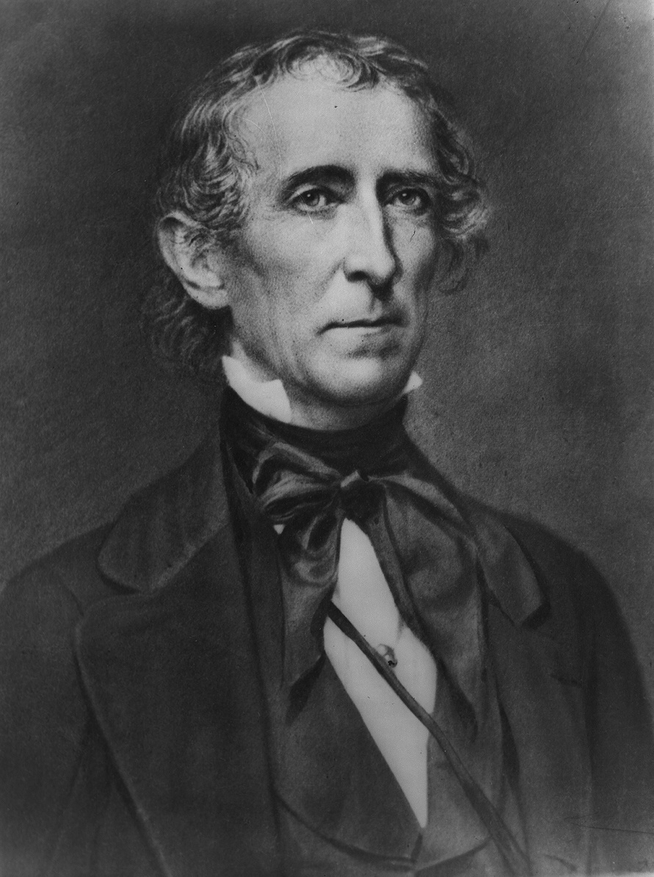
There really isn’t all that much to say about Tyler’s term as president because nothing much was accomplished. He didn’t get along with Congress and Congress didn’t like him. The House of Representatives actually formed a committee to impeach him, but they didn’t have the votes. A treaty was signed between the U.S. and Great Britain that officially recognized the border between the state of Maine and Canada – boy that sounds exciting, doesn’t it?

As for Tyler, he obviously didn’t have the support to run for a second term on his own and he retired to a plantation in Virginia. His term as president helped to further divide the country on the question of states’ rights – as he was a big states’ rights supporter. Both Harrison and Tyler don’t rank very high on most historians’ lists of great presidents.
John Tyler

The Election of 1844
After John Tyler finished the rest of William Henry Harrison’s term, it was clear that neither party was interested in running him as a candidate for president. The Democrats had former President Martin Van Buren looking like the front runner going into the nominating convention. Unfortunately for Van Buren, too many people in the party were upset with his position on delaying annexation of western lands. So the Democrats turned to a “dark horse” candidate in James K. Polk of Tennessee.

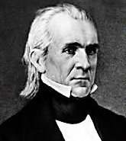
The Whigs turned once more to their most powerful Congressional leader in Henry Clay, even though he had already lost two presidential elections in the past. Clay had the advantage in that the country was already familiar with him, but they knew very little about Polk. The Democratic candidate was able to gain support when he declared that he favored the annexation of Texas, a potential slave state, with the acquisition and eventual annexation of Oregon – which would be a free state, therefore keeping the delicate balance in the Senate. There was only one problem with Polk’s plan. Oregon was jointly controlled by the United States and Great Britain. Polk’s campaign strategy was to demand control of all of Oregon. Polk also promised that if elected, he would only serve one term as president.
James K. Polk

Clay and the Whigs tried to match Polk on the expansion issue but they also focused on economic issues. Another third party was formed called the Liberty Party. It ran a candidate named James Birney and its primary issue was the abolition of slavery. They didn’t receive any Electoral votes but did win enough popular votes to damage Clay and the Whigs. The popular vote was a close one. Polk won 50% of the vote with Clay getting 48% and Birney winning 2%. But, of course, Polk won in the Electoral College with 62% and became the eleventh president of the United States.

Lesson 1 Review Questions – (write answers in complete sentences on a piece of loose-leaf paper).

- What caused the death of President Harrison? How long did he serve?
- How did the Whig Party feel about President Tyler?
- What was the focal point of James K. Polk's campaign and what did he promise Americans if he was elected?

Lesson 2 – From Sea to Shining Sea

Main Idea: Americans believed that as a people, we were special and that our culture gave us the right to rule the North American continent.

Manifest Destiny
This is a phrase that defined the United States in the 19th Century. What does it mean? Well, let’s start by breaking the phrase down into the individual words. First, we have “manifest”. According to Dictionary.com it means: readily perceived by the eye or the understanding; evident; obvious; apparent; plain. Now let’s take the word “destiny”. Dictionary.com says this means: the predetermined, usually inevitable or irresistible, course of events. So in other words, your destiny is something that is going to happen. It’s like when Darth Vader tells Luke Skywalker in Star Wars that it is his “destiny” to become like him. You’ve never seen Star Wars? Go rent it – it’s cool!

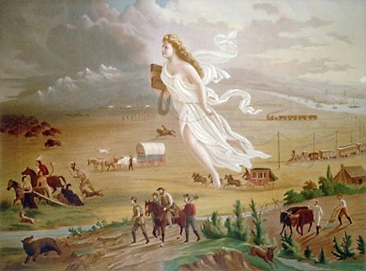
Ok, enough about science fiction movies and back to the whole idea of Manifest Destiny. If we take it for just the dictionary meaning we would say that it means something that is clearly going to happen – like if you don’t study, it’s your manifest destiny to fail. So what does this phrase mean for the United States in the 19th Century? It refers to the idea that the United States was to expand across the continent. According to many people who lived at the time, it was obvious that our system of government, our democracy, was supposed to rule from sea to shining sea.
1872 Painting by John Gast called “American Progress”

What this means is that we thought that since we were the best, everyone would clearly want to be like us. This sounds pretty self-centered, doesn’t it? We used this thinking to justify our actions when it came to taking over territory. After all, what other reason could we use for taking over the land that belonged to the Native Americans? Combine this concept with the racist feelings toward different groups of people and you begin to understand why things happened the way they did. It might not sound so good now but it’s what many Americans believed in and I suppose it made us feel better about taking things (like land) that wasn’t ours in the first place.
“Luke… it is your DESTINY!”

From the middle to the end of the 19th Century, the United States used this concept to justify expanding our borders. How we expanded those borders is something we’re going to be learning about so I’ll leave it up to you to decide if how our country went about this was morally acceptable. That’s the great thing about studying history. We get to look back at what other people did and make our own determination about whether what they did was right. Remember that someday people will be making the same observations about what we are doing.

President Polk
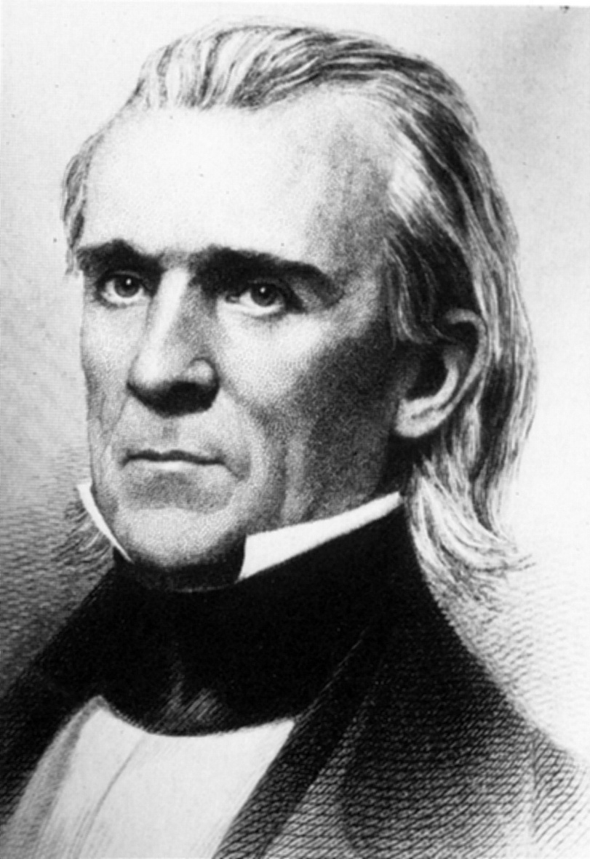
Upon taking office in 1845, President Polk set out with the goals of expanding our boundaries as well as reducing the tariff. He had four years to accomplish his goals because he intended to keep his promise about leaving office after one term. The remarkable thing about Polk is that he was able to achieve these goals.

Texas Annexation
You will remember from your last reading how Texas had gained its independence from Mexico in 1836. You should also remember how the Republic of Texas remained an independent country for the next nine years. Mexico had always disputed the boundary with Texas throughout its history and that will be an issue you’ll need to remember when we start learning about the Mexican War. In 1845, Texas was annexed to the United States. Why did they not want to remain an independent country? First of all, they owed a lot of money. If the U.S. annexed them, the United States government would assume their debt. Secondly, the vast majority of Texans were expatriated Americans who were happy to rejoin the Union.

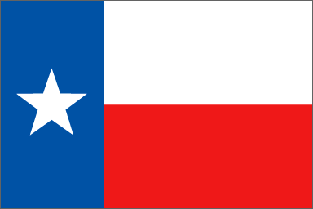
The problem that remained was how this would affect the balance of slave and free states in the United States Senate. One of the reasons why people in the United States had hesitated when it came to annexing Texas was because it would give the slave-holding states an edge in the Senate. But our new president was determined to add territory to the country and he was able to convince Congress to add Texas. In addition to Texas, which became a state in December 1845, Florida had already achieved statehood earlier that same year in March. This gave slave states an edge in the Senate, if only for the next year and a half. (Iowa & Wisconsin became free states in 1846 & 1848).

Oregon
In the campaign, Polk had said that the Oregon Country should belong to the United States. You’ll remember that I pointed out to you that Oregon was controlled jointly with Great Britain. So if we were going to control it by ourselves we would have to either negotiate with Great Britain for Oregon or go to war with them over it. Going to war was not a really good option when you think about it. We had already fought the British twice in the past 70 years. We were fortunate enough to win our independence the first time but we fought to a draw in the War of 1812. In the meantime, Great Britain had continued to remain a world military power. That meant negotiation would be the best alternative.

The issue would be where the U.S. and Great Britain would draw the line that would divide the Oregon Country. Previously, the U.S. had proposed drawing the line at 49° North Latitude. The British didn’t like that idea because they wanted to control the Columbia River which was to the South. When Polk took over as president, he made the same pitch to the British and again they refused. So Polk countered by demanding all of Oregon. Many expansionists here in America used the expression “Fifty-four forty or fight” in reference to the Oregon Country’s northern boundary at 54° 40’ North Latitude. But fighting really would not have been a good idea.

Finally, in the Oregon Treaty of 1846, the British agreed to the division of Oregon at 49° parallel. There would be no fight when it came to Oregon and the United States expanded yet again, but this time, all the way to the Pacific Ocean. This meant that the thousands of Americans who were blazing the Oregon Trail were now occupying a land that belonged completely to the United States.
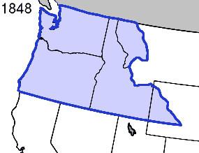
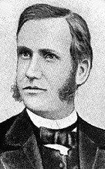
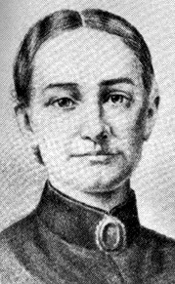
Speaking of the Oregon Trail, it is an important part of American history and the settlement of the West. The first organized wagon train set out in 1842 with roughly 100 settlers and in 1843 approximately 800 pioneers went west on the trail led by missionary and doctor, Marcus Whitman. Whitman and his wife Narcissa settled in the Willamette Valley with the goal of converting the local Indian population to Christianity. Others soon followed as land was plentiful and originally free – a married couple could claim up to 640 acres (1 square mile) of land. Even when the land was no longer free in 1854 one acre cost only $1.25. When more land to the West became annexed to the United States, the Oregon Trail became a major route west, with other routes to California and New Mexico branching off it.
Narcissa Whitman

As for the Whitmans, they developed a good relationship with the local Cayuse and Nez Percé Indians. The relationship went bad, however, when the large amount of white settlers brought measles and other diseases to the Indian tribes in 1847. Because so many Indians died as a result of their lack of immunity to the diseases, the Natives blamed the white settlers. On November 29, 1847 a group of Cayuse Indians murdered the Whitmans in their home as well as 12 other settlers in the region. It would not be the last violent conflict between settlers and Native Americans in the West.
Marcus Whitman

Lesson 2 Review Questions – (write answers in complete sentences on a piece of loose-leaf paper).

- What does the term “Manifest Destiny” refer to?
- Why did Americans in Texas want annexation to the United States?
- What was the slogan American expansionists used when it came to Oregon?

Lesson 3 –

War with Mexico

Main Idea: American plans for Manifest Destiny met resistance in the form of a sovereign nation - Mexico. The U.S. government would go to extraordinary lengths to take what it wanted.

Provoking a War
The American public had demonstrated their belief in Manifest Destiny when it had elected James Polk president. Polk delivered when it came to Oregon. Texas had been annexed to the United States. The territory between Texas and the Pacific south of Oregon was the area on which Americans and Polk next set their sights. The problem was that it belonged to Mexico.

This wasn’t the only problem when it came to Mexico. The Mexican government was extremely upset when we annexed Texas. Their government had never formally recognized the independence of Texas and when Texas became part of the United States they cut off diplomatic relations with the U.S. To make matters worse, the political situation in Mexico was unstable. The government there kept changing. In 1845 Polk sent diplomat John Slidell to Mexico City to negotiate four things:
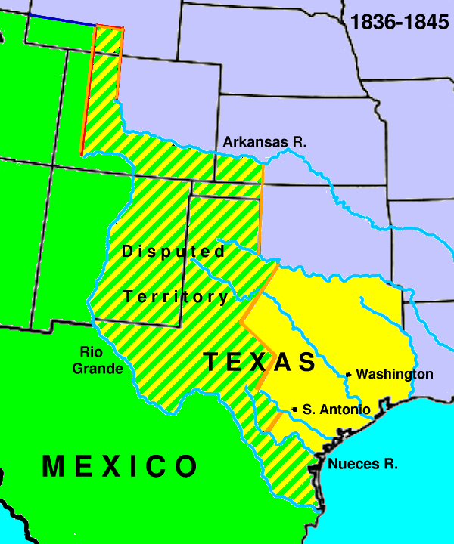
- Set the border between Mexico and Texas at the Rio Grande River. The Mexicans said the border was the Nueces River 150-175 miles to the North.
- Come to an agreement about the approximate $4.5 million dollars owed by Mexico to U.S. citizens from their war of independence with Spain.
- See if Mexico would be willing to sell their territory of California.
- See if Mexico would be willing to sell their territory of New Mexico (between California and Texas)

It’s important to understand that Polk wanted Slidell to offer to forgive the Mexican debt in return for setting the border at the Rio Grande. It’s also important to understand that the issue of California was important to Polk because he was fearful that Great Britain might get it. Mexico owed the British a lot of money and Polk feared they would give the territory to the British in return for forgiveness on their debt.

Slidell went to Mexico and didn’t really even get the chance to meet with anyone. The Mexicans were still pretty upset about the whole Texas thing when he arrived so they ignored him. Polk should have known that this would probably happen but it seems pretty clear he didn’t think too highly of the Mexican government in the first place. At the same time, there were many abolitionists in the United States as well as the opposition Whig Party in Congress who didn’t like the whole idea anyway. They thought that any expansion would just be another chance to add more slave states to the Union.

Polk had been successful in pressuring the British into a settlement on Oregon so he felt that he could do the same with Mexico. He came up with a plan that would force the military into the equation. He hoped that he could force the Mexicans to negotiate and prevent a full scale war. This way he could get what he wanted without too must protest here at home. But at the same time the government of Mexico underwent another change as a new, aggressively anti-American government took over. Mariano Paredes’ government came to power vowing not to give in to the United States and that Texas was rightfully part of Mexico.
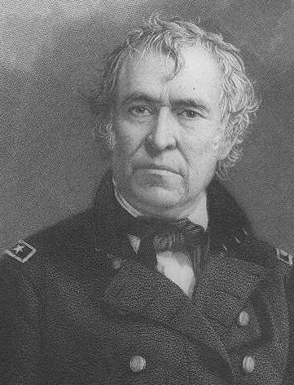
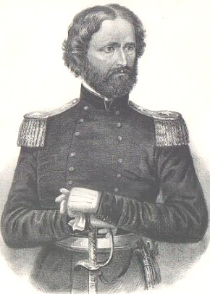
In order to get things moving, Polk ordered General Zachary Taylor and about 4,000 U.S. troops into the disputed area between the Nueces and Rio Grande Rivers. When this provoked no response by the Mexicans, Taylor was ordered to move to the Rio Grande River to protect against Mexican invasion. Let’s remember that this was the area claimed by both countries and to go all the way to the edge of that area was like poking a hornet’s nest with a stick. You know that something is going to happen. In April 1846 something did happen. An American force was attacked by a larger Mexican force and 16 soldiers were killed. It’s still disputed as to whether this attack took place south of the Rio Grande (which would have been an invasion by American troops) or north of the river. Regardless, Polk had gotten the excuse he was looking for and he went to Congress to ask for a declaration of war.
General Zachary Taylor
Captain John C. Frémont
In his address asking for a declaration of war, Polk said, “American blood has been shed on American soil.” Only 14 Whigs in Congress voted no. Among those was a first-term Whig from Springfield, Illinois – Abraham Lincoln. Lincoln demanded to know if the incident in which Americans were killed took place north or south of the Rio Grande. In the long term it didn’t matter because the country was at war.

Mexican president Paredes thought that any war with the United States would be a victory for his country. His army was better prepared since it had been dealing with rebellions in its own country for years. He also thought that the Americans wouldn’t stomach fighting such a long way from home. He assumed that if he could score some victories, particularly near Texas, it would cause a slave rebellion in the American south that would force the U.S. to take care of that and negotiate a peace that would be more beneficial to Mexico. Polk, meanwhile, didn’t want a long war. He expected the army to quickly defeat Mexico and force them to the negotiating table for terms benefiting America.

The Bear Flag Republic
California was a northern territory that belonged to Mexico. A small force of U.S. soldiers under the command of Captain John C. Frémont had been traveling through the territory to Oregon when word reached him about war with Mexico. Frémont turned back toward Sonoma, California telling settlers (predominantly Americans) about the war. In June 1846 these settlers established the California Republic. They created a flag with a bear on it and the words “California Republic”. About a week later Frémont’s troops arrived and the U.S. was in control. But the flag still remains as the state flag of California today.

Fighting Mexico
Mexico lost a few early battles, and this caused problems for Paredes. You should remember Antonio López de Santa Anna from your last reading about the fight for independence in Texas. After his defeat at San Jacinto he was disgraced and lost his dictatorship. At the time that the war with the United States broke out he was living in exile in Cuba. He was able to return to Mexico and once again take over as president.

General Taylor by now had advanced into northern Mexico. He had secured a victory in the Battle of Monterrey, capturing the city. In early 1847, Santa Anna once again took direct control of the army and moved his much larger force north to attack Taylor at a place called Buena Vista. Despite an advantage of about three to one, Santa Anna’s forces could not defeat Taylor and his army was forced to retreat.

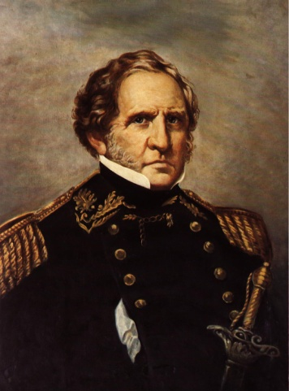
Meanwhile, President Polk sent another army under the command of General Winfield Scott to the eastern port city of Veracruz on the Gulf of Mexico. After a siege of 12 days, Veracruz fell to Scott and he began his preparations for moving west toward the capital at Mexico City. As Scott moved, Santa Anna attempted to defend the route toward the city with troops and artillery. General Scott’s advance forces located Santa Anna’s larger army, so he moved around their position and holding the high ground, launched an attack that crippled the Mexican force.
General Winfield Scott
Chapultepec Castle overlooking Mexico City

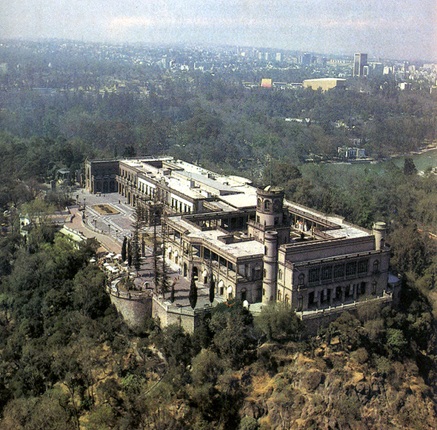
Scott’s army reached the outskirts of Mexico City in September 1847. Guarding the city was Chapultepec Castle. This place was used as a military academy for young Mexican officers. The Americans captured the castle and what remained of the Mexican army retreated into the city. However, six teenage military cadets refused to surrender. One by one they were killed with the last wrapping himself in a Mexican flag and jumped from the roof to his death. The six young men, known today in Mexico as Los Ninos Héroes, had rather commit suicide than surrender to the Americans. At this site is today a monument to their bravery.

Ending the War
Mexico City fell shortly after this and it was clear that the war was lost for the Mexicans. In February 1848, the Treaty of Guadalupe Hidalgo was signed ending the war. The treaty resulted in the following:
- Ended the war.
- Gave the United States an area of land that was about 1/3rd of Mexico’s entire country. This land was known as the Mexican Cession (cession means something that has been given up) and it made up what would become the states of California, Nevada, Utah and parts of Wyoming, Colorado, Texas and New Mexico.
- The U.S. gave Mexico $15 million and took over the debts Mexico owed to U.S. citizens from their War of Independence in 1821.

Polk had achieved another one of his goals – acquiring California and New Mexico. He had gone to war to do it. This part of our history should cause you to contemplate the following questions:
- Was it right for the United States to go to war just to get more land? Is that something that is ever right for a country to do?
- How do you think this part of history affects the relationship between the United States and Mexico today? How would you expect Mexicans to feel about this?

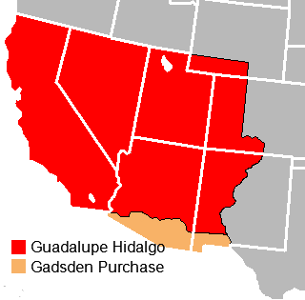
Lesson 3 Review Questions – (write answers in complete sentences on a piece of loose-leaf paper).

- Why didn’t John Slidell get the opportunity to negotiate with Mexico over Texas and California?
- Who was one of the 14 Whigs who voted no on the declaration of war with Mexico and who demanded to know if the Americans killed in April 1846 were killed north or south of the Rio Grande River?
- How was Chapultepec Castle similar to the Alamo?
- Grab a modern map - using the map of the Mexican Cession (to the right), name the modern day states that were created as a result (including parts of states).

Lesson 4 –

America Grows

Main Idea: After the war with Mexico, it would become clear that the newly acquired land would be beneficial yet controversial.

Wilmot Proviso
With the end of the Mexican War and the addition of the Mexican Cession, there were new problems. Sure, the United States was again a much bigger country. Regardless of how we got the new territory, it was now ours and its future became a big issue. As Americans moved west to settle there, what would happen when it came to slavery? Would the new lands develop into slave or free states? Opponents of the war argued that it was fought to extend slavery further to the west.

Even before the war was over, David Wilmot, a Democratic member of the House of Representatives introduced what is called the Wilmot Proviso. A proviso in this case is an attachment (or amendment) to other bills that were being written in Congress. The Wilmot Proviso called for making slavery illegal in any new territory acquired from Mexico. It never passed in Congress but it did succeed in becoming the founding principle of a new political party called the Free Soil Party.

The Election of 1848
With the war over and most of his goals achieved, President Polk kept his promise of only serving one term in Congress. In truth, he was exhausted. Polk worked hard as president, often working 16 hour days. He only spent 37 days out of the four years as president away from his desk. After leaving office, Polk lived just another 3 months, dying at age 53 – the youngest retired president to die.

Since there would be no incumbent, both political parties needed to find candidates. The Whig Party, who was last successful with a war hero candidate in William Henry Harrison, turned to another war hero. This time they selected General Zachary Taylor of Kentucky. Taylor had distinguished himself in the Mexican War. The only problem was that he had no political ambitions. He had never even voted in an election let alone run for public office.
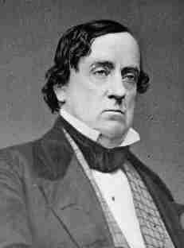
The Democrats chose Lewis Cass, Senator from Michigan. Cass had served as territorial governor of Michigan and had also been U.S. ambassador to France. Former president Martin Van Buren ran again, this time as a third party candidate for the Free Soil Party. Just like in the last election (1844), a third political party played in role in this election. The main issue was the expansion of slavery into the Mexican Cession.
Senator Lewis Cass
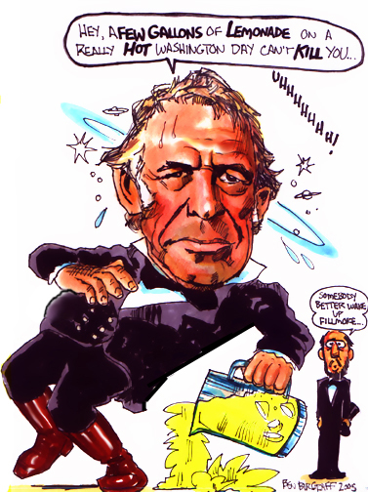
As its name implies, the Free Soil Party was in favor of keeping the territories of the Mexican Cession free of slavery. The Democrats and Senator Cass were in favor of allowing the people in the territories deciding the issue for themselves (something called popular sovereignty – a subject we’ll get into later). The Whig candidate, Taylor, said very little about his political opinions, but he was from Kentucky and he owned over 200 slaves.

Although the Free Soil Party didn’t win any electoral votes, they did gain 10% of the popular vote, enough to make a difference. Cass and the Democrats won 43% with Taylor and the Whigs getting 47%. Taylor won the majority of the electoral votes and became president. It’s too bad he didn’t even know he won. Back then, when you got mail, if the postage wasn’t already paid you had to go to the post office and pay for it yourself. Taylor had been getting all kinds of fan mail but he didn’t like paying for postage. So when the letter telling him he was elected came without postage, he never got it. It was only after a postage-paid letter arrived that he learned he was the next president.

President Taylor
Taylor turned out to be a president who didn’t really follow the examples of past presidents. That probably had something to do with the fact that he wasn’t even that much interested in the job when he got it. Once again the Whigs wound up with a president who didn’t follow their plans. They had thought the president would go along with their legislative agenda like creating a new national bank and restoring the protective tariff. They had thought wrong.

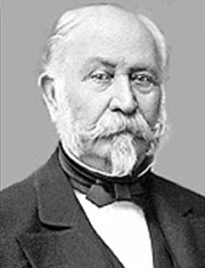
The last time the Whigs had a president elected he had died just 30 days after his inauguration. Taylor made it past 30 days but he wouldn’t make it past 16 months. Maybe the Whigs just had bad luck or maybe it was Harrison and Taylor who had bad luck. Nevertheless, Taylor didn’t really get much of a chance to do much as president. On July 4, 1850 Taylor laid the cornerstone for the Washington Monument. During the day’s celebration, Taylor was dressed in a thick suit with a stiff shirt even though it was a hot and humid day. Some feel that he may have suffered from heat stroke as a result. We do know that he consumed iced milk, cold cherries and pickles during the day and developed gastroenteritis. Whatever the actual cause, Taylor was dead by July 9. In 1991 medical examiners exhumed his body and performed an autopsy looking into an old rumor that he might have been poisoned. It turns out he wasn’t.

Gold Rush
We can’t finish learning about the 1840s without learning about the California Gold Rush. Before we get into this, you need to understand the concept of gold fever. It might sound like a physical illness but it’s not. If anything, gold fever is a mental illness. No, you won’t find it in any psychology book but it is real. Back in the middle of the 19th Century, much of continent was still relatively unexplored and a vast amount of resources were untapped. Gold had for centuries been a precious metal that was desired by human beings. Europeans in particular had always equated wealth with amounts of gold or silver. Think back to the reason why the Spanish Conquistadors had come to the New World. They weren’t here to kill Native Americans. They were here for gold and if it came to killing thousands of innocent people to get it, they didn’t really see that as a problem.
John Sutter

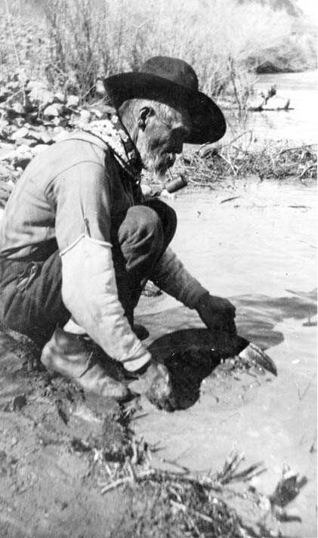
So, when people heard about gold being available in parts of the American frontier, they were willing to take great risks for the opportunity to get it. That’s really what gold fever is – risking your physical well-being for the chance to become rich. Some people would call it greed while others would say that it represents the American Dream of improving one’s livelihood. Regardless of what it is, gold fever caused thousands of Americans to move and it shaped the development of the American West.

In January 1848 John Sutter was building a lumber mill on the American River not too far from Sacramento, California. James Marshall was working for Sutter in building the mill. He found what was determined to be gold in the American River. Although Sutter tried to keep the find secret, word leaked out of the discovery at his mill. By August word of the find had reached newspapers in New York City. Gold fever instantly took hold as thousands of Americans began their trek to California. Many on the East Coast who could afford it booked passage on ships that sailed around South America to San Francisco. The population of San Francisco exploded by 250% in just two years. These people along with the thousands who came by land, were called forty-niners since many had traveled during 1849. (Now you know why they call San Francisco’s NFL team the 49ers).

John Sutter’s fears were fulfilled as his workers left to search for gold and people came to his land-claim ultimately stealing his crops and cattle. Unfortunately for all the people who came west for gold only a few people actually got rich. Most found it incredibly difficult to find enough gold to survive. Many people came to the areas around mining camps to make money selling the miners supplies. Hardware, restaurant, hotel and saloon owners knew that they could make money off the people who had headed off to dig or pan for gold.

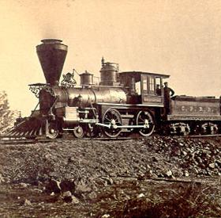
Gold miners came not only from the United States but from other parts of the world as well. Australians, Chinese, Latin Americans and Europeans all arrived hoping to strike it rich. By 1850 so many people had come to California that it had the necessary amount to apply for statehood. This territory which had been taken from Mexico as a result of the Treaty of Guadalupe-Hidalgo turned out to be worth much more that the United States had paid for it.

Transportation & Communication
Quick communication across vast distances had always been a problem. We know from our study of the War of 1812 that the whole war could have been avoided if the people involved had only posted on the Internet. Unfortunately that technology didn’t exist then. In fact, the best way to communicate across a long distance was by boat. That all changed when a portrait painter by the name of Samuel Morse decided to try his hand at electromagnetic communication.

Morse did not invent the technology for the telegraph, he just was the first person in the United States to make it practical. He was able to show that electric current traveled along a wire. His invention allowed that electrical current to be interrupted and he developed a code (Morse Code) to interpret that interruption. Since electrical current travels incredibly fast, this meant that communication across a great distance could be achieved. Within the next several decades, telegraph wire spread across the country. In the Mexican War the telegraph was used by the military for the first time. This allowed commanders to get orders to their soldiers in the field incredibly quickly. Improved communication helped the Americans win the war.

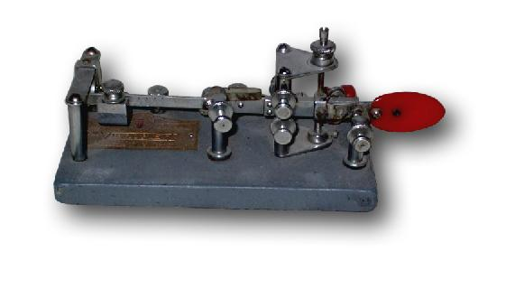
Improvements in transportation were also coming at a rapid pace. On the water, a new type of ship was being built. Clipper ships had narrow hulls and large, massive sails that allowed it to move through the water at a quicker pace. These faster ships cut the time it took to sail vast distances across the sea. Shortening the time for oceanic travel ultimately improved communication.

Transportation by land was improving all the time. The major development here dates back to the invention of the steam engine back in the 1700s. Most of the uses for the steam engine were for industry and this technology was perfected in England. British engine builders worked on creating a steam engine for transportation during the beginning of the 19th Century. By 1829 George Stephenson built a locomotive called The Rocket and it could travel up to 30 miles per hour.

In the United States during the 1820s and 1830s, John Stevens and Peter Cooper were the first Americans to employ steam power with a track system. Soon railroad tracks and trains were sprouting up all across the growing country. As technology improved transportation by rail became more reliable and faster. By the 1860s railroad travel had become commonplace and Chicago would become a center for both railroad and shipping traffic. Improvements in transportation and communication would help the young American economy to grow through the rest of the 19th Century.

Things are going to get interesting in 1850s. The nation will be poised on the brink of civil war. Unfortunately it will be impossible to avoid. America will begin to tear itself apart in the 1850s. You’ve just learned about the roots of that division.

Lesson 4 Review Questions – (write answers in complete sentences on a piece of loose-leaf paper).

    - What was the purpose of the Wilmot Proviso?
- What was the goal of the Free Soil Party?
- What did Samuel Morse do that radically improved communication?

Extra Credit Question (worth 10 points – answer in complete sentences on a piece of loose-leaf paper)

Choose one of the following options:

- The “Zero Year Curse” is mentioned on page 2. Do some research – what caused the deaths of each of these presidents?

- The section about the Mexican War on page 9 mentions “Los Ninos Héroes”. Do some research – why did these young men decide to fight to the last? Was there anyway that the Americans could have avoided this? Why are they memorialized in Mexico today?

- What is the real story behind the discovery of gold at John Sutter’s lumber mill? Do some research – how did word get out about the finding of gold? What ultimately happened to John Sutter?

- Peter Cooper is mentioned on page 13 about railroad development. Do some research – what was the story behind the Tom Thumb – Cooper’s steam locomotive?

Timeline of Events

1841 | - William Henry Harrison becomes the 9th U.S. President then dies 30 days later.  - John Tyler becomes the 10th U.S. President taking over for Harrison.
1845 | - James K. Polk becomes the 11th U.S. President after winning the Election of 1844 as a dark horse candidate.  - Texas is annexed to the United States – becomes a state  - Oregon boundary dispute settled with Great Britain
1846 | - U.S. declares war on Mexico  - Bear Flag Republic established in California  - Wilmot Proviso attempted to ban slavery in new territories
1848 | - Treaty of Guadalupe-Hidalgo ends war with Mexico – U.S. gets the Mexican Cession  - Gold is discovered near John Sutter’s mill near Sacramento, California
1849 | - Zachary Taylor defeats Lewis Cass to become the 12th U.S. President.  - Population of California soars as forty-niners rush to find gold
1850 | - Zachary Taylor dies of gastroenteritis  - California applies for statehood

pneumonia: An acute or chronic disease marked by inflammation of the lungs and caused by viruses, bacteria, or other microorganisms and sometimes by physical and chemical irritants

