Chapter 9 – American Movements – Mid 19th Century

Introduction
There are a number of events and people that we need to be aware of because of how they impact our nation’s history in the middle of the 19th Century. We may have touched on a few of these things in previous readings; however, this is a chance to go a little deeper into some very important topics. The bottom line is that these people and the events that surrounded them helped make our country what it is today. That is why we are learning about them.

Lesson 1 –

Religion & Alcohol

Main Idea: A new form of Christianity developed in the United States causing controversy. Growing concern over alcohol consumption became a political movement.

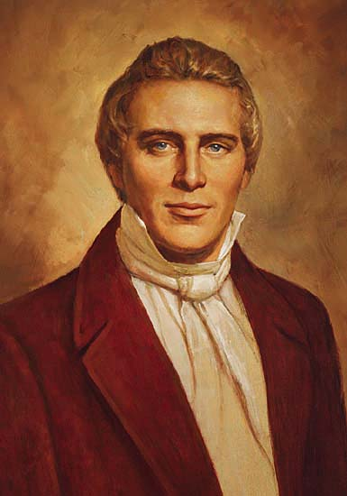
Mormonism
Joseph Smith
Religion has always played an important role in the lives of Americans. The freedom of religion outlined in the First Amendment has become a core value in our culture. During the course of the 19th Century there have been a number of religious movements. And as we’ll see, these movements are often connected to other reform movements. But one 19th Century religious movement became responsible for the settlement of a vast area out west. Mormonism began in upstate New York by Joseph Smith in 1830.

Smith said he was visited by an angel who revealed to him the Book of Mormon, a lost book of the Bible that told of a group of Hebrews who had traveled to the Americas many years ago and who had been visited by Jesus. He translated the book and attracted a small group of followers. This was the foundation of the Church of Jesus Christ of Latter-Day Saints. Because the name is so long, most people refer to the group as Mormons after the name of their holy book.

Some of the teachings of this religion caused some problems. First of all, the followers of this new, Christian-based religion believed in developing a very close-knit society where religion and government were the same. They practiced the communal ownership of land and shared the profits of their work with each other. Although this might not sound like too much of a problem, because of their desire to convert outsiders to their beliefs, they may have rubbed some people the wrong way. The Mormons wanted to create a utopian society where everything within their community was perfect and everything outside was wrong. But perhaps the most morally troubling part of Smith’s beliefs for outsiders was the practice of polygamy. The practice of having multiple wives just didn’t sit well with most Americans.

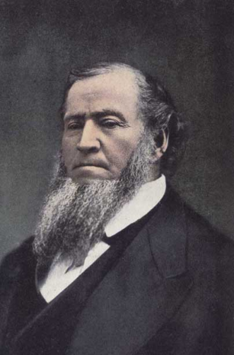
As a result, the Mormons found themselves continually on the move, yet they continued to grow in numbers. From New York, they moved to Ohio. Smith and his followers lasted only a few years there before being chased out. It was then that the Mormons moved to Independence, Missouri where they planned the building a permanent community. But again, violent conflicts with neighbors caused Missouri’s governor to order the Mormons to leave and charged Smith with treason. From here the Mormons regrouped in Illinois on the banks of the Mississippi River. They were granted a charter by the state of Illinois to build the town of Nauvoo. A temple was built and again their community continued to grow. In fact, Nauvoo had the biggest population of any city in Illinois by 1844.
Brigham Young
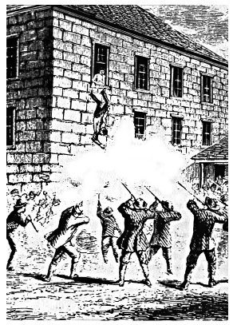
The death of Joseph Smith – a mob shoots him as he falls from the second-floor window of the jail.
It was in 1844 that Smith began losing the support of some of his followers. He made some controversial and unpopular decisions such as declaring himself a candidate for president. As mayor of Nauvoo, his city council ordered the destruction of a printing press run by a paper critical of Smith’s leadership. Charges were brought against him by outsiders and he was accused again of treason – planning violence against the people of Illinois. In June 1844 he turned himself in to officials in near-by Carthage, Illinois. A mob of nearly 200 stormed the jail where he was being held and shot him to death.

Ultimately the Mormons were forced to leave Nauvoo. After some wrangling over whom would lead them, Brigham Young became the new Mormon leader and brought the community to what would later become Utah but at the time was part of Mexico. There they founded Salt Lake City on the shore of the Great Salt Lake. As Utah became a U.S. Territory following the Mexican War, Young was replaced by a non-Mormon governor because of the open practice of polygamy by the church. Despite Young’s removal from political power, he remained very powerful as the head of the church because of the large number of Mormons living in Utah. Eventually, the Mormons abandoned polygamy or plural marriage and the relationship of the Mormon community and the Utah Territory improved with the United States. Today there are approximately 13 million members of the Church of Jesus Christ of Latter-Day Saints.

The Temperance Movement
There is a long history in this country when it comes to alcohol. The consumption of alcohol and the social problems attributed to it has been hotly debated since the time of the Founding Fathers. But before we can even discuss those problems, we need to understand how and why the use of alcohol had become so prevalent in American society.

You are probably aware by now of how dangerous it was to live in the 19th Century. We’ve learned about how people died from all kinds of illness. One of the most common ways to contract a deadly illness was through drinking water. The technology that we enjoy today was not available back then and if the drinking water was bad, there was a good chance that it could cause some really bad things to happen. Heck, even drinking milk had its drawbacks. Just ask Abraham Lincoln about that. His poor mother died from the “milk sickness”. As a result, it became more common for people, young and old, to consume alcohol. The brewing of beer dates all the way back to the ancient Egyptians. That process eliminates the disease that could come from drinking the water. That’s why people, even kids, drank beer as a way to refresh themselves.

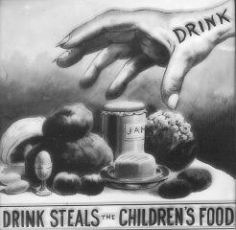
Now before you get all excited and run off to tell your parents that you’re going to start drinking beer because it’s healthy, you should also be aware of the problems that all of this caused. With so many people drinking, there were bound to be health and social problems. First of all, you need to be aware that alcohol is essentially toxic when it enters your body. Consumption of too much alcohol will kill you. Your body has a filtration system to eliminate any toxins – your liver is the biggest internal organ you have, and its job is to do just that. Over time, your filtration system can do only so much and if it fails, you will die. Also, alcohol is shown to affect the central nervous system and kills brain cells. This often causes poor judgment and leads to all of those social problems.

Addiction of alcohol or alcoholism slowly destroys the body and as you’re probably aware, causes terrible problems for families. Spousal and child abuse can often occur as a result of this. People lose their jobs and all sorts of terrible things can happen. So, this is why so many people in the 19th Century and early 20th Century were concerned. As a result, the temperance movement was formed.

The early temperance movement wanted people to drink in moderation. They wanted to educate people as to the evils of consuming too much alcohol. In 1826 the American Temperance Society was formed. But by the 1830s and 1840s many people believed that the only way to stop these problems was through abstinence. So, the movement switched to pushing for the prohibition of alcohol. This movement was soon connected with religious groups and they made efforts to politically pressure government officials to ban the sale of alcohol.

In 1851, Maine passed a law prohibited the sale of alcohol except for medicinal purposes. It was so successful that by 1855 there were a total of 13 “dry” states with a ban on alcohol. The remaining states were considered “wet” states. Obviously, these laws were not popular with everybody, especially many working-class people. The temperance movement’s successes were interrupted by the Civil War but their motivation for a nationwide ban continued and finally reached achievement with the passage of the 18th Amendment – but we’ll get back to that when we cover the 20th Century.

Lesson 1 Review Questions – (write answers in complete sentences on a piece of loose-leaf paper).

- Why was the Church of Jesus Christ of Latter Day Saints so controversial?
- Why did so many people, including kids, drink beer?
- What is the difference between temperance and abstinence? Why did states begin the prohibition of alcohol?

Lesson 2 –

The Movement to End Slavery

Main Idea: The idea of slavery in a country that professed “All men are created equal…” was hypocritical. As the 19th Century wore on, opposition to slavery became a growing political movement.

Abolitionism
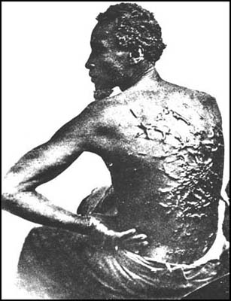
You’re probably thinking right now that you already know about abolition. You know that the abolition movement of the 19th Century was all about abolishing slavery. You know that basically there were two schools of thought when it came to this – immediate abolition: all slavery is ended in the United States right now; and gradual abolition: stop the spread of slavery in the new territories. But there are some things you might not be completely knowledgeable about and that’s what we’re going to try to cure with this section.

The first thing that I want you to be sure to do is to not confuse the slavery issue with the concept of racism. Slavery is fundamentally an economic issue. People who owned slaves, did so because slaves were the most cost-effective means of running their businesses. Slaves are not paid a wage but instead must be cared for in terms of the basic necessities of life – food, clothing and shelter. How much a slave owner wants to invest in those things are up to him. Does racism play a role in slavery? Of course, it does. People of African ancestry were slaves. You can’t ignore that.
Scars from severe whipping are evident on the back of this slave.

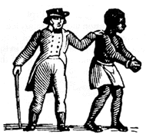
What most people don’t really understand when it comes to this issue is that in terms of racism, most Northerners were incredibly racist when compared to the people of the South. That might seem like a ridiculous statement but it’s pretty accurate. The reason for this is that people in the North didn’t really come in contact with black people very often. It was common for people in both the North and the South and in other parts of the world to believe that people of European ancestry were superior to Africans and the rest of the world. The logic for such thinking comes from the technological dominance of Europeans (and Americans) over the rest of the world. So, it’s pretty easy to see how people in the North assumed that blacks could never be their equals and that way most people there treated African Americans when they came in contact with them.

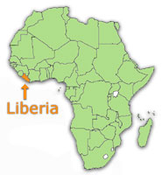
So, what about the people in the South and how could you ever claim that they weren’t as racist as the people in the North? Southerners were very familiar with black people. Of course, the majority of southern whites who owned slaves were racist – they were slave owners for goodness sake! But because they actually knew them, grew up with them, often times worked side-by-side with them, they developed relationships with them that were far more civil than one might think. Treatment of slaves varied from owner to owner but because many Southerners grew up with black people as part of their lives, they most definitely weren’t as hostile as many Northerners were. But weren’t some slaves beaten, whipped and even killed? Yes, they were, and families could be broken up at the whim of their owner. Essentially slavery is a very de-humanizing thing, and no one today would disagree with that statement. What I want you to know, however, is that geographically, because there were so many blacks living as slaves in the South and playing vital roles in the lives of southern whites, their treatment at the hands of those white people was more likely not as bad as it would be by people in the North.

Now obviously there were people in the North (most likely abolitionists) who treated blacks fairly and without contempt. But even within the abolitionist community there was a strong call for the ending of the slave issue by “returning them to Africa.” This was known as the Colonization Movement. The American Colonization Society was created by abolitionists in New England in 1817. The idea was that slaves would be gradually freed and then sent to the colony of Liberia, a colony that was created on the west coast of Africa specifically for former American slaves.

The attraction of the colonization idea was that blacks would be leaving the country and therefore that would eliminate the racism problem. In other words, slavery was a bad thing and we should get rid of it, but we didn’t want to live with black people once they were free. That idea is obviously racist. There was a bigger problem, however. The idea of sending them “back to Africa” was ridiculous. That’s because these slaves had most likely been living in the United States for generations. They were essentially Americans. In my background, I have both German and Portuguese ancestry. These distant relatives are at least a couple of generations in the past. Would I want to “go back” to Europe? No way! Heck, I’ve never even been there for vacation. I don’t speak either language and would have a very difficult time adjusting to a new culture. So, I can completely understand why only about 1,400 African Americans moved to Liberia back at this time. These people didn’t want to have to move thousands of miles away. They just wanted those things that every American takes for granted today – the right to live free and enjoy those basic rights guaranteed in the Constitution.

Famous Abolitionists
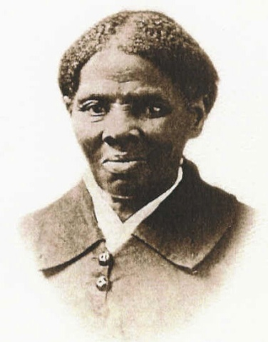
Again, you are probably already familiar with some of the most famous of the abolition movement. We learned about William Lloyd Garrison and his abolitionist newspaper The Liberator. You should remember the role of former president John Quincy Adams in the case of the Amistad. But there are others that you should know as well. Odds are that you’ve probably heard of these people, but now we’re going to go a little deeper into their backgrounds and how they played an important role in American history.

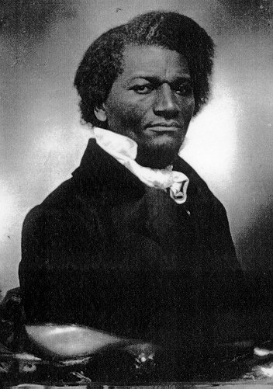
We’ll start first with Harriet Tubman. She was a slave born sometime around 1822 in Maryland. As a young girl she was hired out to other masters and while in her teens, she was almost killed when she was hit in the head by an overseer who was trying to capture a runaway slave. In 1849 her owner died, and his wife was in need of paying off debts. So, to ease those debts she planned on selling off some of her slaves. One of the biggest fears of slaves living in the “border states” (those states close to the North) was being sold “down the river” meaning to big plantations in the Deep South. So, Harriet Tubman escaped to the North.
Harriet Tubman

Tubman was assisted by members of the Underground Railroad. Subsequently she made numerous trips back to Maryland to help others, including her family members escape via the Underground Railroad. She was so well respected by abolitionists that she was called “Moses” for risking her life and freedom by returning south to save others. She even worked as a spy for the Union government during the Civil War and actually led a military operation when she helped free more than 750 slaves. She lived to be 91 and is still honored on every March 10 – the day of her death in 1913. (U.S. Congress 1990).
Frederick Douglass

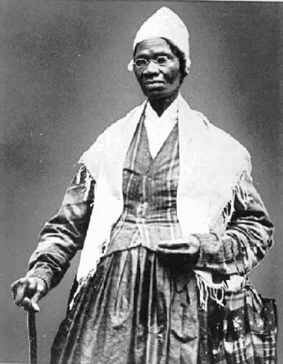
You can’t really have a good understanding about abolitionism or even race relations in the United States in the mid- 19th Century without knowing about Frederick Douglass. Like Harriet Tubman, Douglass was born a slave in Maryland but in 1818. It is possible his father was a white man but that never was proven. What we do know is that his mother died when he was 7 years old and that he was the property of a few different owners. When he was 12, the wife of his owner broke the law by teaching him a few letters of the alphabet. From there, Frederick Douglass was able to teach himself how to read. Eventually he was in the care of a violent slave-owner who beat him regularly until, at age 16, Douglass fought back and was never hassled again.

Finally, in September 1838, Frederick Douglass was able to escape North, eventually arriving in New York just 24 hours after making his break. After this Douglass became a member of several abolitionist groups and began making speeches about his own experiences as a slave. Audiences were shocked that this young, black man could deliver such powerful, articulate speeches. By the age of 27 he wrote the first of three autobiographies, Narrative of the Life of Frederick Douglass, an American Slave. It was his most successful book, but skeptics thought that there was no way that a former slave could have written so eloquently.
Sojourner Truth

Douglass traveled extensively, even going to Europe to further the abolitionist cause. He was one of the best-known abolitionists in the United States and had a great deal of influence within that group. John Brown sought his approval before launching his ill-fated slave rebellion with the seizure of the federal arsenal at Harpers Ferry, Virginia. Douglass was impressed with Brown’s dedication to the cause, but felt the idea was a bad one – one that would anger all of the United States.

Frederick Douglass went on to champion the cause of civil rights for former slaves after the Emancipation Proclamation. He also was an outspoken supporter of women’s rights and called for women to receive the right to vote. He became the most widely recognized African American of the middle to late 19th Century. Douglass held government positions and continued to work for improved conditions for black Americans throughout his lifetime.

Another important abolitionist to remember is Sojourner Truth. She was born a slave in New York as Isabella Baumfree in 1797. When the state of New York abolished slavery in 1827, she became free. While living with a Quaker family she had a life-changing, religious experience that converted her to a devout Christian. In June 1843 she changed her name to Sojourner Truth and joined an abolitionist group, making speeches against slavery and in favor of women’s rights. You should keep in mind that this was a time when women weren’t supposed to be speaking publically about political issues. So, when she was speaking she had to overcome two prejudices, racism and sexism. Her ability to get her point across was fantastic and soon the people listening to her speak often overlooked the fact that she was black and a woman.

Truth’s most famous speech came in 1851 at the Ohio Women’s Rights Convention called “Ain’t I a Woman?” Here’s a bit from that speech:

…That man over there says that women need to be helped into carriages, and lifted over ditches, and to have the best place everywhere. Nobody ever helps me into carriages, or over mud-puddles, or gives me any best place! And ain't I a woman? Look at me! Look at my arm! I have ploughed and planted, and gathered into barns, and no man could head me! And ain't I a woman? I could work as much and eat as much as a man - when I could get it - and bear the lash as well! And ain't I a woman? I have borne thirteen children, and seen most all sold off to slavery, and when I cried out with my mother's grief, none but Jesus heard me! And ain't I a woman? …Then that little man in black there, he says women can't have as much rights as men, 'cause Christ wasn't a woman! Where did your Christ come from? Where did your Christ come from? From God and a woman! Man had nothing to do with Him.

Her life, like so many, was dedicated to achieving equal rights for all people. Truth will always be remembered as a person who would not tolerate injustice be it racist, sexist or intolerance of religion.

Review Questions – (write answers in complete sentences on a piece of loose-leaf paper).
- Why was the North considered far more racist compared to the people of the South?
- Why was the goal of sending blacks “back to Africa” impractical?
- Besides being known as an abolitionist and champion of civil rights for former slaves, what other cause did Frederick Douglass support?

Lesson 3 –

Women’s Rights

Main Idea: Many of these reform movements had supporters that crossed over – and at the center of most were women. The push for equal rights for women was usually at the center of 19th Century Reform.

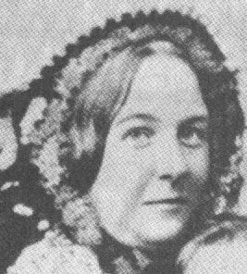
We’ve already talked about Sojourner Truth who fought for abolition as well as equal rights for women. What you should notice is that there is a connection between many of these 19th Century reform movements. The struggle for women’s rights in the United States goes all the way back to the creation of the country. Abigail Adams, the wife of revolutionary John Adams, pressed her husband to do what he could to incorporate women into the political process. She was in every way his intellectual equal but she and every other woman in America was denied equality.

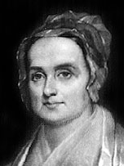
Again, you have to try to think about what life was like back then. Socially, women were not expected to do what they do today. A woman’s place in the middle 19th Century was supposed to be in the home. Women were not expected to speak publicly or even think about the way things were run. That was supposed to be a man’s job. A woman who acted differently was looked down upon. But that’s the case whenever anybody goes against the norm. You already know how that works just in your daily lives. Anytime anybody does something differently or acts differently, usually that person gets ridiculed. It’s not right but that’s just the way things are. It’s a reaction of ignorance. Whenever people see something they don’t understand, it’s their natural reaction to make fun of it or belittle the people who are doing it. Something you may want to remember is that the people who do act differently or challenge the norm to make things better, are the people who are often times remembered as great individuals. Think about that the next time you feel the desire to make fun of someone.
Elizabeth Cady Stanton

Let’s get back to women’s rights. As already stated, there is a connection between people who favored this and abolition (as well as temperance, religious tolerance, etc.) A perfect example of this is the story of two great women involved in the women’s rights movement. Lucretia Mott was an abolitionist who went to London, England in 1840 to attend an international convention against slavery. While she was there she met Elizabeth Cady Stanton, who was traveling with her husband, a delegate to the convention. The two of them discovered that they had some things in common. They both were against slavery and neither one of them could attend the convention. The reason, you ask? Women were not allowed to attend.

These women were furious about that and decided that they needed to do something about it. The result of their anger turned out to be the 1848 Seneca Falls Convention held in western New York. The official purpose of the convention was “to discuss the social, civil, and religious rights of women.” More than 300 men and women attended this convention (including Frederick Douglass) and they came out with some pretty good ideas.

The primary result of the convention was a document called the Declaration of Sentiments. It was based on Thomas Jefferson’s Declaration of Independence. A subtle difference is that this document stated, “All men and women are created equal.” The basic theme throughout the Declaration of Sentiments is that women, making up one-half the number of people in this country, lacked the right to vote and therefore their rights were not being protected by the government. This document became the foundation for the women’s rights movement beyond the 19th Century. It would give rise to the women’s suffrage movement in the United States – a movement that would finally achieve its goal in the 20th Century.
Lucretia Mott
Review Questions – (write answers in complete sentences on a piece of loose-leaf paper).
- Why were women who demanded equal rights looked down upon by many people?
- What was hypocritical about the 1840 London Antislavery Convention?
- Why do you think it was important that men played a big part of the Seneca Falls Convention?

Lesson 4 –

Reform Movements

Main Idea: To understand our society today, we need to look at how some of our basic institutions became what they are today.

Education Reform
You go to school. Well, duh – if you didn’t, then you wouldn’t be reading this. Odds are that you’d rather not be reading this and not going to school. Too bad! Get over it! Maybe when you’re done reading this section you’ll have a little more appreciation for your education. Regardless, let’s get to the heart of the matter. In the 19th Century in the United States, very few people had the opportunity that you have – attending a public school. A public school is one that is funded by taxpayer dollars. The students attending don’t have to pay a tuition fee. Instead, they can attend for free (minus some small expenses for gym clothes, assignment books, etc.)

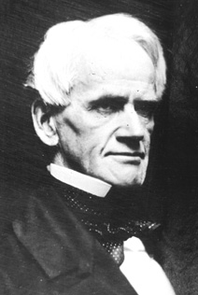
Big deal, you say? Well, actually it is. Most people who went to school were the children of wealthy families. As a result, they were able to use this education to continue to hold a job or position that would allow them to continue to be wealthy. Poor people couldn’t afford to go to school and their children would continue to be poor because they lacked the skills necessary to make a lot of money. So as a result, you have a privileged class within society that is small but controls the wealth. Many people are uneducated and can’t even read.

There was a group of people in this time period that saw this as a recipe for disaster down the road. Eventually, they argued, there could be big problems – violent revolution, economic disaster – as the principles of our democratic republic are forgotten. One of these reformers was Horace Mann of Massachusetts. The state of Massachusetts was the first to provide public schools. The idea goes back to the time of the Puritans in Massachusetts, who believed that children needed to be educated in order to read the Bible. By the 19th Century, the public-school system in Massachusetts needed some work. Horace Mann was one of those people to set about fixing things.
Horace Mann

Mann was a member of the Massachusetts state legislature. He became a key figure in the creation of the first state board of education in the country. After this, he became the secretary of the Massachusetts Board of Education – in other words, the guy in charge. He made it his goal to organize the entire school system in the entire state. He helped create university programs for teacher training. Mann argued for the creation of a “common school” – what we consider to be today’s public school. It should be supported by the community and attended by all people regardless of race or gender. Today that sounds normal, but back then it was a radical idea.

These ideas were quickly adopted by a number of Northeastern states. It would take a while for them to spread westward and southward. In fact, as we look at the South it’s important to remember that southern society was more like the old European society of past generations. A small ruling class of wealthy planters controlled politics. Because they were the only ones with a private education, they were able to maintain control over an uneducated minority. Why did the minority – those poor and middle-class farmers, allow this? Most likely they accepted this because they hoped to achieve someday, the status of those wealthy few. And maybe they accepted this because this is the way things always were. Just remember that the changes in education in the Northeastern part of the country was another example of how there was a growing division in our country – and this had nothing to do with slavery. We were dividing into two very different societies in the North and South.

Prison Reform
The topic of reforming our nation’s prisons has been around since the time of the middle 19th Century. The debate over what should constitute punishment in this country goes back to the passage of the Eighth Amendment which forbids cruel and unusual punishments. To understand things better, we need to have some insight into what life was like back then when the law was broken.

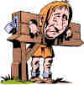
Punishments were harsh. The death sentence was common for serious crimes. Today we would associate that with murder, but death was a sentence that was handed out for other serious crimes as well. Other offenses could bring about public floggings and branding. If you’re not sure what this means, it involves the whipping of convicts or taking a red-hot branding iron and burning a symbol representing the crime into a person’s skin. Jails were reserved for people waiting their punishments and more times than not that meant absolutely horrible conditions. People who owed money (debtors) were also sent to prison but were charged for food and lodging. That doesn’t make sense, now does it? How are you supposed to pay for prison if you couldn’t even pay off a debt? If you didn’t have someone like a relative to help you out, there was a very good chance you could die in prison. With the conditions the way they were, that wasn’t all that unlikely.

During the mid-19th Century ideas on punishment began to change. The idea of rehabilitation became popular. Supporters of this idea felt that criminals could change their ways by working hard and being socially isolated from other prisoners. Also, the idea of the courts declaring innocence by reason of insanity was first introduced. One of the earliest cases involved an assassination attempt on President Andrew Jackson’s life. The would-be assassin, Richard Lawrence was a delusional Englishman who tried to kill Jackson because the president had essentially done away with the Second Bank of the United States. Lawrence claimed that this caused him to lose the money he needed to be the King of England. The court declared him insane and sent him to a mental asylum. Speaking of mental health…

Reform for the Disabled
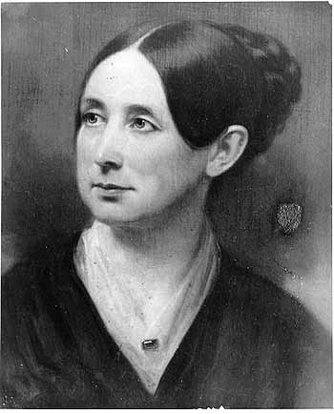
Another problem with the prison system was that it was also used as a method to handle people who were mentally ill. In Massachusetts, Dorothea Dix, a former school teacher had volunteered to help women in a state prison. When she was there she was horrified to discover that mentally ill people were there and being treated terribly. She began a crusade to see treatment for these people improve. Dix made a report to the Massachusetts legislature that resulted in expanded state mental health care facilities.

Dorothea Dix traveled extensively across the country calling for reform for the mentally ill. Her efforts resulted in similar state-sponsored institutional care for the mentally ill in a number of different states. Thomas Gallaudet helped deaf Americans when he opened a school for the deaf in 1817 in Connecticut. Samuel Howe was the director of the first school for the blind in 1832 in Boston, Massachusetts. The efforts of people like Dix, Gallaudet and Howe helped to bring about better conditions for disabled Americans.
Dorothea Dix

Review Questions – (write answers in complete sentences on a piece of loose-leaf paper).
- Why was the development of public schools such a big deal?
- What was rehabilitation and how was it different than simply punishing a person?
- What did Dorothea Dix do that improved conditions for mentally ill people?

Lesson 5 –

Developing an American Culture

Main Idea: The foundations of American Society and Culture were formed in the 19th Century.

Transcendentalism & Individualism
The title for this section sure sounds like a mouthful. In fact, we could go on and on about these concepts forever. That’s because what this is about is philosophy. They also have to do with religion. What is at stake here is the creation of a unique, American identity and culture. You have to keep in mind that our country in the 19th Century was still very young. We started out as colonies of the Old World and when it came to the way we thought, read, created art and even prayed, we found ourselves still tied to those Old-World ways. What we’re talking about here is breaking out of that format and creating something that was distinctively our own. If we had done it politically (e.g. the American Revolution), then we could do it in other areas.

Let’s start with Transcendentalism. There’s a lot to this but I’ll stick to just some of the basics. It deals with a new way of looking at things religiously and spiritually. The Enlightenment – that period in the 18th Century that emphasized the scientific method and was sometimes referred to as the Age of Reason – brought about all kinds of new ideas. Many of the Founding Fathers got their ideas for government from European thinkers from this period. Transcendentalism was a break from this with an emphasis on nature and human intuition. This is also a religious break from the Protestant Christianity that dominated during the foundation of this New World in America. Transcendentalism was about God’s gift of human inspiration and insight.
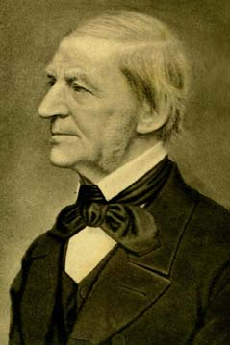
You might be a bit confused, but it’s not all that difficult to understand. It’s kind of like trusting your conscience to guide you. The idea is that you make your decisions based on this sort of “gut instinct” rather than on what science or even religion tells you are correct. Obviously, there’s way more to it than that but this will do for now. You’ll learn more about it in high school and college.
Ralph Waldo Emerson

One of the most well known, Transcendentalists of the period was Ralph Waldo Emerson. He was born the son of a Boston minister in 1803 and attended Harvard. Emerson attended the Harvard Divinity School but eventually broke with the traditional Christian theology. Through his published works such as Nature and Self-Reliance, Emerson believed that man must see things for himself rather than trust things established by others. He was influenced by the recent (at the time) translations of Hindu and Buddhist texts. In terms of religion, God was to be found within everything and everyone. Emerson felt one must believe in one’s self and trust your inner instincts. This is the foundation for Individualism. For Emerson, there could be no conformity to anything. Man must live by his individual choices and those should not be determined by outside forces whether that be society, religion or even government. In Self-Reliance Emerson writes:

Trust thyself: every heart vibrates to that iron string. Accept the place the divine providence has found for you… Great men have always done so, and confided themselves childlike to the genius of their age, betraying their perception that the absolutely trustworthy was seated at their heart, working through their hands, predominating in all their being.

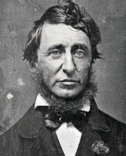
Emerson influenced a number of American thinkers and writers of the middle 19th Century. You should be familiar with one of those by the name of Henry David Thoreau. He is best known for a book he wrote called Walden. For a period of about two years, he lived on his own, in a small cabin on the shore of Walden Pond just outside of Concord, Massachusetts. The property that Thoreau lived on was actually owned by Emerson. During his stay at Walden Pond, Thoreau wrote about his experiences there as well as his own take on Individualism. He writes of a natural religion that is central to Transcendentalism. Walden is filled with criticism of the modern world and society. He states:
Henry David Thoreau

Most of the luxuries, and many of the so-called comforts of life, are not only not indispensable, but positive hindrances to the elevation of mankind. With respect to luxuries and comforts, the wisest have ever lived a more simple and meager life than the poor.

In explaining why he went to live this way, Thoreau states:

I went to the woods because I wished to live deliberately, to front only the essential facts of life, and see if I could not learn what it had to teach, and not, when I came to die, discover that I had not lived. I did not wish to live what was not life, living is so dear; nor did I wish to practice resignation, unless it was quite necessary.
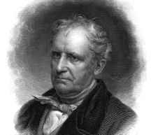
Henry David Thoreau was also the kind of person who acted on what he believed in. In July 1846, he refused to pay taxes he owed because of his opposition to the Mexican War. He went to jail and although he refused to pay, he was bailed out by a relative. Thoreau believed in civil disobedience – he even wrote an essay called On the Duty of Civil Disobedience. What this means is the refusal to obey laws that you feel are unjust or immoral. As an opponent of the war with Mexico, Thoreau refused to pay his taxes and was willing to accept his punishment. Acts of civil disobedience are acts of nonviolence intended to demonstrate how the government’s actions are unfair. But to truly follow through, one has to be willing to accept the consequences and that is never easy. Following upon the Individualist theme of living by your own conscience, Thoreau believed that you had a moral responsibility to disobey anything that was against your moral beliefs. This idea became the central theme for such 20th Century reformers as Mohandas Gandhi in India and Martin Luther King, Jr. in the American Civil Rights movement.
James Fennimore Cooper

The writings of Emerson and Thoreau were unique to American literature. Their philosophy or beliefs became the core of a new American culture. Their ideas may have been radical, but they gave us an identity as a nation of individuals. One could argue that this is true today. It is our individualism, our ability to question things that are happening around us and criticize things we disagree with that makes us a strong and vibrant republic.

Literature and Art
Since we’re on the subject, let’s talk a little more about literature. For years, Americans had an inferiority complex when it came to literature. The best writing, of course, came from Europe. That belief was the same when it came to art. As writers and artists, Americans needed to find their own identities separate from what was happening in Europe. In the early part of the 19th Century that began with writers like Washington Irving and James Fennimore Cooper. Irving wrote Rip Van Winkle and The Legend of Sleepy Hollow. These stories are still well-known today. Cooper wrote a collection of novels called The Leatherstocking Tales which included The Deerslayer and The Last of the Mohicans. They are excellent books that criticize the advance of society upon nature and the conflict with Native Americans. Irving’s and Cooper’s works were widely read in Europe and set a standard for American writing.
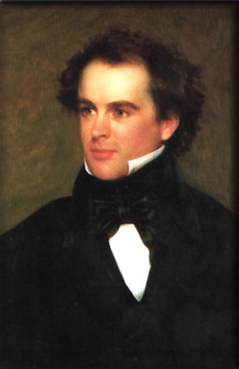
Nathaniel Hawthorne
Other writers of the middle 19th Century solidified America’s influence in the world of literature. Herman Melville wrote Moby Dick, a story about a man’s obsession with a whale that had nearly killed him. His book wasn’t even popular when he wrote it, but over time has come to be considered one of the greatest works of American literature. Nathaniel Hawthorne was fascinated with his Puritan ancestry and wrote books such as The Scarlet Letter and The House of the Seven Gables. In these books, there is a connection to the ideas of Emerson and Thoreau as Hawthorne is critical of the rigid beliefs of the Puritans.

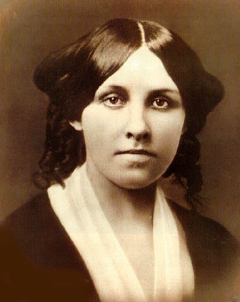
Louisa May Alcott was a famous author of the period. Her father was a friend of both Emerson and Thoreau and she was even taught writing by Hawthorne. Alcott wrote Little Women, a book based upon her life growing up with her three sisters in Concord, Massachusetts. The book is about overcoming character flaws as girls become women. It has become a classic of American literature.
Louisa May Alcott
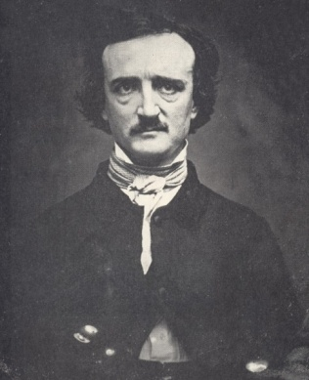
Another author of the period was Edgar Allan Poe. He is best known for his short stories, poems and mysteries. Poe’s writing was considered macabre and his influence on today’s writers is huge. He is even credited with being one of the earliest science fiction writers. But people who have read his work recognize him for its horrific nature. You will probably read stories The Tell-Tale Heart, The Cask of Amontillado, or the poem The Raven. If you do a little research, you’ll find that his life was pretty odd as well.
Edgar Allan Poe

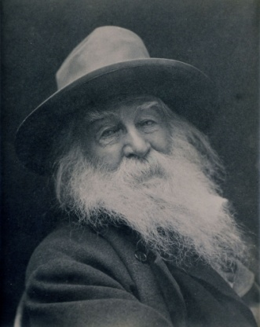
We can’t overlook the development of American poetry either. Henry Wadsworth Longfellow wrote classic poems such as The Midnight Ride of Paul Revere and The Song of Hiawatha. These poems gave us a national identity with a connection to our past. And when discussing poetry of the mid-19th Century in America you shouldn’t overlook Walt Whitman. Whitman wrote a collection of poetry called Leaves of Grass. During the Civil War, Whitman wrote another collection known as Drum Taps.
Walt Whitman

Perhaps the best-known poet of the time was Emily Dickenson. She is considered by some to be the greatest American poet ever. The ironic thing is that most of her poems remained unpublished at the time of her death. It was only after her death in 1886 that people finally learned of her brilliance.
When it came to art and music, trends were developing that again helped to create a unique American cultural identity. Going along with the Transcendentalist emphasis on nature, the Hudson River School of art painted primarily beautiful American landscape scenes. In music, we begin to see the roots of what we consider American music today in the form of Negro Spirituals. This form of music was developed by African American slaves and focused on religious themes.
Emily Dickenson

One of the best-known songwriters of the period was Stephen Foster. You’ve probably even heard his music and didn’t even know it. He wrote songs like “Camptown Races”, “Oh! Susanna”, and “Old Folks at Home” (Swanee River). Those songs are considered American classics and I’m pretty sure you’ve heard them before.

Review Questions – (write answers in complete sentences on a piece of loose-leaf paper).
- According to Ralph Waldo Emerson, where could God be found?
- Henry David Thoreau clearly believed in civil disobedience. What issue was he very upset with and what did he do (or not do)?
- If you had read something from one of the writers listed above, which writer would you choose and why?

Conclusion
There’s some pretty heavy stuff here. The purpose of introducing you to it was to make you aware of what American life was like in the middle 19th Century. In the future you will probably learn about these things in more detail. But what is really important is that you get a little understanding about how these things have influenced our nation and made it what it is today.

Extra Credit Question (worth 10 points – answer in complete sentences on a piece of loose-leaf paper)

Choose one of the following options:

- On the bookshelves near the windows are a number of books. Look for A History of US – Volume 5 – Liberty for All? – Read Chapter 18 (on pages 107 to 111). The chapter is about American cities and progress in the 19th Century. Explain how today’s cities are different and similar to the cities described by the author.

- Pages 12 to 14 deal with Literature and Art in the Mid 19th Century in America. Many works of literature have been turned into films over the course of the 20th Century. Pick one that is based on one of those books (try using www.imdb.com for help) and do a movie review.

Timeline of Events

1817 | - American Colonization Society founded  - Thomas Gallaudet opens a school for the deaf in Connecticut
1820 | - Washington Irving publishes The Legend of Sleepy Hallow
1826 | - American Temperance Union formed  - James Fennimore Cooper publishes The Last of the Mohicans
1830 | - Joseph Smith founds the Church of Jesus Christ of Later Day Saints
1832 | - Samuel Howe opens a school for the blind in Boston, Massachusetts
1837 | - Horace Mann appointed secretary of Massachusetts Board of Education
1838 | - Frederick Douglass escapes slavery
1840 | - Dorothea Dix begins an investigation into how Massachusetts cared for the insane poor of the state
1841 | - Ralph Waldo Emerson publishes Self-Reliance
1845 | - Edgar Allan Poe publishes The Raven
1846 | - Henry David Thoreau refuses to pay his taxes in protest over the government’s War with Mexico
1848 | - Elizabeth Cady Stanton & Lucretia Mott organize the Seneca Falls Convention  - Stephen Foster publishes song “Oh Susanna”
1849 | - Harriet Tubman escapes slavery – begins returning to free others in 1850
1850 | - Nathaniel Hawthorne publishes The Scarlett Letter
1851 | - Maine becomes the first state to ban the sale of alcohol  - Sojourner Truth delivers her Ain’t I a Woman speech  - Herman Melville publishes Moby Dick
1854 | - Henry David Thoreau publishes Wladen
1855 | - Walt Whitman publishes poetry collection Leaves of Grass
1858-1868 | - Several of Emily Dickenson’s poems appear in publications
1886 | - Emily Dickenson dies at age 55 – the first volume of her collection of nearly 1,800 poems is published in 1890

prevalent: widespread; of wide extent or occurrence; in general use or acceptance.
toxic: Capable of causing injury or death, especially by chemical means; poisonous.
Quaker: A member of the Religious Society of Friends. The Quakers are a group of Christians who use no scripture and believe in great simplicity in daily life and in worship. Their services consist mainly of silent meditation
hypocritical: the pretense of having virtues, beliefs, principles, etc., that one does not actually possess.
philosophy: Investigation of the nature, causes, or principles of reality, knowledge, or values, based on logical reasoning
intuition: The act of knowing or sensing without the use of rational processes.

