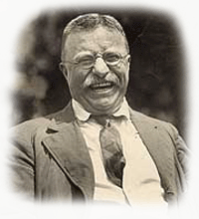

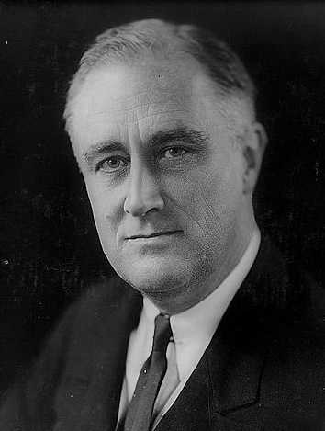
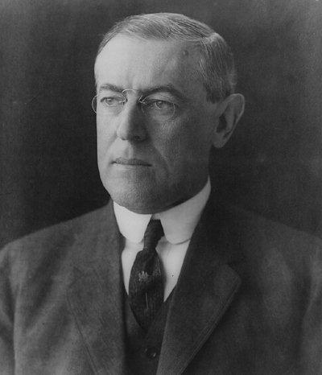

Welcome to Eighth Grade Social Studies! We finished last year's study of American history with the end of the Civil War. We will pick up from that point and continue our studies into the later part of the 20th Century.

Eighth Grade Social Studies will be very similar in structure to last year. There will be some differences, however, and you'll need to make some adjustments. You will have more responsibility. You will be asked to look a little deeper into what we are studying.

As this is your last year here at Sahs, there is quite a bit anticipated of you. I expect the eighth grade to be the most mature and most serious of my students. I also expect you to serve as an example to the rest of the school. If you approach this class and the subject matter seriously, you will get more out of it. This should be a great year and I look forward to a fun learning experience with you.

Syllabus

Chapter | Time in History | # of Pages | Point Value of Quizzes/Tests | Approximate Days to Cover
13 | 1865 to 1877 | 19 | 50 | 14
14 | 1851 to 1890 | 13 | 35 | 10
15 | Late 19th Cent. | 7 | 25 | 8
16 | 1878 to 1889 | 15 | 43 | 10
17 | 1890 to 1897 | 14 | 37 | 10
18 | 1898 to 1900 | 10 | 30 | 9
19 | 1901 to 1913 | 12 | 36 | 10
20 | 1914 to 1919 | 14 | 55 | 10
21 | 1920 to 1928 | 14 | 45 | 10
22 | 1929 to 1938 | 13 | 45 | 10
23 | 1922 to 1941 | 9 | 35 | 9
24 | 1941 to 1945 | 16 | 45 | 12
25 | 1945 to 1959 | 18 | 50 | 16
26 | 1960 to 1969 | 21 | 60 | 16
27 | 1970 to 1979 | 21 | 40 | 16
Totals: |  | 216 | 631 | 170

The table above represents what you will be covering this year in Social Studies class. The last column is the best guess as to how long it should take us to cover each chapter. This is an estimate – we will do our best to make sure that you understand the material before we move on.

Responsibilities

How Social Studies Class Works:
Daily Assignment Board:
In the front of the room on my dry-erase board, you will see the daily assignment board. It is divided by grade level and into what we will be doing that day along with any homework. Your first job when you come into the room is to take out your assignment books and write down any homework listed on the board. If nothing is on the board, you must still write the word “none” in your assignment book under Social Studies.

READ:
This is a pretty simple class. With the exception of the two Constitutions, you are expected to read the material assigned, take notes, ask questions, do your assignments and take tests. Here’s how it works. At the beginning of a chapter, I’ll give you a handout – that will be your book. The total number of pages per chapter is listed above. Your biggest responsibility will be to READ!!!

Test Coupons (NEW):
During our note-taking for each chapter, there will be opportunities for you to earn free points toward your test score. At certain times we will stop taking notes and you may be asked a question based on your reading. If you answer correctly, you will receive a coupon that is worth one question (one point) on your test.

Vocabulary:
You’ll also be given a vocabulary/identification sheet(s) for each chapter. Your job will be to fill out that sheet and have it ready on the day that it is due. You won’t be turning it in – instead I will check your vocabulary when I check your assignment books (at the beginning of every class). If you have your vocab done then you’ll get the full 10 points. If you don’t have it done you won’t get any points and may be marked as unprepared. If you’ve only done some of it, you’ll get a few points. Doing vocab is really easy – you can look up the definitions in the master list or you can go to www.danforthnews.com and click on the 8th Grade Vocabulary and 8th Grade Identification pages.

Worksheets:
Occasionally, you will be given worksheets that go along with the subject matter that we are studying. These worksheets will also have a point value (usually 10 to 20 points). They will be due in the appropriate tray on the bookshelves near the windows on the day that is assigned. Read them carefully, answer the questions and turn them in on time – that’s all there is to it. Turn them in late and you’ll lose 10% right off the top – and you run the risk of going to S.O.S.

Crossword Puzzles:
At the end of every chapter you will get a crossword puzzle that reviews the chapter and is designed to help you prepare for your test. They are usually worth anywhere from 25 to 40 points. The same rules apply as with worksheets (see paragraph above).

Jeopardy Review:
We will review before every test. If the class is well behaved and being responsible, we will have a Jeopardy Review game. It is a fun way to prepare for the test. You’ll get a copy of all the questions & answers to use for studying. Just don’t depend only on that when you study.

Short Answer Questions (NEW):
When you receive your vocabulary, you will have a set of short answer questions for the chapter test. You will choose ONE of these questions and either write or type out your response - answering in complete sentences and doing your best to fully respond to the question. It will be worth 10 points and will be due on the same day as your chapter test.

Tests:
You will be evaluated on the material we’ve covered in every chapter. You can see on the syllabus table how many questions will be on each test – they are worth one point each. I suggest that you use everything available to you when you study. The best thing to use for studying will be your notes. You will soon figure out what you need to do in terms of studying in order to be successful.

Points – Grades:
If you haven’t figured it out already, you should know that your grade in this class will be determined by how many points you earn. Look at the example to see how this works.

Assignment | Total Points Possible | Student X’s Points | Percentage
Chapter 28 Vocabulary | 10 | 10 | 100%
Harding & Scandals Worksheet | 10 | 9 | 90%
Opportunities for Business Worksheet | 10 | 8 | 80%
Charles Lindbergh Worksheet | 12 | 12 | 100%
Chapter 28 Crossword | 35 | 33 | 94%
Chapter 28 Short Answer | 10 | 7 | 70%
Chapter 28 Test | 45 | 32 | 71%
Totals: | 132 | 111 | 84%

As you can see here, Student X didn’t do so well on the test, yet because he did his homework fairly well, he is averaging an 84% in Social Studies class. This is why doing your homework correctly will help you in class. If you don’t understand how this all works, please make sure you ask me.

Needed Materials:
- Your packet of reading material (Chapter Reading)
- Vocabulary/Identification Sheet
- Spiral Notebook – at least 70 pages
- Something to write with – either pen (blue or black ink only) or pencil
- Highlighter – to highlight notes or reading packets

You must have the above materials at all times during Social Studies Class. NO EXCEPTIONS!!! If you need a pen or pencil, you may purchase a pen for $ .25 or a pencil for $ .10 before class begins. If you are not prepared for class, you will be marked as unprepared.

Homework:
The majority of all Social Studies homework will consist of reading assigned pages from the reading packet. In order to be prepared for class, you must be familiar with the material being discussed. The only way to do this is to read!!! Reading assigned, will most likely consist of less than ten pages and should not take up more than 30 minutes of your time. Homework other than reading is to be expected on an “as assigned” basis.

Your Job:
- Ask questions when you don’t understand something
- Read the materials assigned
- Have your work done and turned into the correct tray on time
- Study for quizzes/tests
- Do the best you can do
- Have fun!
My Job:
- Answer your questions
- Grade your work in as timely a manner as possible
- Do the best I can to help you understand the subject
- Make your experience as enjoyable as possible

Web Site: www.danforthnews.com
Going to my website will be helpful to you if you have Internet access. I try to keep it updated as much as I can. You will be able to get your vocabulary and identification there. You will sometimes be able to get extra copies of material handed out in class. If you forget something at school and are at home, this way you can get instant access to your work (especially if you have a printer at home). Even more importantly, you can send me an email from there – mrdan4th@hotmail.com

Other:
Remember that you determine the grade you receive in Social Studies class. If you cover all of the points under “Your Job” above, you will easily pass this class – and hopefully you’ll have a good time doing it. There’s nothing we will be doing that you won’t be able to do. If you find yourself having problems or just have a question, be sure to come see me! I am always available – before school, after school, and on the Internet.

Let’s Have a Great Year!!!

Extra Notes

______________________________________________________________________________

______________________________________________________________________________

______________________________________________________________________________

______________________________________________________________________________

______________________________________________________________________________

______________________________________________________________________________

______________________________________________________________________________

______________________________________________________________________________

______________________________________________________________________________

______________________________________________________________________________

______________________________________________________________________________

______________________________________________________________________________

______________________________________________________________________________

______________________________________________________________________________

______________________________________________________________________________

An outline or a summary of the main points of a text, lecture, or course of study.

