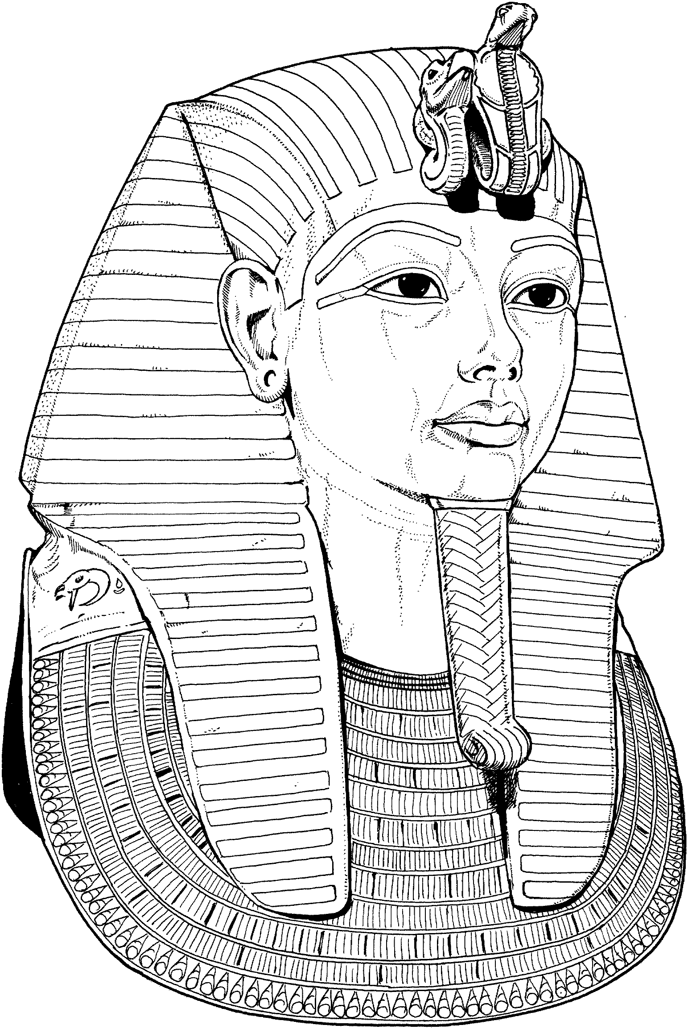
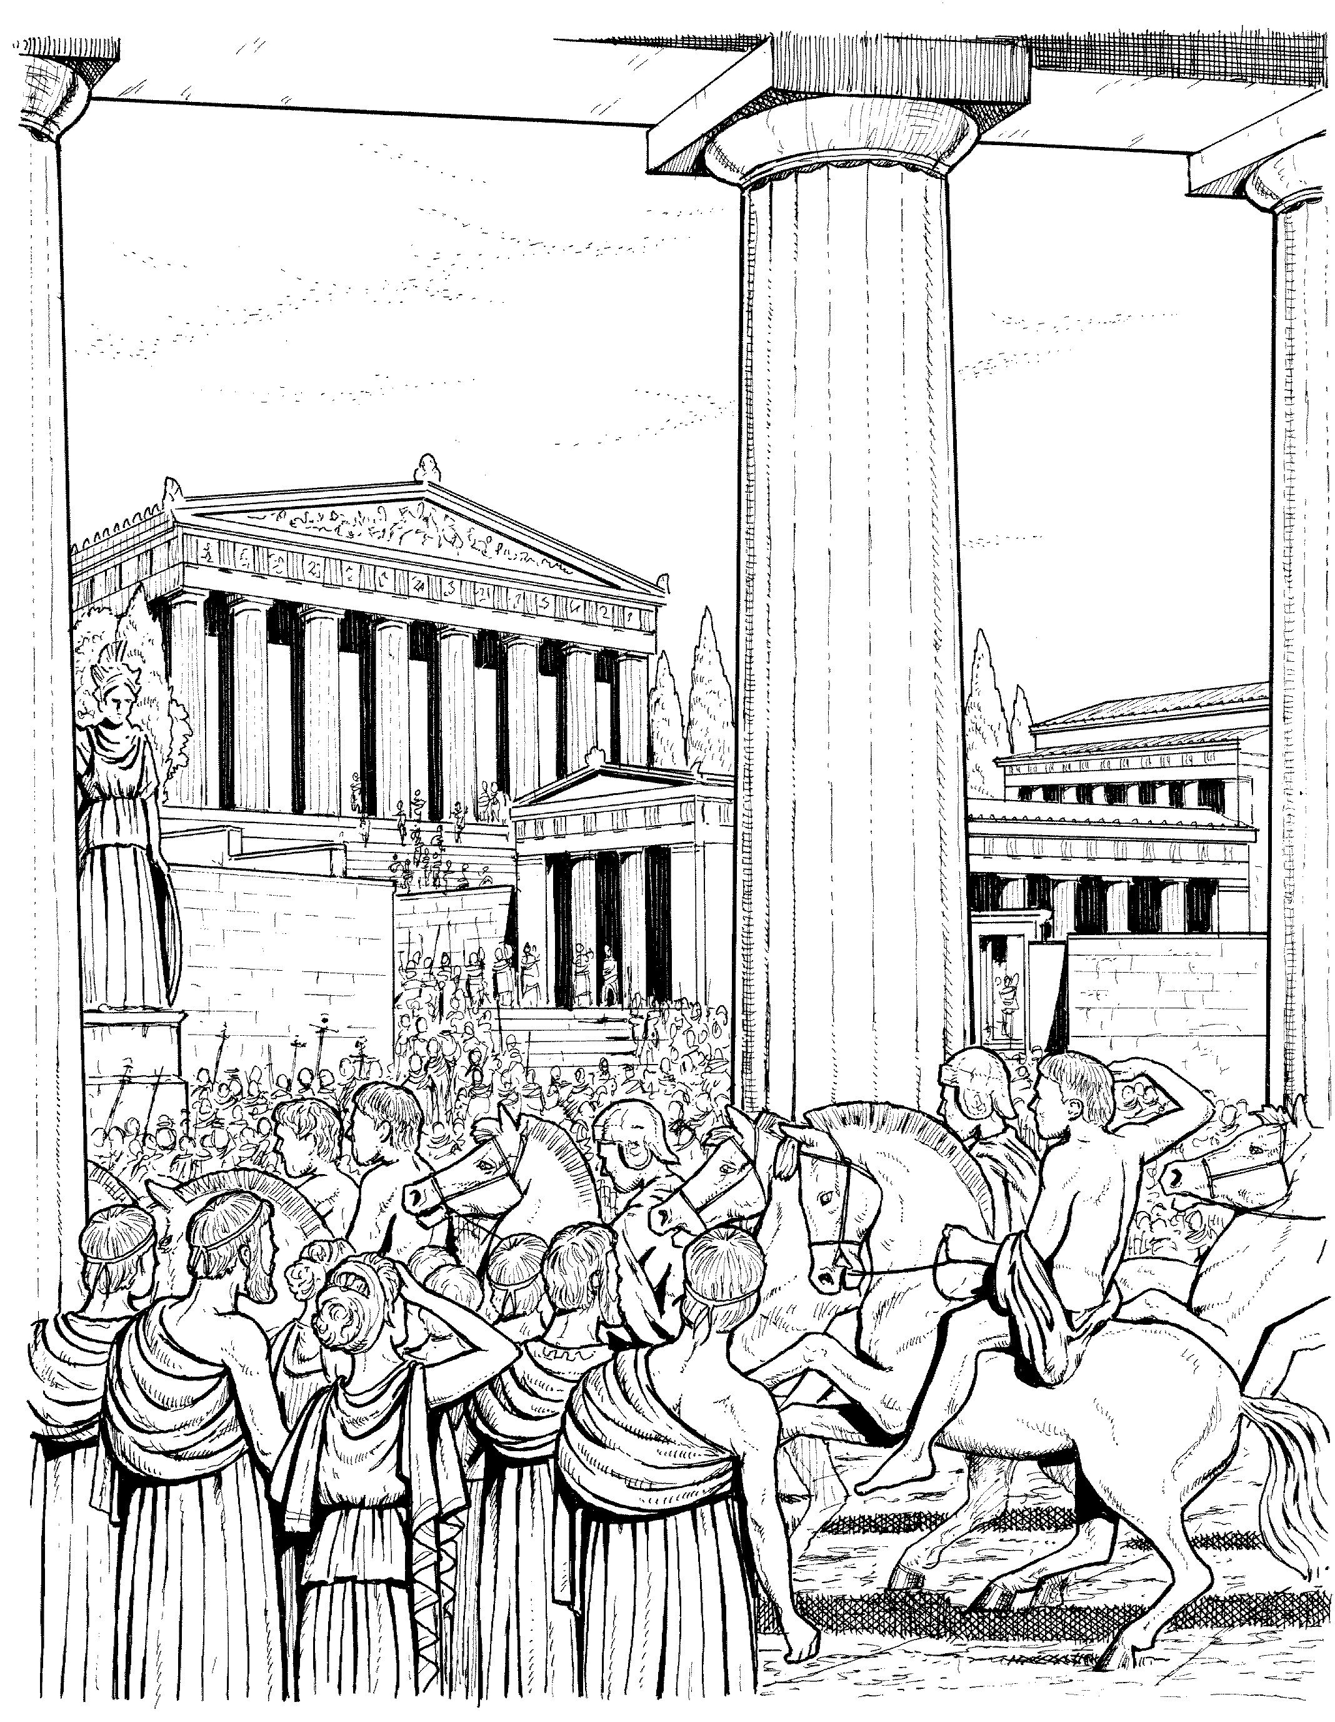
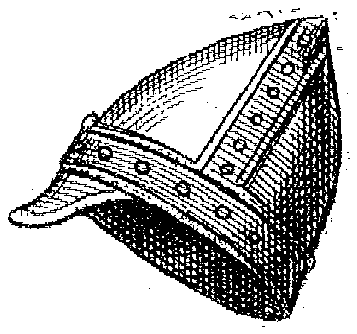
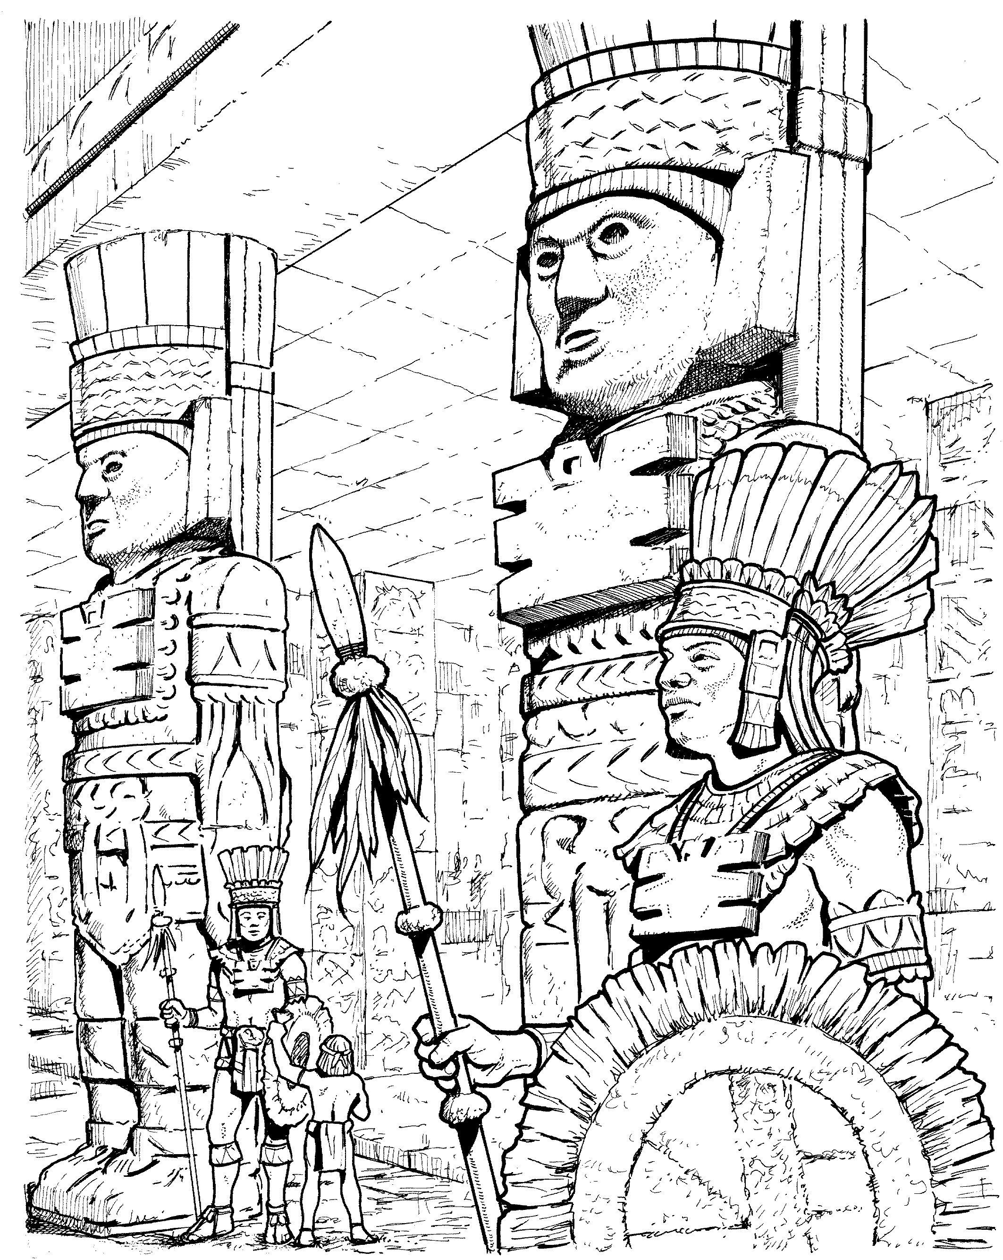
Sixth Grade
Social Studies

Welcome to Sixth Grade Social Studies! Things will be a bit different from what you’ve been learning in Social Studies in the past. You’ll find that this class can be interesting.

We will be focusing on some of the earliest civilizations known to man. After reviewing some easy Social Studies basics like geography, climates & cultures, we will learn about things that have made us the people that we are today. It might seem like we are learning about a lot of dead people and ancient empires, but these long gone people have contributed to our culture.

We will learn about Ancient Egypt’s mummies and the beginnings of law in Mesopotamia. We will discuss the foundations of our government by learning about democracy in Ancient Greece. One of the world’s largest empires will be explored when we learn about Ancient Rome. You will see how Europe became a world power and will be introduced to new cultures in the Middle East and Africa.

I think that we will have an interesting time learning these things in our sixth grade Social Studies class!

Responsibilities

How Social Studies Class Works:
Daily Assignment Board:
In the front of the room on my dry-erase board, you will see the daily assignment board. It is divided by grade level and into what we will be doing that day along with any homework. Your first job when you come into the room is to take out your assignment books and write down any homework listed on the board. If nothing is on the board, you must still write the word “none” in your assignment book under Social Studies.

READ:
This is a pretty simple class. You are expected to read the material assigned, discuss it in class, ask questions, do your assignments and take tests. There’s really not that much more to it. Your biggest responsibility will be to READ!!!

Vocabulary:
You will have a vocabulary packet that you should always have with you in this class. Your job will be to fill out the chapter section that we are working on and have it ready on the day that it is due. You won’t be turning it in – instead I will check your vocabulary when I check your assignment books (at the beginning of every class). If you have your vocab done then you’ll get the full 10 points. If you don’t have it done you won’t get any points and may be marked as unprepared. If you’ve only done some of it, you’ll get a few points. Doing vocab is really easy – you just look up the definitions in the glossary of your textbook or go to www.danforthnews.com and click on the 6th Grade Vocabulary page.

Worksheets:
Occasionally, you will be given worksheets that go along with the subject matter that we are studying. These worksheets will also have a point value (usually 10 to 20 points). They will be due in the appropriate tray on the bookshelves near the windows on the day that is assigned. Read the directions carefully, use your textbook, answer the questions and turn the worksheets in on time – that’s all there is to it. Turn them in late and you’ll lose 10% right off the top – and you run the risk of going to S.O.S.

Crossword Puzzles:
At the end of every chapter you will get a crossword puzzle that reviews the chapter and is designed to help you prepare for your test. They are usually worth anywhere from 25 to 40 points. The same rules apply as with worksheets (see paragraph above).

Jeopardy Review:
We will review before every test. If the class is well behaved and being responsible, we will have a Jeopardy Review game. It is a fun way to prepare for the test. You’ll get a copy of all the questions & answers to use for studying. Just don’t depend only on that when you study.

Tests:
You will be evaluated on the material we’ve covered in every chapter. I suggest that you use everything available to you when you study. The best thing is to review (possibly re-read) the chapter in your textbook as well as your vocabulary. You will soon figure out what you need to do in terms of studying in order to be successful.

Points – Grades:
If you haven’t figured it out already, you should know that your grade in this class will be determined by how many points you earn. Look at the example to see how this works.

Assignment | Total Points Possible | Student X’s Points | Percentage
Ch. 3 Vocabulary | 10 | 10 | 100%
Worksheet 18/19 | 12 | 9 | 75%
Worksheet 21 | 11 | 10 | 91%
Ch. 3 Crossword | 30 | 27 | 90%
Ch. 3 Test | 35 | 25 | 71%
Totals: | 98 | 81 | 83%

As you can see here, Student X didn’t do so well on the test, yet because he did his homework fairly well, he is averaging an 83% in Social Studies class. This is why doing your homework correctly will help you in class. If you don’t understand how this all works, please make sure you ask me.

Needed Materials:
- Your textbook – The World – IT MUST BE COVERED AT ALL TIMES!!!
- Vocabulary Packet
- Spiral Notebook – at least 70 pages (optional)
- Something to write with – either pen (blue or black ink only) or pencil
- Highlighter – to highlight when needed
- Colored pencils when assigned

You must have the above materials at all times during Social Studies Class. NO EXCEPTIONS!!! If you need a pen or pencil, you may purchase a pen for $ .25 or a pencil for $ .10 before class begins. If you are not prepared for class, you will be marked as unprepared.

Homework:
The majority of all Social Studies homework will consist of reading assigned pages from the textbook. In order to be prepared for class, you must be familiar with the material being discussed. The only way to do this is to read!!! Reading assigned, will most likely consist of less than ten pages and should not take up more than 20 to 30 minutes of your time. Homework other than reading is to be expected on an “as assigned” basis.

Your Job:
- Ask questions when you don’t understand something
- Read the materials assigned
- Have your work done and turned into the correct tray on time
- Study for quizzes/tests
- Do the best you can do
- Have fun!

My Job:
- Answer your questions
- Grade your work in as timely a manner as possible
- Do the best I can to help you understand the subject
- Make your experience as enjoyable as possible

Web Site: www.danforthnews.com
Going to my website will be helpful to you if you have Internet access. I try to keep it updated as much as I can. You will be able to get your vocabulary and identification there. You will sometimes be able to get extra copies of material handed out in class. If you forget something at school and are at home, this way you can get instant access to your work (especially if you have a printer at home). Even more importantly, you can send me an email from there – mrdan4th@hotmail.com

Other:
Remember that you determine the grade you receive in Social Studies class. If you cover all of the points under “Your Job” above, you will easily pass this class – and hopefully you’ll have a good time doing it. There’s nothing we will be doing that you won’t be able to do. If you find yourself having problems or just have a question, be sure to come see me! I am always available – before school, after school, and on the Internet.

Let’s Have a Great Year!!!

Be sure to check out www.danforthnews.com for updates and helpful material!

Extra Notes

____________________________________________________________________________

____________________________________________________________________________

____________________________________________________________________________

____________________________________________________________________________

____________________________________________________________________________

____________________________________________________________________________

____________________________________________________________________________

____________________________________________________________________________

____________________________________________________________________________

____________________________________________________________________________

____________________________________________________________________________

____________________________________________________________________________

____________________________________________________________________________

____________________________________________________________________________

